For Immediate Release
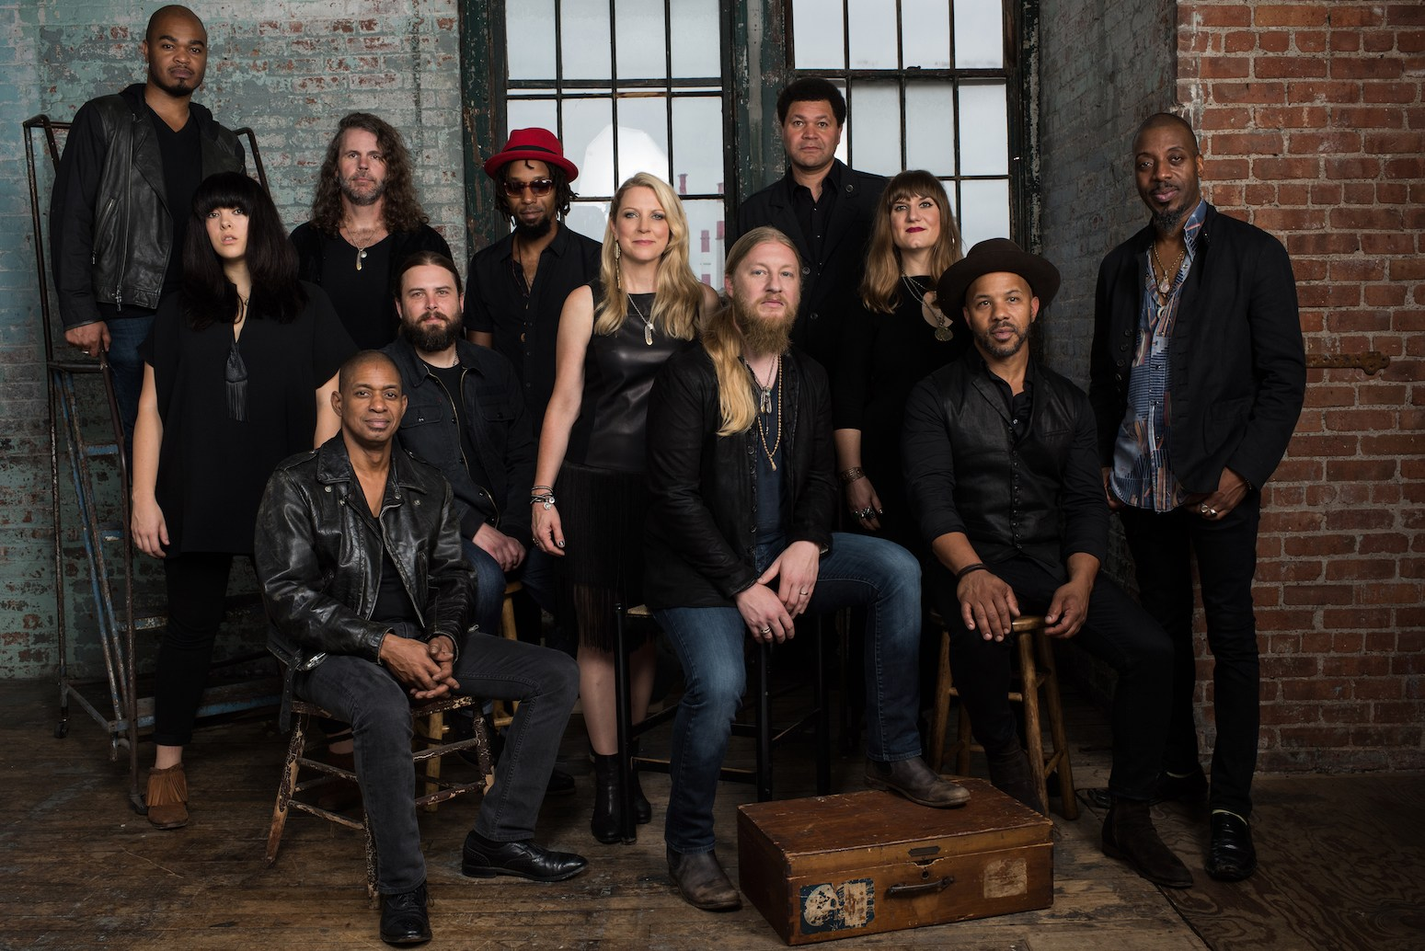

TEDESCHI TRUCKS BAND LINES UP WEST COAST DATES

DEREK & SUSAN ALSO TO PERFORM B.B. KING TRIBUTE CONCERT SEPTEMBER 1

JACKSONVILLE, FL August 16, 2016 - In a year that has seen Tedeschi Trucks Band headline several festivals, perform memorable multi-night residencies, and tour internationally in support of their latest album Let Me Get By, the 12-piece ensemble kicks off their Fall with a return to the West Coast. Driven by guitar virtuoso Derek Trucks and singer-guitarist Susan Tedeschi, the Grammy Award-winning powerhouse hits the Golden State and Pacific Northwest for a series of September shows that include two nights of filming at Oakland's Fox Theater (Sept 8-9) and two nights in Los Angeles at the Orpheum (Sept 16-17).

TTB’s critically-hailed musicianship and full touring schedule have built a dedicated and growing following around the world and earned them a reputation as one of the best live performing bands in the business. Since the January 2016 release of Let Me Get By, their tour has taken the group across the globe, with dates in Australia, Japan, Europe and Canada, multiple sold-out night runs in Nashville, Chicago, Washington DC and Philadelphia, and an unprecedented return engagement to New Orleans Jazz and Heritage Festival. Most recently, the group wrapped up their summer “Wheels of Soul” amphitheater tour with Los Lobos and North Mississippi Allstars. Numerous nightly collaborations had critics describing the show as a “near-religious experience,” “a full night of musical camaraderie” that “boasted plenty of blow-you-away moments,” and Red Rocks’ AEG concert promoter Chuck Morris calling it “one of the best shows in all my years since 1976 when I started here.”

Highly respected by their peers, the demand for the married couple on stage and on record continues to increase. On September 1, Derek and Susan will join the live B.B. King tribute concert in Los Angeles to benefit the GRAMMY Foundation and GRAMMY Museum alongside Keb’ Mo’, Slash, Jimmie Vaughan, Joe Bonamassa, Kenny Wayne Shepherd and Joe Louis Walker among others. Upcoming fall highlights also include a return to Beacon Theatre in New York City for a sixth consecutive year, this year expanding its run to six nights (9/30-10/8) and closing out the year with three nights in Susan’s hometown of Boston at the Orpheum Theatre.

In the past year, Derek and Susan have also made contributions in the studio guesting on a number of projects, including The Songs of Blind Willie Johnson: God Don’t Never Change, The Wood Brothers (Paradise), Randall Bramblett (Devil Music), and featured Susan duets on new releases from both Eric Church (Mr. Misunderstood) and John Prine (For Better, Or Worse).

Since their inception in 2010, TTB have seen all three of their studio albums debut in the Top 15 of the Billboard 200, and won a Grammy for their debut album Revelator. Let Me Get By (Fantasy/Concord) is the first album the band has released since Derek Trucks’ departure from the Allman Brothers Band. It’s a completely homegrown record, produced by Derek and delivering all original material written within the TTB family. Let Me Get By earned praise from Rolling Stone, the Wall Street Journal, and the Associated Press, who called it “one of the great records of the year.” NPR has praised Trucks and Tedeschi as “two of the best roots rock musicians of their generation.”

Video NPR’s Tiny Desk Concerts http://n.pr/1RqgZnd

Watch “Anyhow” Live in Studio
https://www.youtube.com/watch?v=NwgEELSShrU

Austin City Limits “Let Me Get By”
https://www.youtube.com/watch?v=8bBwolfDk9I

TEDESCHI TRUCKS BAND ITINERARY
8/27 Arrington, VA Lockn’ Music Festival
9/2 Scottsdale, AZ The Pool at Talking Stick Resort
9/3 San Diego, CA Copley Symphony Hall +
9/4 San Luis Obispo, CA Avila Beach Golf Resort +
9/6 Arcata, CA Van Duzer Theatre
9/8 Oakland CA Fox Theater +
9/9 Oakland CA Fox Theater
9/10 South Lake Tahoe, NV MontBleu Resort Casino
9/12 Jacksonville, OR Britt Pavilion +
9/13 Bend, OR Peak Summer Nights +
9/14 Seattle, WA McCaw Hall +
9/16 Los Angeles, CA Orpheum Theatre +
9/17 Los Angeles, CA Orpheum Theatre
9/19 Albuquerque , NM Sandia Casino Amphitheater (rescheduled from 8/4) w/ Los Lobos & North Mississippi Allstars
9/30 New York, NY Beacon Theatre &
10/1 New York, NY Beacon Theatre
10/4 New York, NY Beacon Theatre **
10/5 New York, NY Beacon Theatre @
10/7 New York, NY Beacon Theatre
10/8 New York, NY Beacon Theatre
10/30 Uncasville, CT Mohegan Sun
11/11 Minneapolis, MN Orpheum Theatre * sold out
11/12 Milwaukee, WI Riverside Theater * sold out
11/13 Peoria, IL Peoria Civic Center Theatre *
11/15 Louisville, KY Louisville Palace *
11/17 Fort Wayne, IN Embassy Theatre *
11/18 Akron, OH Akron Civic Theatre *
11/19 Pittsburgh, PA Benedum Center * sold out
12/1 Boston, MA Orpheum Theatre @
12/2 Boston, MA Orpheum Theatre &
12/3 Boston, MA Orpheum Theatre - sold out

+ w/ Nicki Bluhm and the Gramblers
* w/ Amy Helm & The Handsome Strangers
@ w/ Jorma Kaukonen
& w/ Amy Ray
** w/ Dave Mason
HIGH RES JEPGS:
www.ontourpr.com/TTB

Press contact:
Renee Pfefer On Tour PR
Email: Renee@ontourpr.com Office: 203-724-9919 cell: 914-806-2834
www.ontourpr.com

