For Immediate Release
July 14, 2017

Tedeschi Trucks Band’s 2017 “Wheels of Soul” Tour Continues Full Speed Ahead with The Wood Brothers and Hot Tuna

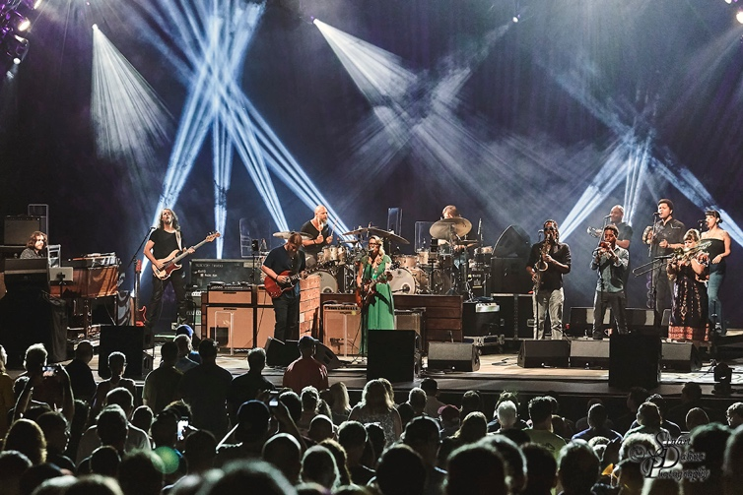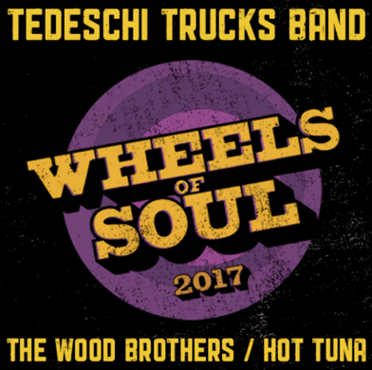

“Impressive and expansive…It was all blues wailing at the Providence Performing Arts Center Friday night — or was it folk? Or soul? Or, combine it all for Americana? The answer is: All of the above” - Providence Journal

“As the “Wheels of Soul” roll on, Tedeschi Trucks Band continues to affirm their stature as one of the best live bands on the road today. Watching this immensely talented collection of musicians come together to form something greater–and more soulful–than the sum of their parts is truly a wonder to behold. Do yourself a favor: don’t miss this tour.” - Live For Live Music

JACKSONVILLE, FL - JULY 14, 2017 - With eight wildly successful shows in the books and 13 more to go, the 2017 incarnation of Tedeschi Trucks Band’s third annual multi-artist “Wheels of Soul” tour is shaping up to be their biggest and best yet. Along with supporting acts Hot Tuna and The Wood Brothers, TTB’s 2017 “Wheels of Soul” run has already brought out fans all along the east coast in unprecedented numbers. Breaking personal attendance records, the tour sold more than 7,200 tickets at both Saratoga Performing Arts Center and Simsbury Meadows Performing Arts Center. Remaining dates are following suit with sold out shows in Atlanta (7/15) and Salt Lake City (8/1) as well as the 1st night (July 29) at the iconic Red Rocks Amphiteatre, with the 2nd night (July 30) rapidly heading in the same direction. The tour continues through August 2 in Montana.

According to TTB’s dynamo guitarist/lead vocalist Susan Tedeschi, "It's been great to develop this tour into an annual event where we get a chance to hit the road and share the stage with fellow musicians we love and respect. Each year we try to find bands that share our musical vision while bringing their own unique talents to this traveling circus.” Derek Trucks, Tedeschi’s husband, co-bandleader, and fearlessly talented lead guitarist, adds, "Every year as the tour rolls along, the collaborations between all the musicians grow and grow. It inspires and challenges us in new ways and I think that really translates to the audience when they see how much fun we're having with our friends."

The collaborative fun is already in full swing, as members of both Hot Tuna and The Wood Brothers have joined the well-oiled powerhouse on several occasions, adding fresh sonic flavor to blues standards like “Key To The Highway” and “Sky Is Crying,” classic rock and roll favorites like Bob Dylan & The Band’s “You Ain’t Going Nowhere” and The Rolling Stones’ “Sweet Virginia.”

Video: Tedeschi Trucks Band & The Wood Brothers “Sweet Virginia” - Live July 9, 2017 https://www.youtube.com/watch?v=C-OVN7o-fks

While The Wood Brothers and Hot Tuna collaborations have served as memorable highlights, the indomitable 12-piece ensemble has remained the high-powered engine that keeps the wheels turning. As the Providence Journal raves, “Watching Trucks attack the frets was absolutely amazing at times” and “Tedeschi’s voice…was a wonderful blend of rasp and power…The depth of the band is part of its magic.” TTB fields a veritable all-star team of world-class musicians on a nightly basis, including bassist Tim Lefebvre, dual drummers Tyler Greenwell and J.J. Johnson, vocalists Mike Mattison, Mark Rivers, and Alecia Chakour, and a three-piece horn section comprised of Kebbi Williams (Saxophone), Ephraim Owens (Trumpet), Elizabeth Lea (Trombone). Tedeschi Trucks Band’s 2017 “Wheels of Soul” lineup also features understudy Carey Frank on keys, who is gradually proving his mettle as he fills in for regular keyboardist Kofi Burbridge while he recovers from recent heart surgery. Together, this one-of-a-kind musical collective is consistently turning in wildly creative, eclectic, and stunningly powerful performances every time they take the stage.

About Tedeschi Trucks Band
Praised by NPR as “two of the best roots rock musicians of their generation,” Tedeschi and Trucks formed Tedeschi Trucks Band in 2010 after recording and touring for years as solo artists. Their latest release, a CD/film combo titled Live From the Fox Oakland (March 2017), was recorded in a single night and beautifully captures the group’s incredible power in concert. The double-disc live recording, which debuted at #1 on Billboard’s Blues and #6 Rock Albums chart, showcases the band’s ability to move seamlessly from blistering rock and blues to soulful ballads. Their previous three studio records, including their Grammy award-winning debut, have all charted in the Top 15 of the Billboard 200, with 2016's Let Met Get By (Fantasy Records) produced entirely by Trucks and praised by the Associated Press as "one of the great records of the year."
Wheels of Soul Summer Tour 2017
July 14 - Raleigh, NC - Red Hat Amphitheater
July 15 - Atlanta, GA - Fox Theatre – sold out
July 16 - Charlotte, NC- Charlotte Metro Credit Union Amphitheatre
July 19 - Indianapolis, IN - Farm Bureau Insurance Lawn
July 21 - Cincinnati, OH - PNC Pavilion at Riverbend Music Center
July 22 - Huber Heights, OH - Rose Music Center
July 23 - Rochester, MI - Meadow Brook Amphitheatre
July 25 - Rogers, AR - Walmart Arkansas Music Pavilion
July 27 - Albuquerque, NM - Sandia Casino
July 29-30 - Morrison, CO - Red Rocks Amphitheatre
Aug 1 - Salt Lake City, UT Red Butte Gardens - sold out
Aug 2 – Bonner, MT – KettleHouse Amphitheatre

VIDEO LINKS:
Tedeschi Trucks Band “Let Me Get By” - Live From The Fox Oakland
https://www.youtube.com/watch?v=um9TmblAcnw
The Wood Brothers “Ophelia” - Live From The Barn official video
https://youtu.be/hwzvgH-5CCM
Electric Hot Tuna “99 Year Blues” - Live at Fur Peace Ranch
https://www.youtube.com/watch?v=3ubSwu37-nI

http://www.tedeschitrucksband.com
http://www.thewoodbros.com
http://hottuna.com
For additional press information, please contact: Renee Pfefer, On Tour PR
203-724-9919; Renee@ontourpr.com
High Res JPEGS available for download here:
www.ontourpr.com/TTB

