For Immediate Release

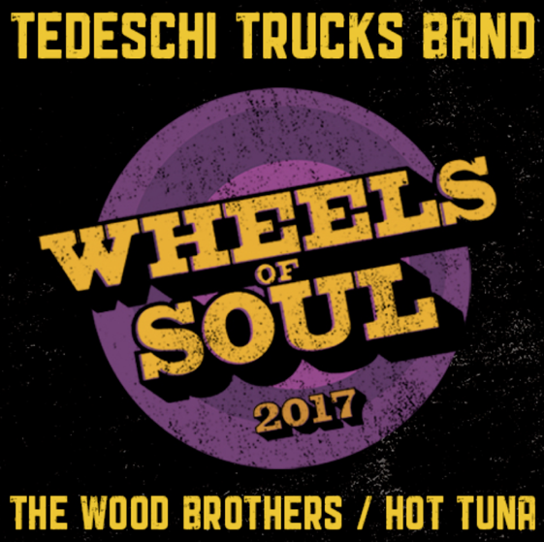

Tedeschi Trucks Band Announce Biggest "Wheels of Soul" Tour to Date for 2017
Third Annual Run features The Wood Brothers and Hot Tuna
NEW YORK, NY - Tedeschi Trucks Band announce the third installment of their wildly popular Wheels of Soul Summer Tour. The 12-piece ensemble led by husband and wife Derek Trucks and Susan Tedeschi will be supported on all dates by longtime friends and collaborators The Wood Brothers and Hot Tuna. The tour is scheduled to hit some of the country's premier outdoor venues on the most ambitious Wheels of Soul tour to date. After four consecutive sold-out shows at Red Rocks for TTB, this year's tour adds a second night at the illustrious Colorado amphitheatre, with special plans in the works to make both nights unique events.
With an incomparable live show which embodies the vision of a large touring family bound by music, the Wheels of Soul summer dates are favorite among fans and critics alike.
The Oakland Press has deemed Wheels of Soul "the best musical hang of the season...a celebration of kindred creative spirits," while Denver Westword calls TTB's summer package "a wall of talent on stage."
Through it all, the annual summer run has become more than just a fan favorite, it has become a highlight for the headliners as well. "It's been great to develop this tour into an annual event where we get a chance to hit the road and share the stage with fellow musicians we love and respect. Each year we try to find bands that share our musical vision while bringing their own unique talents to this traveling circus," says Susan Tedeschi about the summer runs. "We go way back with Derek and Susan. They are some of our favorite friends and collaborators" says Oliver Wood of this year's Wheels of Soul tour. Oliver co-wrote a song on TTB's Grammy-winning debut album, 'Revelator', and Derek and Susan guested on the Wood Brothers 2015 release 'Paradise'.
Derek adds that this tour offers a unique opportunity for both the musicians and fans, "Every year as the tour rolls along the collaborations between all the musicians grow and grow. It inspires and challenges us in new ways and I think that really translates to the audience when they see how much fun we're having with our friends." Jorma Kaukonen (Hot Tuna) crossed paths with Derek and Susan early in their careers and their mutual admiration and kinship has grown as Jorma supported TTB on select shows in 2016. When asked about joining Wheels of Soul this year Jorma offered excitement and praise, "Tedeschi Trucks is arguably one of the greatest band in the world today. It is an honor for me and my Hot Tuna brothers to be part of this great tour"
Formed in 2010 after Tedeschi and Trucks recorded and toured for years as solo artists, Tedeschi Trucks Band is a live music juggernaut, touring over 200 days of the year. Their previous three studio records have all charted in the Top 15 of the Billboard 200, with their most recent studio effort 2016's 'Let Met Get By' (Fantasy Records) produced by Trucks entirely and praised by Rolling Stone, the Wall Street Journal, and Associated Press, who called it "one of the great records of the year."
Their latest release, Live From the Fox Oakland, a CD and film – was released on March 31, 2017 and recorded in a single night at a show that fans and band members all regard as one of their finest performances to date. The double disc live recording, which debuted at #1 on Billboard’s Blues and #6 Rock Albums chart, showcases the band’s ability to move seamlessly from blistering rock and blues to soulful ballads and includes their take on classics from Derek and the Dominos, Leonard Cohen, and even Miles Davis among TTB’s original songs. The film also gives a behind the scenes look at the band on the road.
TTB is currently on a spring European tour and returns to the US at the end of May.
Dubbed "masters of soulful folk" by Paste Magazine, The Wood Brothers are coming off their most successful year yet, including performances at Bonnaroo, Red Rocks and Carnegie Hall. Upon the release of their debut studio album in 2006, Chris Wood already had legions of devoted fans for his incomparable work as one-third of Medeski Martin & Wood, while his brother Oliver toured with Tinsley Ellis before releasing a half-dozen albums with his band King Johnson. The Wood Brothers' latest album, Live At The Barn--recorded in front of a sold out audience at Levon Helm's barn in Woodstock, NY--was released earlier this year.
Susan and Derek have a deep and creative history with The Wood Brothers. Oliver Wood co-wrote “Ball and Chain” from Revelator and the title track “Made Up Mind.”
Both appear on The Wood Brothers’ 2015 album Paradise on the track “Never and Always.”
For more than four decades, Hot Tuna has played, toured, and recorded some of the best and most memorable acoustic and electric music ever. Jorma Kaukonen and Jack Casady are former members of Jefferson Airplane, the influential San Francisco psychedelic rock band.
Itinerary - Wheels of Soul Summer Tour 2017
July 1 - Gilford, NH - Bank of New Hampshire Pavilion
July 2 - Essex, VT (Burlington) - Midway Lawn at Champlain Valley Exposition
July 3 - Saratoga, NY - Saratoga Performing Arts Center
July 5 - Vienna, VA (DC) -Wolf Trap
July 7 – Providence, RI – Providence Performing Arts Center
July 8 - Rochester, NY - Highland Bowl
July 9 - Simsbury, CT - Simsbury Meadows Performing Arts Center
July 12 - Virginia Beach, VA - Veterans United Home Loans Amphitheater
July 14 - Raleigh, NC - Red Hat Amphitheater
July 15 - Atlanta, GA - Fox Theatre
July 16 - Charlotte, NC- Charlotte Metro Credit Union Amphitheatre
July 19 - Indianapolis, IN - Farm Bureau Insurance Lawn
July 21 - Cincinnati, OH - PNC Pavilion at Riverbend Music Center
July 22 - Huber Heights, OH (Dayton) - Rose Music Center
July 23 - Rochester, MI (Detroit) - Meadow Brook Amphitheatre
July 25 - Rogers, AR - Walmart Arkansas Music Pavilion
July 27 - Albuquerque, NM - Sandia Casino
July 29-30 - Morrison, CO - Red Rocks Amphitheatre
Aug 1 - Salt Lake City, UT Red Butte Gardens
Aug 2 – Bonner, MT – KettleHouse Amphitheatre
MORE INFO
http://www.tedeschitrucksband.com
http://www.thewoodbros.com
http://hottuna.com
For additional press information, please contact: Renee Pfefer, On Tour PR
203-724-9919; Renee@ontourpr.com
High Res JPEGS available for download here:
www.ontourpr.com/TTB

