For Immediate Release
May 10, 2017
TEDESCHI TRUCKS BAND GEARS UP FOR SUMMER
SIX NIGHTS AT BEACON THEATRE IN NYC JUST ANNOUNCED
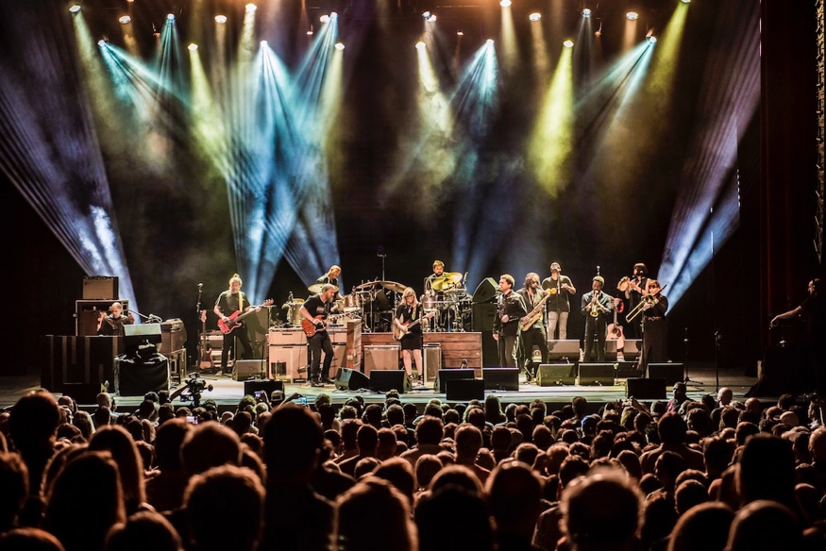
Now in their eighth year, Grammy-winning Tedeschi Trucks Band has earned their reputation as one of the premier live acts touring today. The 12-piece ensemble, led by the husband-and-wife team of guitarist Derek Trucks and guitarist-singer Susan Tedeschi, is a true collective; a rarity in rock-and-roll with every musician featured nightly while serving the band’s unified vision, pushing the boundaries of group dynamics and improvisation to inspiring new heights.
Following their most successful touring year to-date, the group eagerly returns to the road in 2017. Upcoming highlights include the opening of a new concert venue in their home city of Jacksonville, FL among a series of shows in the Southeast. They also head up the east coast for a three-night run in Philadelphia - 2 are already sold out. The group then anchors a third installment of a 22-date, cross-country “Wheels of Soul” amphitheater tour, once again as headliners of a bill curated by Trucks that adds Hot Tuna and The Wood Brothers to their list of “rock ‘n soul” collaborators.
Tedeschi Trucks Band just announced their return to the Beacon Theatre for the seventh consecutive year. Continuing their tradition of multiple-night residencies at the famed New York City venue, the group lines up six performances, set for October 6 – October 14.
In March, Tedeschi Trucks Band released a live collection, Live from the Fox Oakland, that sets a new peak in the continuing story of this great American rock & roll family band. The CD/DVD beautifully captures the group’s incredible power in concert that has earned them a dedicated and growing following around the world. It’s the band’s first-ever concert DVD, displaying on film “that exemplary
-more-

TEDESCHI TRUCKS BAND -
page 2
live interplay…” (Rolling Stone) and “the impact of the Tedeschi Trucks Band firing on all cylinders in their natural habitat.” (American Songwriter)
Live From the Fox Oakland, which debuted at #1 on Billboard’s Blues and #6 on the Rock Albums chart, follows four critically-hailed and commercially successful TTB albums, including their Grammy-winning inaugural studio effort Revelator (2011), Made Up Mind two years later and and 2016’s Let Me Get By, the first to be solely produced by Trucks and written in house in the TTB family and called by the Associated Press “one of the great records of the year”.
From their steady rise as solo artists, now to one of music’s most prominent partnerships, Tedeschi and Trucks have climbed to new peaks, both together and individually. From appearances at the White House to tributes for B.B. King, Bob Dylan and Hubert Sumlin, or guesting on albums by John Prine, Rosanne Cash, Eric Church, the duo is constantly in-demand. They've frequented late-night television, on shows hosted by Jay Leno, Conan O'Brien, Stephen Colbert’s The Late Show; and hosted special all-star musical salutes themselves, including Bonnaroo’s Superjam in 2014 (with Chaka Khan, Ben Harper, Taj Mahal, and others), and lead an extraordinary assembly of musicians for a reunited Tribute to Joe Cocker’s Mad Dogs and Englishmen in 2015 (with Leon Russell, Rita Coolidge, and many other original members.) More recently this spring, the pair shared the stage with such artists as Jackson Browne, Aaron Neville and Billy Gibbons at the Love Rocks NYC! benefit concert.
Praised by reviewers for their “joy-filled blast of blues, soul and rock” (Philadelphia Inquirer) and “stellar musicianship” (Denver Post), the group delivers an ever-growing repertoire of originals and tasty covers that have dazzled fans and critics alike: "Tedeschi Trucks took us to church," (No Depression). “Spectacle and sizzle,” (Oakland Press). “(An) excitement level through the roof,” (Florida Times-Union).
Videos:
"Keep On Growing" - Live From The Fox Oakland
https://www.youtube.com/watch?v=h0kXfPrHHcw

“Let Me Get By” – Live From The Fox Oakland
https://www.youtube.com/watch?v=um9TmblAcnw
www.tedeschitrucksband.com

TEDESCHI TRUCKS BAND ITINERARY

May 27 Jacksonville, FL Daily’s Place Amphitheater
May 28 Orlando, FL Dr. Phillips Center for the Performing Arts
June 8 Philadelphia, PA Merriam Theater
June 9 Philadelphia, PA Merriam Theater
June 10 Philadelphia, PA Merriam Theater
June 13 Augusta, GA Williams B. Bell Auditorium
June 14 N. Charleston, SC North Charleston Performing Arts Center
June 16 Wilmington, NC Greenfield Lake Amphitheater
June 17 Selbyville, DE The Freeman Stage at Bayside
July 1 - Gilford, NH - Bank of New Hampshire Pavilion *
July 2 - Essex, VT (Burlington) - Midway Lawn at Champlain Valley Exposition *
July 3 - Saratoga, NY - Saratoga Performing Arts Center *
July 5 - Vienna, VA (DC) -Wolf Trap *
July 7 – Providence, RI – Providence Performing Arts Center *
July 8 - Rochester, NY - Highland Bowl *
July 9 - Simsbury, CT - Simsbury Meadows Performing Arts Center *
July 12 - Virginia Beach, VA - Veterans United Home Loans Amphitheater *
July 14 - Raleigh, NC - Red Hat Amphitheater *
July 15 - Atlanta, GA - Fox Theatre *
July 16 - Charlotte, NC- Charlotte Metro Credit Union Amphitheatre *
July 19 - Indianapolis, IN - Farm Bureau Insurance Lawn *
July 21 - Cincinnati, OH - PNC Pavilion at Riverbend Music Center *
July 22 - Huber Heights, OH (Dayton) - Rose Music Center *
July 23 - Rochester, MI (Detroit) - Meadow Brook Amphitheatre *
July 25 - Rogers, AR - Walmart Arkansas Music Pavilion *
July 27 - Albuquerque, NM - Sandia Casino *
July 29-30 - Morrison, CO - Red Rocks Amphitheatre *
Aug 1 - Salt Lake City, UT Red Butte Gardens *
Aug 2 – Bonner, MT – KettleHouse Amphitheatre *
Sept 21 Houston, TX Hobby Center for the Performing Arts
Sept 22 Dallas, TX Music Hall at Fair Park
Sept 23 Austin, TX Austin City Limits Live at the Moody Theater
Oct 6 New York, NY Beacon Theatre w/ Greyhounds
Oct 7 New York, NY Beacon Theatre
Oct 10 New York, NY Beacon Theatre w/ The Wood Brothers
Oct 11 New York, NY Beacon Theatre w/ North Mississippi Allstars
Oct 13 New York, NY Beacon Theatre
Oct 14 New York, NY Beacon Theatre
*Wheels of Soul w/ The Wood Brothers & Hot Tuna
# # #
For additional press information, please contact:
Renee Pfefer, On Tour PR
email: renee@ontourpr.com
office: 203-724-9919
cell: 914-806-2834
High Res JPEGS available for download here: www.ontourpr.com/TTB

