For Immediate Release

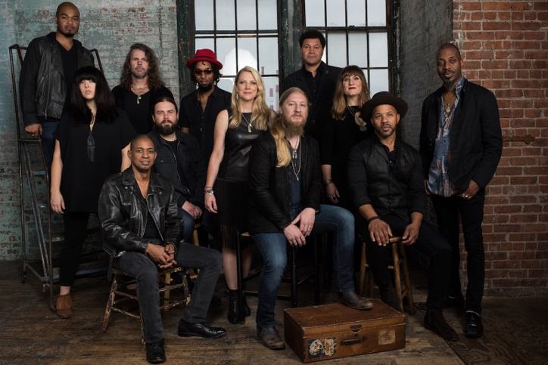

Tedeschi Trucks Band Plans a Big 2017 After Their Most Successful Year Yet

JACKSONVILLE, FL – December 8, 2016 - - For Tedeschi Trucks Band, 2016 was the 12-piece juggernaut’s most impressive and successful year to date. Loaded with triumphant follow-ups and notable firsts- from headlining the New Orleans Jazz and Heritage Festival to performances in seven countries abroad and multiple-night sell-outs in major cities across the U.S., including a six-night stint at New York City’s Beacon Theatre, to a second annual “Wheels of Soul” summer amphitheater tour- the group played more shows and sold more tickets than in any year of their six-year history; not to mention releasing their third studio album, Let Me Get By, produced by Derek Trucks with songs written for the first time as an ensemble, praised by Rolling Stone for its “Stax-Volt funk muscle and jazzy New Orleans elegance,” and by the Associated Press, who called it “one of the great records of the year.”
After wrapping their fall/winter tour schedule of West Coast and Midwest dates, the band closed the calendar, fittingly, with a 3-night sold-out run of shows in singer- guitarist Susan Tedeschi’s hometown of Boston. Increasingly, as well, Tedeschi and husband Trucks have been in demand outside of the group, including Tedsechi’s duets on releases from both Eric Church (Mr. Misunderstood) and John Prine (For Better, Or Worse), with the couple performing in Los Angeles at a tribute concert for B.B. King and Derek’s appearance on Eric Clapton’s live set, plus as a guest on the wildly popular WTF with Marc Maron podcast, scheduled to air Dec. 22. Even this year’s most historic World Series provided a viral video moment, as Trucks jammed post-game in Chicago with Pearl Jam’s Eddie Vedder and actor Bill Murray.
The slate for 2017, including the band’s own Sunshine Music Festival in January, is filling in rapidly. Growing audience demand for the group means another round of multi-night stands in Chicago, Washington DC, and Nashville’s famed Ryman Auditorium to warm up the winter before the band returns to Europe for a string of Spring shows. A summer reprise of the Wheels of Soul 2017, a third installment of the amphitheater tour headlined and curated by Tedeschi Trucks Band promises, once again, to feature top flight collaborations between bands night after night.
A relentless touring machine, with another live album potentially in the pipeline, Tedeschi Trucks Band’s performances have become legendary. An ever-growing repertoire of band originals and covers of classic rock royalty have dazzled fans and critics alike: “Spectacle and sizzle,” (Oakland Press). “(An) excitement level through the roof,” (Florida Times-Union). “Virtuosity,” (Salt Lake Tribune).
In between stretches on tour, the group continues to focus on writing as a collaborative unit, working on new material in their Swamp Raga studio at band headquarters in Jacksonville, Fla. Down-time for Tedeschi Trucks Band is shrinking, and that’s just how Trucks likes it. “I don’t want to let up. I feel like there’s more good music right around the corner,” said the guitarist. “You have to keep going after it when it’s so close.” (Ultimate Classic Rock).
Tedeschi Trucks Band is unlike any other group performing in modern rock music. A 12-piece ensemble of multiple vocalists, horns, and drummers, the band is led by the husband-and-wife team of guitarist Derek Trucks and guitarist-singer Susan Tedeschi. This Grammy-winning group, with four critically-hailed and commercially successful albums to its credit, is known worldwide, as well, for their unforgettable concert appearances that mix rock, blues, jazz, and soul into ever-changing set lists. Tedeschi Trucks Band is a true collective; a rarity in rock-and-roll that harkens back to a golden age of live music, nightly pushing the boundaries of group dynamics and improvisation to inspiring and amazing new heights.
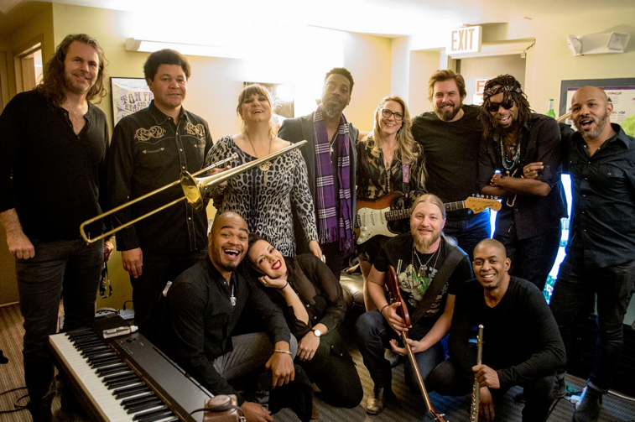
www.tedeschitrucksband.com
Tedeschi Trucks Band 2017
1/13 Mobile, AL Saenger Theatre
1/14 St. Petersburg, FL Sunshine Music Festival – Vinoy Park ^
1/15 Boca Raton, FL Sunshine Music Festival – Mizner Park ^
1/17 Memphis, TN Orpheum Theatre +
1/19 Chicago, IL Chicago Theatre +
1/20 Chicago, IL Chicago Theatre
1/21 Chicago, IL Chicago Theatre
1/23 Columbus, OH Palace Theatre +
1/25 St. Louis, MO Peabody +
1/26 Knoxville, TN Tennessee Theater &
1/28 Chattanooga, TN Tivoli Theater &
1/29 Savannah, GA Johnny Mercer Theatre
2/23 Washington DC Warner Theater
2/24 Washington DC Warner Theater
2/25 Washington DC Warner Theater
2/28 Charleston, WV Charleston Municipal Auditorium %
3/2 Nashivlle, TN Ryman %
3/3 Nashville, TN Ryman
3/4 Nashville, TN Ryman
3/17 – 4/8 Europe
6/8 Philadelphia, PA Merriam Theater - NEW
6/9 Philadelphia, PA Merriam Theater - NEW
6/10 Philadelphia, PA Merriam Theater - NEW

+ w/ North Mississippi Allstars opening
& w/ Jack Pearson opening
% w/ Jorma Kaukonen opening
^ Festival line up incl. Joe Russo’s Almost Dead, Mavis Staples, Bruce Hornsby, Railroad Earth, North Mississippi Allstars, The Greyhounds

For additional press information, please contact:
Renee Pfefer, On Tour PR
Email: Renee@ontourpr.com Office: 203-724-9919 Cell: 914-806-2834
HIGH RES JEPGS: www.ontourpr.com/TTB

