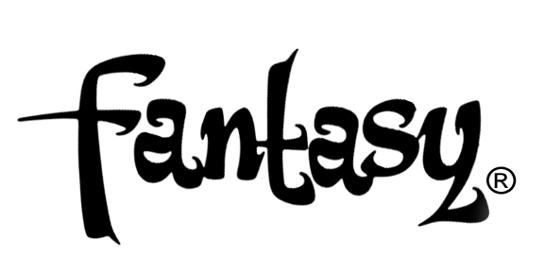

TEDESCHI TRUCKS BAND SCORES HIGHEST SALES CHART DEBUT & CRITICAL ACCLAIM

NEW LP LET ME GET BY OUT NOW
VIA FANTASY/CONCORD
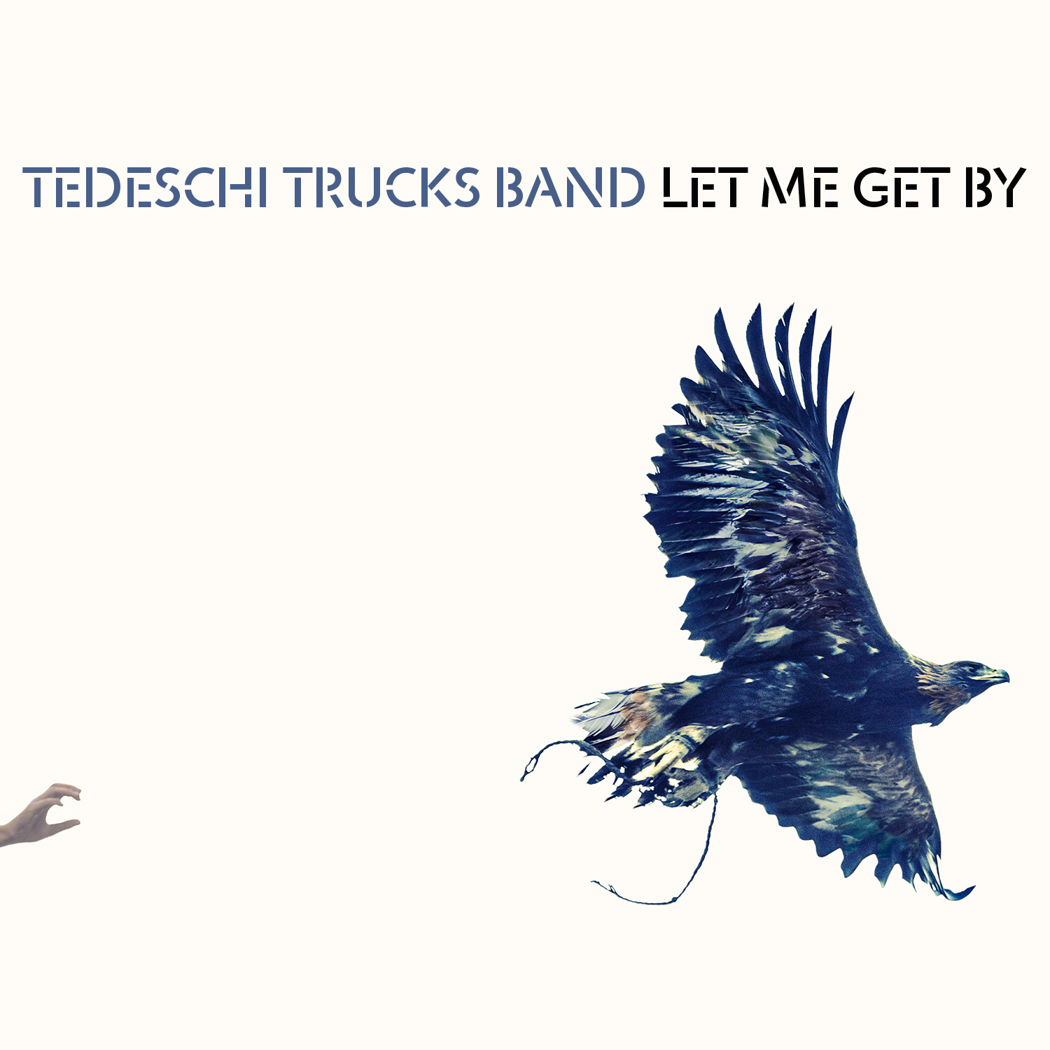

FOR IMMEDIATE RELEASE – FEBRUARY 9TH, 2016 - Garnering glowing reviews, the Tedeschi Trucks Band’s new LP Let Me Get has landed at #9 on Billboard’s sales chart in its first week, the band’s highest sales chart position ever. The new album also debuted at #2 on Billboard’s Rock chart and #1 on the Blues chart.

Let Me Get By, (Fantasy/Concord) TTB’s third album overall (and Derek Trucks' first since the Allman Brothers disbanded last year) has been profiled with major features in Rolling Stone, the New Yorker, Wall Street Journal, a Relix cover story + more. Stream it in full here via WSJ: http://on.wsj.com/1RDolIw

TTB are on tour through the spring, and recently announced their Wheels of Soul summer tour. Full itinerary here: http://tedeschitrucksband.com/

Raves for Let Me Get By:

“It's barely 2016, but the Tedeschi Trucks Band has already released one of the great records of the year” - AP

"’Let Me Get By’ reflects the transformation: It’s a varied collection that sounds cohesive even while gliding through rock, soul, blues, jazz and world music.” - Wall Street Journal

“'Let Me Get By' is an absorbing, self-assured, artistic leap forward.” - Guitar World

“‘Let Me Get By’ is the album the group has been striving for since their formation. You need this.” - All Music

Buy Let Me Get By:
iTunes: http://smarturl.it/TTBlmgbiTunes
Amazon Vinyl LP: http://smarturl.it/TTBlmgbAMZNvinylLP
Amazon Deluxe CD: http://smarturl.it/TTBlmgbAMZNdlx
Amazon Standard CD: http://smarturl.it/TTBlmgbAMZN

http://www.tedeschitrucksband.com
https://www.facebook.com/DerekAndSusan
https://twitter.com/derekandsusan
www.concordmusicgroup.com

For more information, please contact:
Matt Hanks/Bryant Kitching – Shore Fire Media
mhanks@shorefire.com bkitching@shorefire.com
718-522-7171 or Joel Amsterdam – Concord Music Group
Joel.amsterdam@concordmusicgroup.com
310-385-4206

