Produced by John Scher/Metropolitan Entertainment

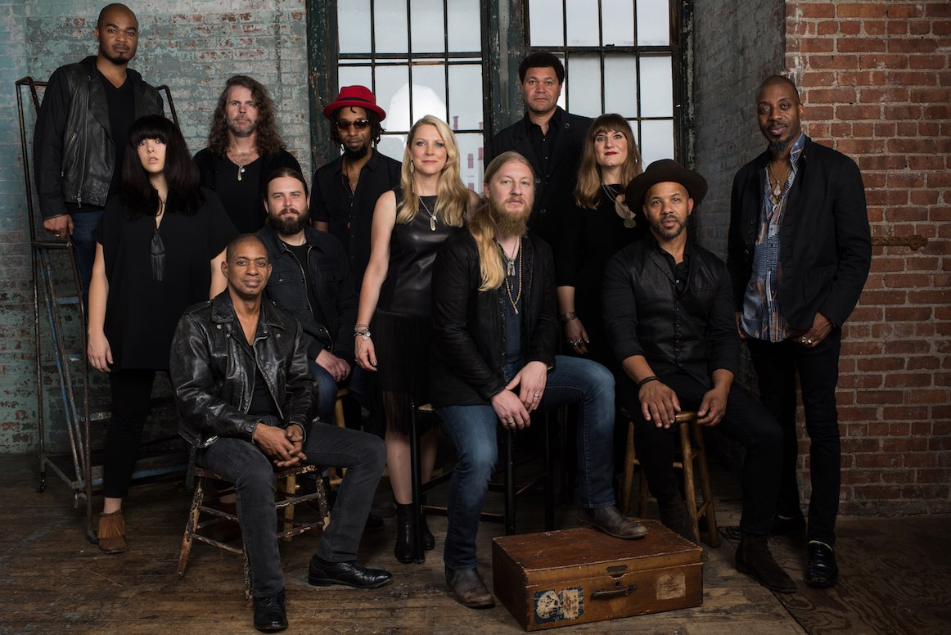

Tedeschi Trucks Band Returns To NYC’s Beacon Theatre For A Groundbreaking Six Night Residency This Fall

September 30, October 1, 4, 5, 7, and 8
NEW YORK, NY June 2016 This fall Tedeschi Trucks Band will continue their Beacon Theatre tradition of multiple-night residencies for the sixth consecutive year with the greatest number of shows to date. The 12-piece band led by husband and wife Derek Trucks and Susan Tedeschi have performed at the Beacon Theatre since 2011, and this year's run has expanded to six shows with special guest openers Amy Ray (9/30), Dave Mason (10/4), and Jorma Kaukonen (10/5). Select weekend nights (10/1, 10/7, 10/8) will feature TTB performing two full sets with no openers.
The return to the Beacon adds to the Grammy Award-winning band’s growing legacy of delivering one-of-a-kind, unforgettable performances in New York City. Last year, during its sold-out 4 night run, the ensemble debuted numerous new songs, changed up their set lists nightly for fans and played host to brilliant surprise collaborations with guests Jon Batiste, Rosanne Cash, Charles Bradley and David Hidalgo.
Touring in support of their new album, Let Me Get By, Tedeschi Trucks Band have built a dedicated and growing following around the world, one powerful performance at a time. Highlights this year have included multiple sold-out night runs in Nashville, Chicago, Washington DC and Philadelphia, an unprecedented return engagement to New Orleans Jazz and Heritage Festival, and the band’s current 19-city headlining “Wheels of Soul” tour with Los Lobos and North Mississippi Allstars. Upcoming highpoints include two nights in Oakland, CA (Sept 8-9), two nights in Los Angeles (Sept 16-17) and the six-night residency at the Beacon Theatre in NYC (Sept. 30 – Oct. 8).
‘Let Me Get By’ (Fantasy/Concord) is the first album the band has released since Derek Trucks’ departure from the Allman Brothers Band. It’s a completely homegrown record, produced by Derek and delivering all original material written within the TTB family. Let Me Get By earned praise from Rolling Stone, the Wall Street Journal, and the Associated Press, who called it “one of the great records of the year.” NPR has praised Trucks and Tedeschi as “two of the best roots rock musicians of their generation.”
Friday, September 30 New York, NY @ Beacon Theatre w/ Amy Ray
Saturday October 1 New York, NY @ Beacon Theatre - Sold out
Tuesday, October 4 New York, NY @ Beacon Theatre w/ Dave Mason
Wednesday, October 5 New York, NY @ Beacon Theatre w/ Jorma Kaukonen
Friday, October 7 New York, NY @ Beacon Theatre
Saturday, October 8 New York, NY @ Beacon Theatre - Sold out
Check out NPR’s Tiny Desk Concerts
Watch “Anyhow” Live in Studio
Read New Yorker profile
TICKET INFORMATION: Tickets are priced at $49.50, $83.50 and $125, plus applicable fees. In addition, the band has arranged for specially priced multi-show ticket packages to be available for these shows in addition to a limited number of seats at $29.50 with all fees included. All tickets are available via via Ticketmaster.com, BeaconTheatre.com and by calling 866-858-0008. Showtimes are 7:30pm on weekdays and 8:00pm on weekends.
For additional press information, please contact:
Renee Pfefer, On Tour PR – 203-724-9919 Renee@ontourpr.com

