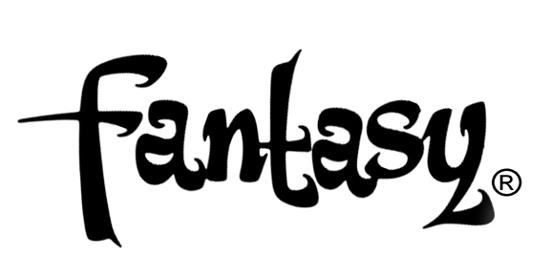

TEDESCHI TRUCKS BAND REBORN ON
LET ME GET BY - BRAND NEW LP OUT JAN 29TH, 2015
VIA FANTASY/CONCORD

STREAM DAZZLING LEAD TRACK “ANYHOW” HERE: http://tedeschitrucksband.com/

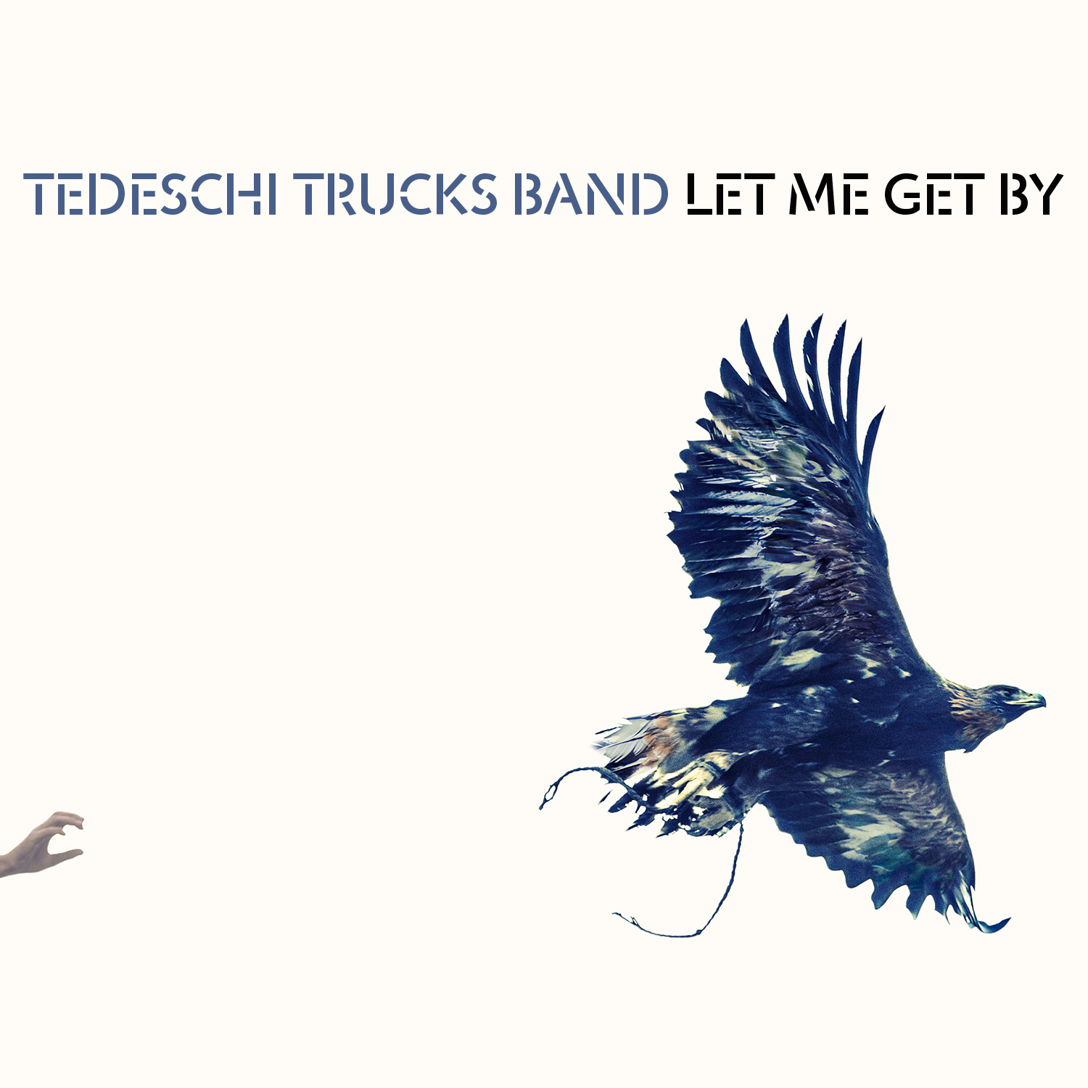

FOR IMMEDIATE RELEASE - NOVEMBER 17TH, 2015 - On January 29th, 2015 Tedeschi Trucks Band, led by the husband-and-wife team of singer-guitarist Susan Tedeschi and guitar virtuoso Derek Trucks, will cap an extraordinary and transformative year with the release Let Me Get By, their third full-length LP and debut for Fantasy Records. Listen to the lead album track “Anyhow” on the band’s website: http://tedeschitrucksband.com/

In addition, the special, 2-Disc deluxe version of Let Me Get By includes an 8-track bonus disc featuring live recordings from the legendary Beacon Theatre in New York, alternate mixes, early song takes and additional studio material, along with an expanded booklet containing exclusive studio and live photos, all housed in a custom-designed vintage amp box (photo attached). The 10-track standard version and 18-track deluxe version are both available for pre-order beginning today on the TTB website and via iTunes and Amazon beginning Friday.

Recorded at Swamp Raga Studios, the band’s home studio in Jacksonville, Florida, Let Me Get By is an absorbing, self-assured, artistic leap forward. Playing with an economy of power and uncommon grace, the 12-piece outfit—one of the most deeply skilled and admired musical ensembles in the world—explores themes of independence, love and release.

Let Me Get By is an album of firsts – in addition to being the first TTB record Trucks produced on his own, and the first on which he and Tedeschi wrote all the songs within the TTB family, it’s Trucks’ first album since his 15-year run as a member of the Allman Brothers concluded when the group disbanded last year. In Trucks’ own words, “That’s what I hear in the music on this new album - this feeling that we’re now putting 100% of what we have into this band, not going back to anything else, everyone giving it their all.”

The songs are distinct for their communal nature, with each band member contributing to the album’s varied and diverse sonic textures. Opener “Anyhow” perfectly embodies the group’s newfound liberation; with Tedeschi’s voice levitating above a symphony of towering horns and Trucks’ inventive soaring slide guitar tones. Elsewhere, “Don’t Know What It Means” serves up a funky church sermon, and “Crying Over You” delivers a classic 70’s Philly soul throwback.

Combining inspired Memphis soul, electric rhythm & blues, country, rock and classic song craft; TTB has captured the admiration of both concert audiences and critics worldwide. Since their inception in 2010, TTB have seen both of their previous albums debut in the top 15 of the Billboard Top 200 album chart, and won a GRAMMY for their debut album Revelator, which was hailed by Rolling Stone as a “masterpiece.” They tour over 200 days a year, with such highlights as headlining their first Wheels of Soul amphitheater tour this past summer, four consecutive sold-out shows at the Beacon Theatre in NYC this fall, and a surprise appearance on the debut episode of the Late Show with Stephen Colbert. In studio and on stage, TTB continue to flourish and surprise, and the release of Let Me Get By marks the beginning of another exciting chapter in the band’s storied tale.

Let Me Get By track list:

1. Anyhow
2. Laugh About It
3. Don’t Know What It Means
4. Right On Time
5. Let Me Get By
6. Just As Strange*
7. Crying’ Over You/Swamp Raga for Holzapfel, Lefebvre, Flute and Harmonium
8. Hear Me*
9. I Want More*
10. In Every Heart

Produced by Derek Trucks
Recorded and Mixed by Bobby Tis
*Co-produced by Derek Trucks and Doyle Bramhall II
Mastered by Bob Ludwig

TOUR DATES:

Dec 3 - Port Chester, NY - The Capitol Theatre
Dec 4 - New Haven, CT - College Street Music Hall
Dec 5 - Providence, RI - Providence PAC
Dec 8 - Albany, NY - Hart Theatre at The Egg
Dec 10 - Roanoke, VA - Jefferson Center
Dec 11 - Virginia Beach, VA - Sandler Center
Dec 12 - Asheville, NC - U.S. Cellular Center
Dec 143 - Austin, TX - Austin City Limits
Jan 16 - St. Petersburg, FL - Sunshine Music Festival
Jan 17 - Boca Raton, FL - Sunshine Music Festival
Jan 19 - Augusta, GA - Bell Auditorium
Jan 20 - Jackson, MS - Thalia Mara Hall
Jan 22 - Chicago, IL - Chicago Theatre
Jan 23 - Chicago, IL - Chicago Theatre
Feb 18 - Philadelphia, PA - Keswick Theatre
Feb 19 - Philadelphia, PA - Keswick Theatre
Feb 20 - Philadelphia, PA - Keswick Theatre
Feb 25 - Washington, D.C. - Warner Theatre
Feb 26 - Washington, D.C. - Warner Theatre
Feb 27 - Washington, D.C. - Warner Theatre
Mar 3 - Nashville, TN, - Ryman Auditorium
Mar 4 - Nashville, TN, - Ryman Auditorium
Mar 5 - Nashville, TN, - Ryman Auditorium
Mar 19 - Melbourne, AUS - Forum Melbourne
Mar 20 - Canberra, AUS - Canberra Theatre Centre
Mar 22 - Newtown, AUS - Enmore Theatre
Mar 24 - Byron Bay, AUS - Byron Bay Bluesfest
Mar 30 - Nagoya, JPN - Nagoya City Auditorium
Mar 31 - Osaka, JPN - Orix Theater
Apr 1 - Toyko, JPN - Nippon Budokan

http://www.tedeschitrucksband.com
https://www.facebook.com/DerekAndSusan
https://twitter.com/derekandsusan
www.concordmusicgroup.com

For more information, please contact:

Matt Hanks/Bryant Kitching – Shore Fire Media
mhanks@shorefire.com bkitching@shorefire.com
718-522-7171

Joel Amsterdam – Concord Music Group
Joel.amsterdam@concordmusicgroup.com
310-385-4206

