Media Contact:
Renee Pfefer, 203-724-9919
Renee@ontourpr.com
High Res Jpegs: www.ontourpr.com/TTB
For Immediate Release

Produced by John Scher/ Metropolitan Entertainment Presents

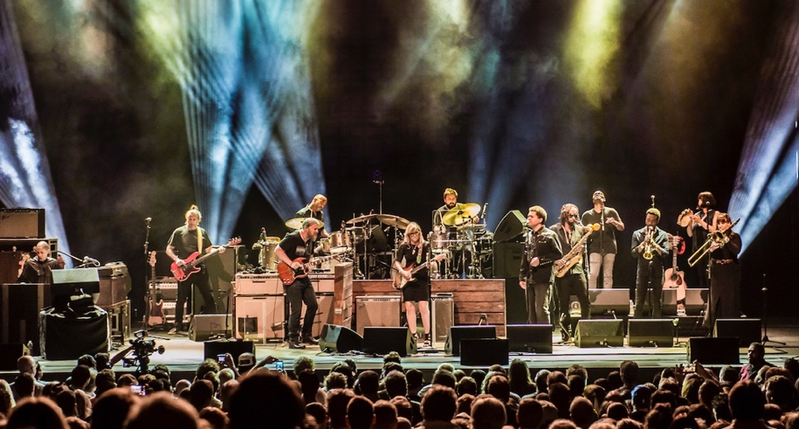
TEDESCHI TRUCKS BAND ANNOUNCES 7TH ANNUAL BEACON THEATRE RESIDENCY
SIX NIGHTS
OCTOBER 6, 7, 10, 11, 13, 14, 2017
Beacon Theatre
New York City

TICKETS ON SALE FRIDAY, MAY 12 AT 10:00AM
NEW YORK, NY May 8, 2017 - Metropolitan Entertainment today announces the return of Tedeschi Trucks Band to the Beacon Theatre for the seventh consecutive year. Continuing their tradition of multiple-night residencies at the famed New York City venue, Tedeschi Trucks Band lines up another half-dozen electrifying performances scheduled for October.
This year's slate of six shows will once again feature a selection of exceptional openers - The Wood Brothers, North Mississippi Allstars, Greyhounds - and select weekend nights will spotlight two full sets without support. Of particular note is Wednesday, October 11, “TTB & Friends” as it will mark the group’s 25th show at the Beacon, a milestone the band is looking forward to celebrating with North Mississippi Allstars opening the show and special guests to join TTB for this momentous night.
The 12-piece ensemble led by “two of the best roots rock musicians of their generation,” (NPR) husband and wife duo, Derek Trucks and Susan Tedeschi, has made the Beacon Theatre an annual stop since 2011.
Derek Trucks was a part of an impressive streak of Beacon residencies as a member of the Allman Brothers Band. Now, Tedeschi Trucks Band has proven itself to be the rightful heir to that legacy, as the Grammy Award-winning group delivers its own one-of-a-kind, unforgettable performances in the Big Apple. Over the past six years, the ensemble has debuted new material from its growing repertoire, thrilled fans nightly with ever-changing setlists, hosted a variety of opening acts and welcomed a diversity of special guests including Taj Mahal, Dickie Betts, Leon Russell, Rosanne Cash, Jimmie Vaughn, Jerry Douglas, Dave Mason, and Jon Batiste for some remarkable onstage collaborations.
Handpicked by Tedeschi Trucks Band, opening the run will be Austin, Texas group Greyhounds, bringing their bluesy, groove-heavy Americana rock. On nights three and four of the residency, TTB welcomes longtime friends The Wood Brothers (October 10) and North Mississippi Allstars (October 11). Dubbed “masters of soulful folk” by Paste Magazine, The Wood Brothers appearance will come fresh on the heels of touring this summer with Tedeschi Trucks Band on their 20-city “Wheels of Soul” 2017 dates. North Mississippi Allstars, the award-winning Southern blues and roots rock guardians are “Wheels of Soul” vets, themselves, having delivered countless magical moments with TTB on last summer’s tour. Both promise to renew their incendiary collaborations onstage at the Beacon.
The Beacon announcement follows Tedeschi Trucks Band’s recent release of Live from the Fox Oakland, the 2017 CD/DVD that beautifully captures the group’s incredible power in concert. It’s the band’s first-ever concert DVD, displaying on film “that exemplary live interplay…” (Rolling Stone) and “the impact of the Tedeschi Trucks Band firing on all cylinders in their natural habitat.” (American Songwriter). The album is the latest in a discography that includes their Grammy Award-winning debut Revelator (2011), and 2016’s Let Me Get By, called by the Associated Press “one of the great records of the year”.
From their steady rise as solo artists, now to one of music’s most prominent partnerships, Tedeschi and Trucks have climbed to new peaks, both together and individually. From appearances at the White House to tributes for B.B. King, Bob Dylan and Hubert Sumlin, or guesting on albums by John Prine, Rosanne Cash, Eric Church, the duo is constantly in-demand. Most recently, the pair shared the stage with Jackson Browne, Aaron Neville and Billy Gibbons this past March at the Love Rocks NYC! benefit concert.

Videos:
"Keep On Growing" - Live From The Fox Oakland
https://www.youtube.com/watch?v=h0kXfPrHHcw

“Let Me Get By” – Live From The Fox Oakland
https://www.youtube.com/watch?v=um9TmblAcnw
www.tedeschitrucksband.com

( CONTINUED )

TEDESCHI TRUCKS BAND - BEACON THEATRE 2017
Fri Oct. 6 With Greyhounds showtime 8pm
Sat Oct. 7 Two sets, no opener showtime 8pm
Tue Oct. 10 With The Wood Brothers showtime 7:30pm
Wed Oct. 11 “TTB & Friends -25th Beacon Show”
w/ special guests and North Mississippi Allstars showtime 7:30pm
Fri Oct.13 Two sets, no opener showtime 8pm
Sat Oct.14 Two sets, no opener showtime 8pm
Tickets are priced at $49.50, $85.50, $126.00 plus applicable fees. There will a limited number of TTB Beacon Balcony seats at $29.50 which is inclusive of all fees. In addition, a specially priced
6-night ticket package will also be available. Tickets can be purchased online at Ticketmaster.com, BeaconTheatre.com and by calling 866.858.0008.

For additional press information, please contact:
Renee Pfefer, On Tour PR 203-724-9919 Renee@ontourpr.com
High Res Jpegs: www.ontourpr.com/TTB

Produced by John Scher/Metropolitan Entertainment
www.metropolitanpresents.com

