For Immediate Release
Media Contact:
Renee Pfefer, On Tour PR
Renee@ontourpr.com 914-806-2834

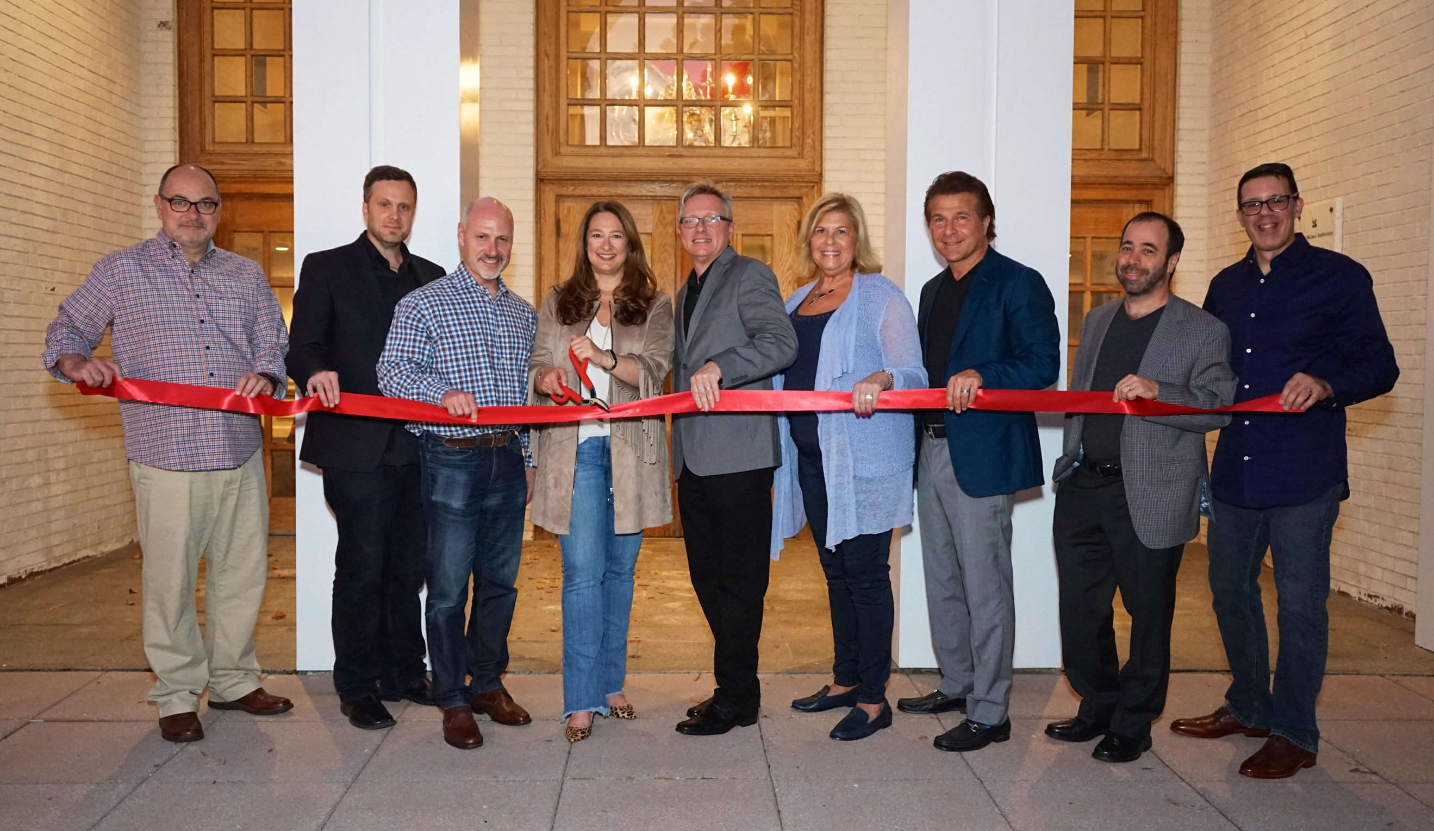
photo credit: Doug DeMarco
Chappaqua Performing Arts Center Welcomes an Enthusiastic Opening Night Crowd
Local Dignitaries Attend Ribbon Cutting Ceremony

CHAPPAQUA, NY – September 28, 2017 On Saturday, September 23, 2017 the Town of New Castle arts community came together to celebrate an evening filled with spectacular entertainment, friends and fellowship and new beginnings, as the Chappaqua Performing Arts Center -- or ChappPAC for short-- officially opened its doors for its inaugural season.

An eager crowd witnessed a ceremonial ribbon cutting and opening comments from ChappPAC manager and veteran theater professional John Fanelli, who extended his welcome to those in attendance. In his comments, he expressed special thanks to Councilwoman Lisa Katz, the individual responsible for renovating what was once the Wallace Auditorium on the Reader’s Digest Campus, saving it from demolition and acquiring it for the town.

Influential individuals supporting the Chappaqua Performing Arts Center including New Castle’s Arts and Culture Committee members participating in the ribbon cutting ceremony and opening night celebration are pictured above: (left to right) Jeffrey Kuduk; David Restivo; Robert Greenstein, Town of New Castle Supervisor; Lisa Katz, Town of New Castle Councilwoman and NCACC Chairperson; John Fanelli, Manager, Chappaqua Performing Arts Center; Michele Gregson, Chair, Friends of Chappaqua Performing Arts Center; Frank Shiner; Jonathan Leibner; and Scott Campbell, owner, Soup’s On Entertainment.
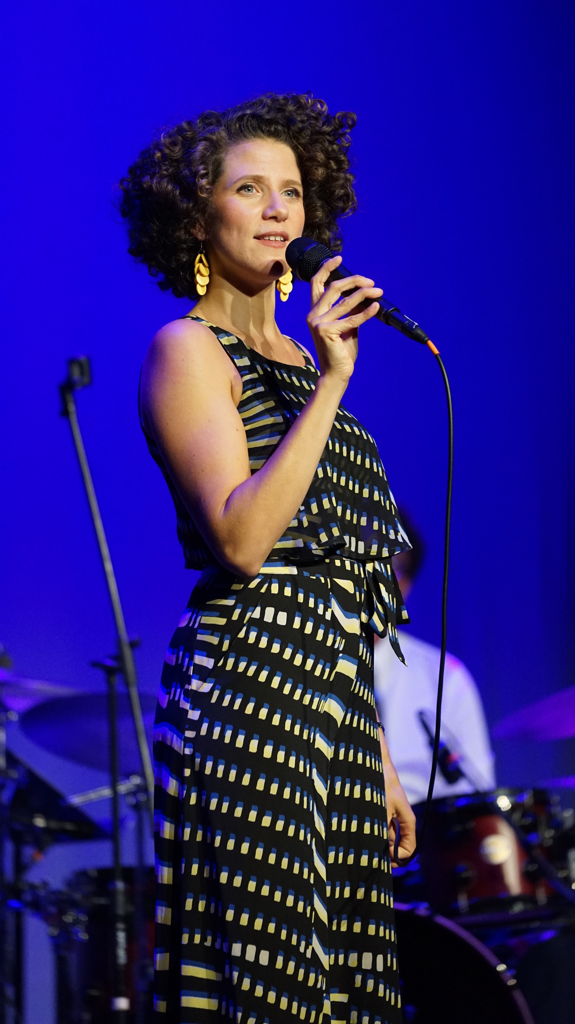
A performance by renowned jazz singer Cyrille Aimée, winner of the 2012 Sarah Vaughn International Jazz Competition, provided the audience with a number of highlights from that point on. Her set list included a number of well-known standards, dazzling originals and a selection of songs that crossed a wide array of genres. A jazz arrangement of Lerner and Loewe’s “I Could Have Danced All Night,” a touching take on the Beatles’ “Blackbird” and a special rendition of Tito Puente’s “Oye Como Va” had the crowd enthralled and chanting for more.

In addition, patrons were treated to an art exhibition and reception entitled “Revolution - Art for Positive Social Change” held in the lobby of ChappPAC earlier that evening. In partnership with Cabell Molina of SoNo's LOVE ART Gallery, it featured regional artists whose works focused on social issues encompassing race, feminism and politics.
All in all, it was a truly magnificent evening and an auspicious way to mark a new milestone in Westchester County’s continuing cultural evolution.
“We couldn’t be more delighted with this new beginning,” Mr. Fanelli commented later. “In the years to come, this arts center will bring this community exceptionally diverse and distinctive programming, one that’s rich in music, theater, comedy, film and family attractions. This was a grand beginning, but indeed, it is, after all, only the beginning.”
The 425-seat venue has ten more events planned for its Inaugural Fall Season, with some fifty to sixty shows slated for next season.
The lineup for the remainder of the 2017 Inaugural Fall Season is as follows:

Sunday, October 8, 2017
TIM KUBART & THE SPACE CADETS
Fun for the entire family!
Showtime: 2pm. Tickets: $15, $18, $30

Saturday, October 14, 2017
Sō PERCUSSION
Classical Percussion quartet performs John Cage and contemporary pieces.
Showtime: 8pm. Tickets: $30, $45, $60
Lobby Art Exhibit 5-8pm: “Method & Melody” sponsored by Northern Westchester Artists Guild
Friday, October 20, 2017
SOULSHINE: AN ALLMAN BROTHERS EXPERIENCE
Rock tribute performing ABB favorites.
Showtime: 8pm. Tickets: $15, $25

Friday, October 27, 2017
ROCKY HORROR PICTURE SHOW
Film: A Cult Classic!
Showtime: 8pm. Tickets: $20

Saturday, October 28, 2017
ECHOS OF SINATRA
Musical celebration on the life of Frank Sinatra!
Showtime: 8pm. Tickets: $25, $35, $75
Thursday, November 2, 2017
MATT SCHOFIELD
Acclaimed UK-based blues guitarist.
Showtime: 8pm. Tickets: $17.50, $25, $35

Saturday, November 11, 2017
THE GREATEST PIRATE STORY (N)EVER TOLD!
Musical adventure for all ages with audience participation.
Showtime: 2pm. Tickets: $17.50

Friday, December 1, 2017
WHAT FRESH HELL LIVE!
Comedians Margaret Ables and Amy Wilson bring their hit parenting podcast to the stage.
Showtime: 8pm. Tickets: $20

Saturday December 9, 2017
RAGTAG THEATRE’S CINDERELLA
Winner of 2016 Off Broadway Alliance Award for ‘Best Family Show.’
Showtime: 2pm. Tickets: $17.50

Sunday, December 17, 2017
ELF
Film: Modern-day Christmas Classic starring Will Farrell.
Showtime: 2pm. Tickets: $20

Location:
Chappaqua Performing Arts Center
480 Bedford Road, Chappaqua, NY 10514
Tickets: Ticketmaster.com, 1-800-745-3000
Visit us online at www.ChappaquaPAC.org or call 914-458-5143
Follow on Facebook: https://www.facebook.com/ChappaquaPerformingArtsCenter/

# # #
High Res Jpegs and press materials are available here:
www.ontourpr.com/ChappPAC
or Dropbox here:
https://www.dropbox.com/sh/mive5qke5cvilhc/AABXmRes--1g7Sym0wOzX2pDa?dl=0

