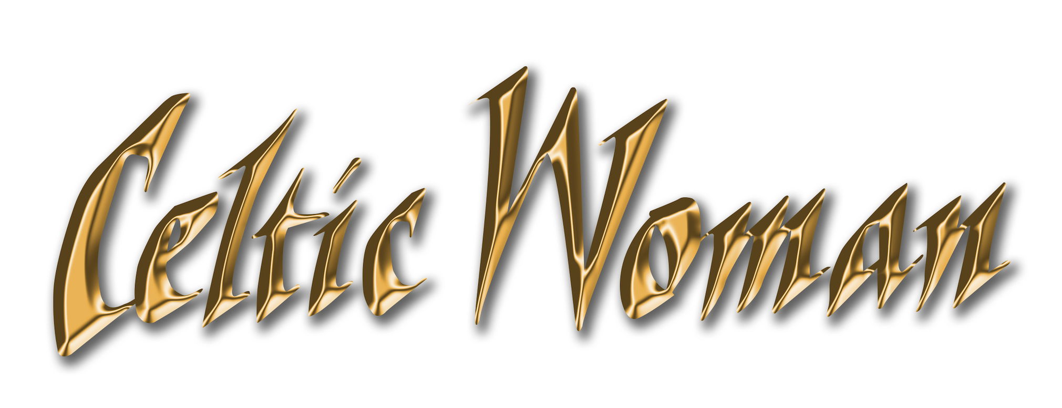
BIOGRAPHY

In the decade since its 2005 debut, global musical sensation Celtic Woman has emerged as both a formidable multimedia presence and a genuine cultural phenomenon. The group's albums and DVD releases have been consistent multi-platinum best-sellers, and its concert tours have touched the hearts of a devoted audience that spans the globe.

Both an accomplished recording ensemble and a one-of-a-kind performing collective, Celtic Woman celebrates Ireland's rich musical and cultural heritage, utilizing the country's finest musical talents and epic stage production to present a uniquely inspiring experience.

Celtic Woman's fresh fusion of traditional Irish music and modern songcraft celebrates Ireland's past while reflecting the vibrant spirit of modern Ireland. The group's repertoire encompasses Irish classics, contemporary songs, classical favorites and stirring originals. The lineup of performers has evolved in the years since the group's inception, but the signature sound of Celtic Woman has remained consistent, showcasing the members' individual and collaborative talents.

2015 marked the tenth anniversary of Celtic Woman's debut CD and DVD releases, which the group celebrated with its 10th Anniversary World Tour. The group continues to perform its sonically and visually stunning concerts in front of capacity crowds around the world, having racked up cumulative ticket sales of over three million and performing for adoring crowds in 23 countries on six continents. 2015 also marked the fifth consecutive year in which Celtic Woman has closed the year touring America with its annual holiday-themed concert tour, for which the group is augmented by a full symphony orchestra.

Celtic Woman is comprised of four young Irish women—dynamic vocalists Susan McFadden, Mairéad Carlin and Éabha McMahon and gifted violinist and founding member Máiréad Nesbitt—whose talent and charisma combine to bring centuries of musical and cultural tradition to life. In concert, their angelic voices and violin virtuosity are accompanied by a robust ensemble that includes Irish dancers, bagpipers and a full band playing an array of traditional Celtic instruments, including bodhran, tin whistle, bouzouki and Uileann pipes.

Celtic Woman's 2016 release, Destiny, is a landmark in more ways than one. In addition to being the group's tenth album and first studio effort since 2011's Believe, Destiny is perhaps the group's most explicitly Irish album to date. This is particularly appropriate, since 2016 marks the 100th anniversary of the 1916 Easter Rising, which set in motion the events that led to Ireland's independence. Several of the album's songs are sung in Gaelic, including the traditional "Siúil A Run" and "Bean Pháidín," which highlight the beauty of Ireland's language, and a rousing version of "Óró sé Do Bheatha 'bhaile," an anthem closely identified with the 1916 events. Contemporary highlights include the stirring "My Land," a distinctive version of "I See Fire," the Ed Sheeran-penned theme song from the film The Hobbit, and uplifting interpretations of "How Can I Keep from Singing," the traditional hymn popularized by Enya, and the Waterboys' classic "The Whole of the Moon."

Destiny's release coincides with Celtic Woman's ninth DVD Destiny: Live in Concert, filmed in Dublin, Ireland at the Round Room at the Mansion House, the historic home of the Lord Mayor of Dublin. The concert—which features live versions of all of the new album's songs, plus such longstanding concert favorites as "Amazing Grace" and "You Raise Me Up"—also aired on PBS stations across the U.S. beginning in December 2015, as the latest in Celtic Woman's lengthy series of successful PBS television concert specials.

Celtic Woman made its American television debut in early 2005 with its self-titled first PBS concert special, which captured a sold-out performance at the Helix in Dublin. Immediately thereafter, Celtic Woman's eponymous debut CD reached #1 on Billboard's World Music Chart and occupied the top slot for an unprecedented 81 weeks. It remained there until the release of Celtic Woman's second album, 2006's A Christmas Celebration, which cemented Celtic Woman's spot at the top for a total of 112 consecutive weeks.

Although initially intended as a one-time-only event, Celtic Woman's music was so warmly received by the public that the group immediately followed with its first concert tour in the United States. Since then, the group has maintained a strong presence on U.S. public television, where its Emmy-nominated concert specials regularly dominate the audience-supported network's viewer pledge drives.

Celtic Woman has sold more than eight million CDs and DVDs, making it the only all-female act to achieve multi-platinum success in the classical crossover and world music genres during the past decade. Named Billboard's #1 World Music Artist of the Year six times, each of its CDs has debuted at #1 on Billboard's World Album chart. Celtic Woman has also scored two Top 10 debuts on Billboard's influential album chart and five Top Five DVDs on Billboard's Top Video chart, as well as achieving platinum-level sales in nine countries.

Celtic Woman has performed for three U.S. Presidents and appeared twice at the White House, including the 2009 National Christmas Tree Lighting. The group was seen by 23 million viewers when it performed on ABC-TV's Dancing with the Stars, and gained considerable attention for its appearances in multiple episodes of the daytime drama The Bold and the Beautiful, as well appearing on numerous other television shows in the U.S. and internationally.

Celtic Woman continues to transcend national and cultural boundaries to celebrate the timeless emotion of Ireland's centuries-old heritage, brilliantly extending those musical traditions into the present day. Destiny represents the next chapter of their musical journey.

CELTIC WOMAN DISCOGRAPHY
CDs  Celtic Woman, 2005  A Christmas Celebration, 2006  A New Journey, 2007  The Greatest Journey, 2008  Songs from the Heart, 2010  Lullaby, 2011  Believe, 2011  Home for Christmas, 2012  Emerald: Musical Gems, 2014  Destiny, 2016 | DVDs  Celtic Woman, 2005  A Christmas Celebration, 2006  A New Journey: Live at Slane Castle, 2007  The Greatest Journey, 2008  Songs from the Heart: Powerscourt House and Gardens, 2010  Believe, 2011  Home for Christmas: Live from Dublin, 2013  Emerald: Musical Gems Live In Concert, 2014  Destiny: Live in Concert, 2016

- - January 2016 - -

www.celticwoman.com

