For Immediate Release
November 2, 2015

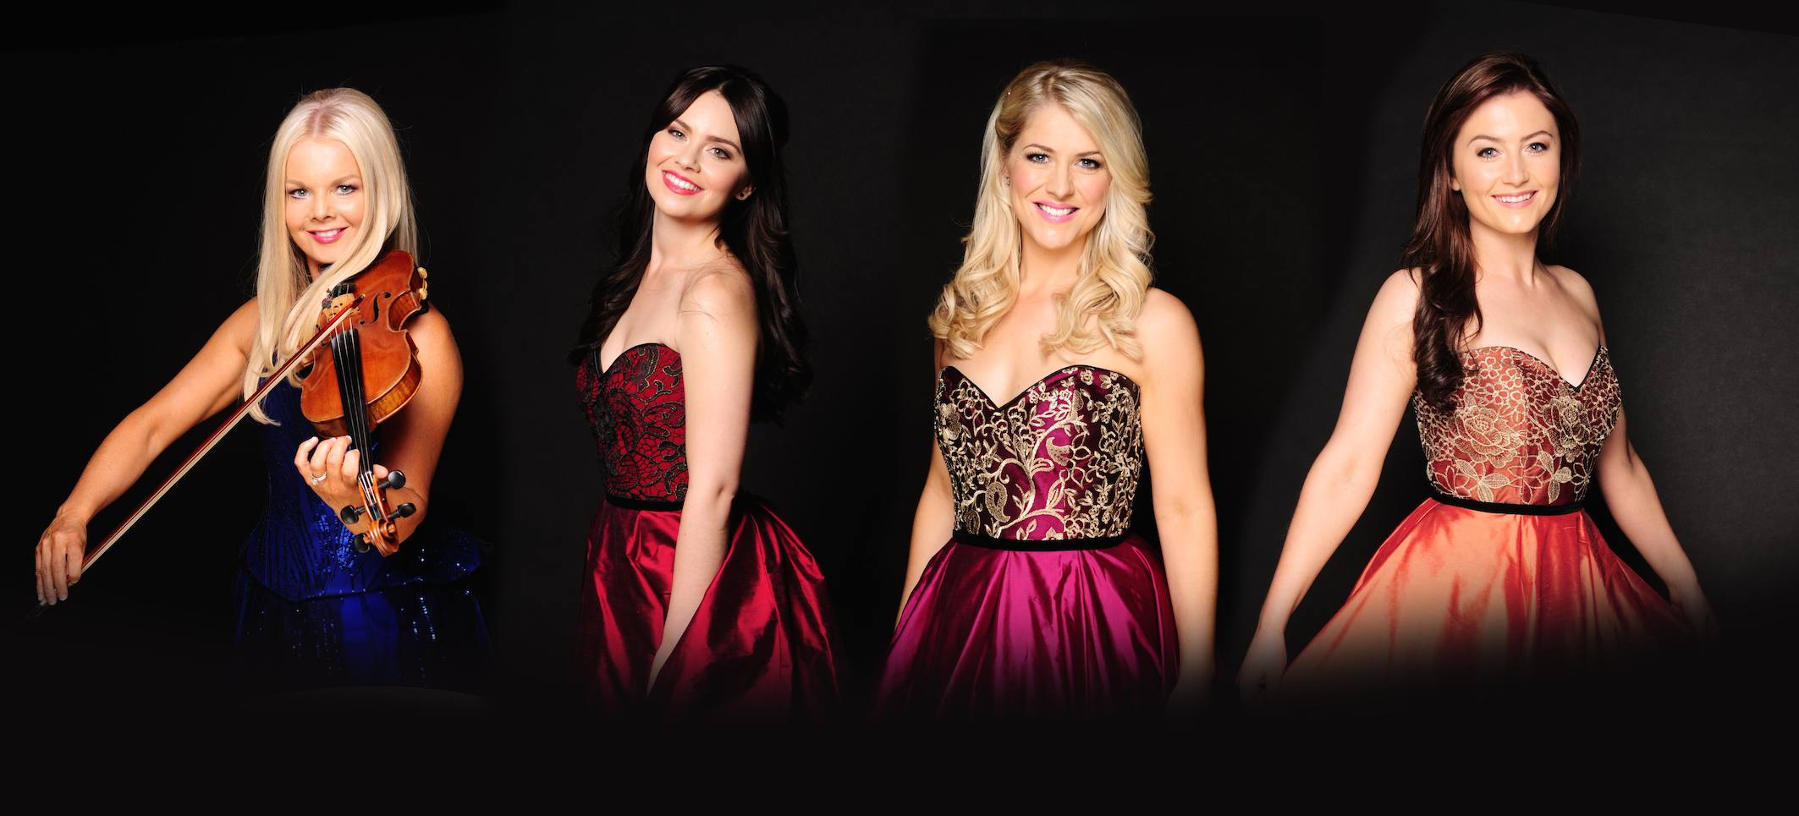
Máiréad Nesbitt, Mairéad Carlin, Susan McFadden, Éabha McMahon
Photo credit: Lili Forberg

BILLBOARD’S #1 WORLD MUSIC ARTIST, CELTIC WOMAN, ANNOUNCES 2016 NORTH AMERICAN CONCERT TOUR
CELTIC WOMAN: THE DESTINY TOUR
Tickets On Sale November 16
Exclusive Amazon Presale Ticket Access with Pre-Order of New DESTINY CD/DVD/BluRay
DUBLIN, Ireland November 2, 2015 -- Multi-platinum Irish music sensation, Celtic Woman, returns to North America in 2016 with a brand new show, Destiny, celebrating the simultaneous release of their new album and DVD, also titled DESTINY. The performances honor Ireland’s past, while bringing a contemporary musical edge to songs old and new in a way that also reflects the vibrant, modern nation that Ireland has become. Celtic Woman kicks off The Destiny Tour on March 4 in Nashville with performances lined up in 85 cities thru early July. Tickets for most cities go on sale November 16, 2015.
Celtic Woman’s new studio album DESTINY and companion DVD DESTINY - - Live in Concert will be available in stores January 15, 2016. The DVD was filmed in Dublin, Ireland at The Round Room at The Mansion House, the historic home of The Lord Mayor of Dublin and will begin airing in December on Public Television stations across the U.S. Watch trailer here.
Amazon is offering exclusive ticket presale access for Celtic Woman: The Destiny Tour with the pre-order purchase of DESTINY CD, DVD or BluRay November 2 through November 15. Visit Amazon for more details.
The heart of Ireland beats strongly throughout The Destiny Tour, which features an entirely new production with many songs from the forthcoming DESTINY CD/ DVD. As the country commemorates the events of 100 years ago that led to the nation’s independence, Celtic Woman offers a rousing version of “Óró sé do bheatha ‘bhaile,” an anthem closely connected with the 1916 uprising. The all female ensemble also delivers other timeless traditional Irish songs such as “Bean Pháidín” and "Siúil A Run" highlighting the beauty of Ireland’s heritage and its Gaelic language. Alongside newer songs such as “Walk Beside Me” and “The Whole Of The Moon,” the show also features reimagined renditions of audience favorites “Amazing Grace” and “You Raise Me Up.”
Named Billboard Magazine’s #1 World Albums Artist Six Times, Celtic Woman showcases three world class vocalists Mairéad Carlin, Susan McFadden and newest member Éabha McMahon and brilliant Celtic violinist Máiréad Nesbitt accompanied by a group of equally talented musicians and dancers whose exceptional skills and high energy bring a fresh fusion to centuries of musical and cultural tradition.
Currently, Celtic Woman is finishing up its 10th Anniversary World Tour, celebrating a decade of music and dance from the Emerald Isles. The busy group wraps up 2015 with a November series in the United Kingdom followed by its fifth annual Christmas holiday tour accompanied by a full symphony orchestra.
Celtic Woman made its debut on PBS in 2005 and achieved massive success encompassing nine albums and eight DVDs which sold over nine million copies worldwide and reached platinum-level sales in nine countries. In the U.S., every Celtic Woman album including 2013’s Emerald Musical Gems - debuted at #1 on Billboard's World Album chart. As a touring powerhouse, the group has performed for over three million fans on six continents in 23 countries.
Join Celtic Woman on the next chapter of their musical journey - a true destiny to be shared by all!.
For complete tour schedule and ticket information, visit www.CelticWoman.com

THE DESTINY TOUR – 2016 ITINERARY
3/4-5 Nashville, TN Tennessee Performing Arts Center
3/6 Memphis, TN Orpheum
3/8 Owensboro, KY RiverPark Center
3/9 Louisville, KY The Palace
3/11 Paducah, KY Carson Center
3/12 Peoria, IL Peoria Civic Center Theater
3/13 Rockford, IL Cornado PAC
3/15 Rosemont, IL Rosemont Theatre
3/18 Fort Wayne, IN Embassy Theatre
3/19 Wabash, IN Honeywell Center
3/20 South Bend, IN Morris Performing Arts Center
3/22 Indianapolis, IN Murat Theatre at Old National Centre
3/23 Bowling Green, KY Sky PAC
3/24 Cincinnati, OH Aronoff Center
3/25 Dayton, OH Schuster Performing Arts Center
3/26 Columbus, OH Palace Theatre
3/29 Cleveland, OH PlayhouseSquare
3/31 Williamsport, PA Community Arts Center
4/1, 2, 3, Lancaster, PA American Music Theater
4/5 Richmond, VA Altria Theater
4/8 Wheeling, WV Capitol Theatre
4/9 Baltimore, MD Hippodrome Theatre
4/10 Salem, VA Salem Civic Center
4/12 Asheville, NC Thomas Wolfe Auditorium
4/14 Spartanburg, SC Spartanburg Memorial Auditorium
4/15 Winston-Salem, NC LJVM Coliseum Complex
4/16 Durham, NC Durham Performing Arts Center
4/17 Charlotte, NC Ovens Auditorium
4/19 Columbia, SC Koger Center for the Arts
4/21 Athens, GA The Classic Center
4/24 Gainesville, FL Curtis M. Phillips Center for the Performing Arts
4/27 Daytona Beach, FL Peabody Auditorium
4/30 Sarasota, FL Van Wezel Performing Arts Hall
5/1 Niceville, FL Mattie Kelly Arts Center
5/6 Jackson, MS Thalia Mara Hall
5/7 New Orleans, LA Saenger Theatre
5/8 Houston, TX Revention Music Center
5/10 San Antonio, TX Majestic Theatre
5/11 Grand Prairie, TX Verizon Theatre
5/13 El Paso, TX The Plaza Theatre
5/14 Tucson, AZ Tucson Music Hall
5/15 Tempe, AZ ASU Gammage Auditorium
5/17 Bakersfield, CA Rabobank Arena
5/20 Eugene, OR Hult Center for the Performing Arts
5/21 Yakima, WA Yakima Valley SunDome
5/23 Portland, OR Arlene Schnitzer Concert Hall
5/24 Boise, ID Morrison Center
5/25 Salt Lake City, UT Maverik Center
5/26 Casper, WY Casper Events Center
5/27 Greeley, CO Monfort Concert Hall
5/28 Colorado Springs, CO Pikes Peak Center
5/31-6/1Denver, CO Buell Theatre at Denver Performing Arts Complex
6/3 Rapid City, SD Rushmore Plaza Civic Center
6/4 Bismarck, ND Bismarck Event Center
6/5 Grand Forks, ND Chester Fritz Auditorium
6/7 Bemidji, MN Sanford Center
6/9 La Crosse, WI La Crosse Center
6/10 Prior Lake MN Mystic Lake Casino
6/12 Grand Rapids, MI DeVos Performance Hall
6/14 Kalamazoo, MI Miller Auditorium
6/16 Warren, OH W.D. Packard Music Hall
6/17 University Park, PA Eisenhower Auditorium
6/19 Schenectady, NY Proctors
6/21 Rochester, NY Auditorium Theatre
6/22 Brooklyn, NY Kings Theatre
6/24-6/25Orillia, Ontario Casino Rama
6/26 Erie, PA Warner Theatre
6/28 Lowell, MA Lowell Memorial Auditorium
6/29-7/2 to be announced

Destiny PBS Trailer link
https://www.youtube.com/watch?v=2QnCHBVM6Y0

Amazon Presale Ticket Access
http://www.amazon.com/gp/feature.html?ie=UTF8&docId=1003018301

www.CelticWoman.com
facebook.com/celticwoman
https://twitter.com/Celtic_Woman

###

High Res JPEGS available here: http://www.ontourpr.com/Celtic

For additional press information, please contact:
Renee Pfefer, On Tour PR
203-724-9919; Renee@ontourpr.com
www.ontourpr.com

