For Immediate Release

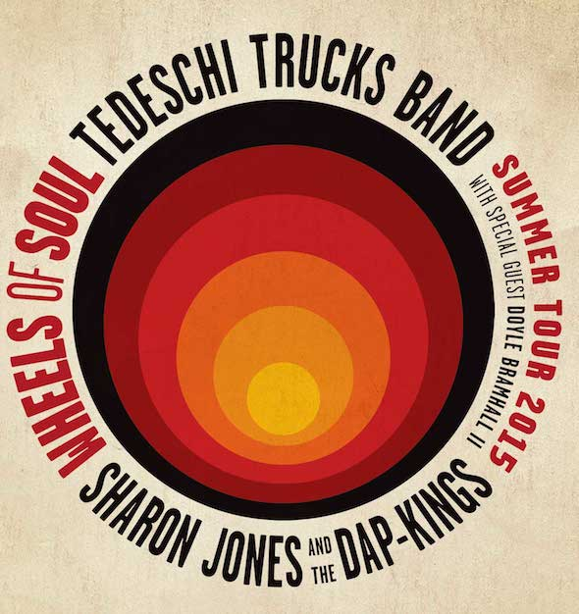

Tedeschi Trucks Band Launches Summer Tour with
Sharon Jones and the Dap-Kings
and special guest Doyle Bramhall II
“Wheels of Soul” Tour to hit 35 Cities
NEW YORK, NY April 30, 2015 --- Rolling across America on a sizzling summer run, Tedeschi Trucks Band’s “Wheels of Soul” tour brings the Grammy-winning, 11-piece blues-rock dynamo together with soul sensation Sharon Jones and the Dap-Kings, and acclaimed guitarist Doyle Bramhall II, for 35 not-to-be-missed appearances. Delivering over 4 ½ hours of music each night, the artists will perform at some of the finest outdoor venues in the country, and incorporating family-friendly ticket pricing wherever possible. The first of the tour’s two legs kicks off June 5th in Paso Robles, California, one of four nights in the Golden State. The second leg launches on July 10 in Houston, Texas and continues through August 4. (see itinerary below)
For the latest ticket on sale information, please visit artist websites www.tedeschitrucksband.com, www.sharonjonesandthedapkings.com, or www.db2music.com
Perhaps not since the days of Joe Cocker’s supersized Mad Dogs and Englishmen tour of the early ’70s has this much talented rock and soul hit the road together, suggesting some potentially explosive onstage musical fireworks. Singer and guitarist Susan Tedeschi, who fronts TTB with her husband and guitar virtuoso Derek Trucks, is excited about the possibilities. “Sharon is really soulful and sweet and we know a lot of the Dap-King guys through different projects,” said Tedeschi, also thrilled to share the stage with longtime friend and TTB collaborator Doyle Bramhall II. “There’s a lot to look forward to and who knows—maybe we’ll all get up and play together. The wheels of creativity are turning at all times; it should be fun and could be epic.”

Formed in 2010 with a spirit of adventure that saw Tedeschi and Trucks shelve their equally successful solo careers, Tedeschi Trucks Band has quickly become the vanguard of modern roots music. TTB has already earned a Grammy for its debut album, Revelator, followed with a dynamic live double disc, Everybody’s Talkin,’ and most recently released Made Up Mind. Driven by Trucks, #16 of the top 100 Guitarists of All Time (Rolling Stone), and Tedeschi, blessed with a voice that passionately delivers a range of powerful R&B belters to gentle ballads, the group enlists two drummers, two vocalists, a three-piece horn section, bass, and a multi-instrumentalist keyboard player for what is a greater-than-the-sum-of-its-parts collective.

Combining inspired Memphis soul with post-war electric blues and classic songcraft into an award-winning sound, TTB has captured the admiration of both concert audiences and critics worldwide -- recently touted as "a deeply skilled groove machine" (Los Angeles Times). With its legendary live performances featuring a growing repertoire of original material and an astounding range of songs by anyone from blues pioneers Blind Willie Johnson and Elmore James to present-day Ray LaMontagne and David Bowie, TTB thrives on shaking things up and challenging itself. They've recently introduced an intimate acoustic segment into their live set, and fans this summer can also expect to hear new originals that the band has been working on for their next album.

Having wrapped up his 15-year tenure with The Allman Brothers Band, Trucks is entering 2015 with full-time focus and a jam-packed itinerary of TTB concert dates. After launching the new year with their own annual Sunshine Music Festival in Florida, two sold out nights at Nashville’s storied Ryman Auditorium, and a performance by Derek and Susan at February’s high-profile MusicCares concert honoring Bob Dylan, TTB received rave reviews from their mainstage appearance at the New Orleans Jazz & Heritage Festival in April. The band is looking forward to returning to Lockn’ for a special two-night performance in September that includes an all star tribute to Joe Cocker featuring original Mad Dogs and Englishmen band members Leon Russell, Dave Mason, Rita Coolidge plus special guests. Additionally, the group has also lined up another trip to Europe this fall after two treks there in 2014.

Sharon Jones and the Dap-Kings have been hailed as one of the leading forces in the revival of classic soul and funk. The band has traveled the world for more than a decade, blowing minds with their electrifying live performances and their raw, handcrafted studio recordings. The Brooklyn based 11-piece group delivers sharp, danceable funk grooves, impassioned singing and sweet soul hooks that stay in your head for days on end. The group is touring behind it's sixth album under the renowned independent Daptone label, 2014’s Give the People What They Want, which was recently honored with a Grammy nomination for Best R&B Album. The prolific powerhouse and survivor that she is, Sharon Jones has fully recovered from a 2013 cancer diagnosis and bounced back with one of the biggest years of her career, filled with milestone accomplishments and a renewed energy for life.

Doyle Bramhall II is well-known for his extraordinary guitar work, but also as a distinctive vocalist, composer and producer. Just 18 when he was recruited by Jimmie Vaughan to play with the Fabulous Thunderbirds, two years later Doyle co-founded the Arc Angels with Charlie Sexton and Stevie Ray Vaughan’s rhythm section: Chris Layton and Tommy Shannon. So impressed with Doyle too, Eric Clapton invited Bramhall to join Clapton’s group full-time and their association flourished.
Collaborations with such as artists as Sheryl Crow, Tedeschi Trucks Band, Elton John, Gary Clark Jr., Erykah Badu, and Gregg Allman have kept Doyle highly in-demand. He is now completing his fourth solo album, launching the next chapter of his musical journey.

ITINERARY - Wheels of Soul Summer Tour 2015
6/5 Paso Robles, CA Vina Robles Amphitheatre
6/6 Berkeley, CA Greek Theatre
6/7 Santa Barbara, CA Santa Barbara Bowl
6/9 Las Vegas, NV Pearl Concert Theater at Palms Casino Resort
6/10 Los Angeles, CA Greek Theatre
6/12 Salt Lake City, UT Red Butte Gardens Sold Out
6/13 Morrison, CO Red Rocks Amphitheatre
6/14 Snowmass, CO Snowmass Mammoth Festival
6/17 Oklahoma City, OK Zoo Amphitheatre
6/19 Minneapolis, MN State Theatre (w/ Rich Robinson Band not Bramhall)
6/21 Highland Park, IL Ravinia Festival
6/23 Rochester, MI Meadow Brook Music Festival
6/25 Rochester, NY Eastman Theatre (Rochester Jazz Fest) Sold Out
6/26 Cincinnati, OH PNC Pavilion
6/27 Huber Heights, OH Rose Music Center at The Heights

SECOND LEG
7/10 Woodlands, TX Cynthia Woods Mitchell Pavilion
7/11 Dallas, TX Gexa Energy Pavilion
7/12 Austin, TX Austin360 Amphitheater
7/15 Charlotte, NC Uptown Amphitheatre at NC Music Factory
7/17 Alpharetta, GA Verizon Wireless Amphitheatre
7/18 Cary, NC Koka Booth Amphitheatre
7/19 Cleveland, OH Jacobs Pavilion at Nautica
7/22 Boston, MA Blue Hills Bank Pavilion
7/24 Portland, ME Maine State Pier
7/25 Gilford, NH Bank of New Hampshire Pavilion at Meadowbrook
7/26 Readington, NJ QuickChek New Jersey Festival of Ballooning; Solberg Airport
7/29 Saratoga Springs, NY Saratoga Performing Arts Center
7/31 Bridgeport, CT Gathering of the Vibes
8/1 Baltimore, MD Pier Six Pavilion
8/2 Philadelphia, PA Mann Center for the Performing Arts
8/4 Lewiston, NY Artpark

http://www.tedeschitrucksband.com
http://www.sharonjonesandthedapkings.com
http://www.db2music.com

VIDEO LINKS:
Tedeschi Trucks Band: "Do I Look Worried" (live from Boston) "Made Up Mind" (live from Vienne)
Sharon Jones & the Dap-Kings: "Stranger to My Happiness", "Retreat"
Doyle Bramhall II: YouTube Channel

For Additional Media Information, please contact:
Tedeschi Trucks Band/Doyle Bramhall
Publicity: Renee Pfefer, On Tour PR
Office: 203.724.9919 Mobile: 914.806.2834
Email: Renee@ontourpr.com
www.ontourpr.com

Sharon Jones
Publicity/management: Hampton Howerton, Lever and Beam, LLC
Office: 212.217.9448 ext. 7238 Mobile: 336.209.4033
Email: hampton@leverandbeam.com

Marketing/ Booking
Entourage Talent Associates 212.633.2600

