For Immediate Release
TEDESCHI TRUCKS BAND'S SIXTH ANNUAL WHEELS OF SOUL POSTPONED TO 2022 WITH NEW LINE-UP
LOS LOBOS JOINS MULTI-BAND BILL NEXT SUMMER
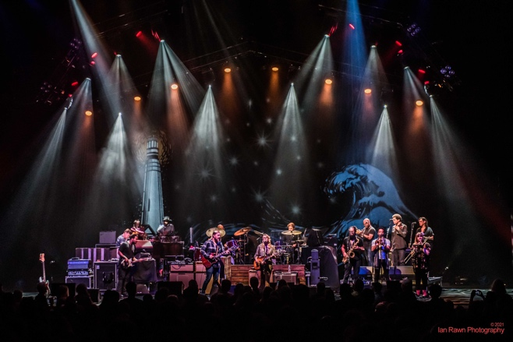
APRIL 5, 2021 Due to the ongoing uncertainty surrounding safe venue capacities and local regulations for the coming months, Tedeschi Trucks Band's 2021 Wheels of Soul tour is being postponed until the summer of 2022. The legendary Los Lobos, longtime TTB friends and collaborators, and veterans of 2016’s Wheels of Soul will replace St. Paul and the Broken Bones for the 2022 summer amphitheater run. TTB’s talented keyboardist Gabe Dixon and his trio will round out the three-band bill next year as originally planned.

Current Wheels of Soul tickets will be honored for rescheduled 2022 shows. Fans who are unable to attend rescheduled shows should contact point of purchase for refund options. Please note the following special circumstances:
- Cincinnati, OH (July 11) Please hold tickets and stand by for additional information.
- Vienna, VA (July 21 + 22) Ticket holders will be refunded and receive priority access to upcoming pre-sale for the new date: July 19, 2022
- Harrington, DE (July 27) Ticket holders will be automatically refunded after April 15, 2021.
- Red Rocks (July 30 + 31) Please hold tickets and stand by for additional information.

"We are extremely disappointed at having to postpone Wheels of Soul again," says Derek Trucks. “We’re all missing the energy of live music - and there's nothing like playing these large, outdoor shows alongside bands we admire. We were really hoping to get back on stage and dive into some fun big band collaborations with St. Paul, but unfortunately, with all the uncertainty, it just couldn't work this year.”

In the meantime, until venues open fully and with consideration for the safety of their fans and crew, the group is organizing some socially-distanced, limited capacity shows for this summer. The band plans to make an announcement about these special performances in the coming weeks.

WHEELS OF SOUL – 2021 ITINERARY NEW 2022 DATES
June 26 Jacksonville, FL Daily’s Place Rescheduled 6/24/22
June 27 Mobile, AL Mobile Civic Center Rescheduled 6/25/22
June 30 Canandaigua, NY Constellation Brands Marvin Sands PAC Rescheduled 7/1/22
July 2 Saratoga, NY Saratoga Performing Arts Center Rescheduled 7/3/22
July 3 Gilford, NH Bank of New Hampshire Pavilion Rescheduled 7/2/22
July 4 Essex Junction, VT Midway Lawn Rescheduled 7/9/22
July 6 Philadelphia, PA Mann Center for the Performing Arts Rescheduled 7/8/22
July 9 Raleigh, NC Coastal Credit Union Music Park at Walnut Creek Rescheduled 7/21/22
July 10 Charlotte, NC PNC Music Pavilion Rescheduled 7/23/22
July 11 Cincinnati, OH PNC Pavilion at Riverbend TBA
July 13 Lewiston, NY Artpark Rescheduled 7/12/22
July 14 Indianapolis, IN The Amphitheatre at White River State Park Rescheduled 6/28/22
July 15 Aurora, IL RiverEdge Park Rescheduled 7/26/22
July 17 New Haven, CT Westville Music Bowl Rescheduled 7/6/22
July 18 Patchogue, NY Great South Bay Music Festival Rescheduled 7/10/22
July 20-21 Vienna, VA Wolf Trap Rescheduled 7/19/22
July 23-24 Atlanta, GA Fox Theatre Rescheduled 7/15-7/16
July 25 Huber Heights, OH Rose Music Center at The Heights Rescheduled 7/24/22
July 27 Harrington, DE Delaware State Fair Cancelled
July 30-31 Morrison, CO Red Rocks Amphitheatre TBA
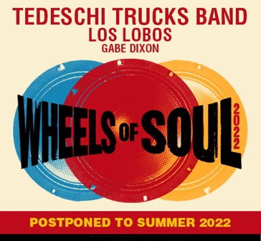
Led by the husband and wife team of guitarist Derek Trucks and vocalist/guitarist Susan Tedeschi, the 12-member strong Tedeschi Trucks Band is acclaimed by critics and fans alike for their uncompromising commitment to bringing the highest level of musicianship to the stage. TTB has meticulously curated their flagship multi-band summer tour with past guests including Sharon Jones & The Dap-Kings, Los Lobos, Drive By-Truckers, The Wood Brothers and The Marcus King Band among several others - earning the Wheels of Soul tour a reputation as “a champion of the summer concert season” (Cincinnati.com), “nothing short of exhilarating,” (Salon), and “nonstop excellence, virtuosity and musical community on all fronts.” (Chicago Blues Guide).
www.tedeschitrucksband.com

Press contact: Renee Pfefer, On Tour PR
Renee@ontourpr.com Cell: 914-806-2834 www.ontourpr.com

