Tedeschi Trucks Band Wraps Up
Triumphant “Wheels Of Soul” Tour

Premieres Footage From Sold-Out Red Rocks Run

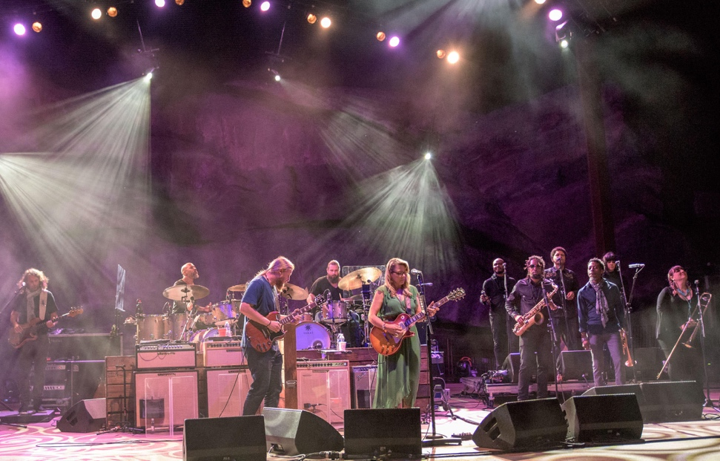

JACKSONVILLE, FL – August 10, 2017 - After 21 fantastic nights of music across 16 different states, Tedeschi Trucks Band have completed their triumphant 3rd annual “Wheels of Soul” tour. With support from “masters of soulful folk” The Wood Brothers and “psychedelic-blues institution” Hot Tuna, the 2017 iteration of the popular multi-band tour proved to be “a champion of the summer concert season” (Cincinnati.com) and TTB’s most successful “Wheels of Soul” voyage to date. Husband-and-wife bandleaders master slide guitarist Derek Trucks and powerhouse guitar/lead vocalist Susan Tedeschi and their well-oiled 12-piece outfit broke their own attendance records, selling out 10 of the shows on the tour, including two nights at Denver’s iconic Red Rocks Amphitheatre.

The summer run further cemented the “Wheels of Soul” tour’s reputation as a unique and unmatched collaborative musical experience. The band performed more than 70 different songs and peppered their shows with well-chosen covers and a slew of guest sit-ins including The Rolling Stones’ “Sweet Virginia” and Paul McCartney & Wings’ “Let Me Roll It” with The Wood Brothers and Elmore James’ “The Sky Is Crying” and Jefferson Airplane’s “3/5 Of A Mile In 10 Seconds” with Hot Tuna.

The collaborations came to a peak at Red Rocks, which Live for Live Music referred to as “a complete show of mastery.” In addition to The Wood Brothers and Hot Tuna, Tedeschi Trucks Band was joined by John Medeski of Medeski Martin & Wood and John Bell of Widespread Panic. You can check out never-before-seen pro-shot footage of collaborations from the two-night Red Rocks run below:

VIDEO: **Never-before-seen footage from Tedeschi Trucks Band’s backstage rehearsal of Bob Dylan’s “Down Along The Cove” with Widespread Panic’s John Bell at Red Rocks**

VIDEO: **Pro-Shot footage of Tedeschi Trucks Band covering The Rolling Stones’ “Sweet Virginia” with The Wood Brothers at Red Rocks**

This summer’s “Wheels of Soul” tour also held a unique emotional significance for the band due the many legendary musical friends who passed away recently. The list includes Derek’s uncle Butch Trucks and Gregg Allman (both of whom Derek played with for 15 years in the Allman Brothers Band), Leon Russell and “grandfather of the jam scene” Col. Bruce Hampton. The band paid tribute over the summer, breaking out Allman live staples like “Whipping Post,” “Ain’t Wastin’ No More Time,” and “Statesboro Blues.” They also dedicated a cover of Bobby Blue Bland’s “Don’t Cry No More” to Col. Bruce during their performance at Atlanta’s Fox Theatre, where Hampton gave his now-legendary final performance.

“Performing is healing, for everyone on stage,” explains Trucks, “It’s important to get out and play; there is definitely something cathartic about it. You can feel it in the audience, too. People like Bruce and Butch and Gregg, they meant a lot to a lot of people. When you acknowledge those things and play music in the right spirit, you are keeping the flame lit in your own way.”

“Wheels of Soul” 2017 also was successful all summer in its charitable efforts and has raised nearly $100,000 as part of a unique initiative with the tour’s partner Craft for Causes. Local craft brewers created a limited edition “Wheels of Soul”-themed beer in their taprooms for each tour stop, with the proceeds benefitting the Mr. Hollands Opus Foundation, a national nonprofit that works to promote music education and provide musical instruments to underprivileged youths. 40 different breweries hosted launch parties for their special brew, sporting clever names like “Butch’s Brown Ale,” “All That I Need,” and “Harmonious.” The Crafts for Causes van followed behind the tour buses throughout the run, driving 14,500 miles and covering 42 states, visiting 39 different breweries along the way.

Tedeschi Trucks Band will now take a brief break from the road before heading back out for their Fall Tour beginning on September 15th in Birmingham, AL. This run takes the band to New Orleans and Texas before their annual six-night residency at the Beacon Theatre, which will include their milestone 25th performance at the storied Manhattan venue on Wednesday, October 11th. The band will wrap up the year with a string of 2-night performances along the West Coast and a 3-night stand in Susan’s native Boston. Tedeschi Trucks Band is also currently working on material for their next studio album, the follow-up to their acclaimed 2016 studio release, Let Me Get By.

TOUR REVIEWS

“For fans of the Tedeschi Trucks Band, its annual summer tours have become a feel-good, seasonal highlight full of incredible musicianship, unpredictable set lists, and collaborations with hand-picked opening acts.” – Charlotte Observer

There’s a reason two of the band’s most popular albums were recorded live, including this year’s Live from the Fox Oakland. The inspired improvisational interplay is almost impossible to script in the studio because the players feed off the vibe of the crowd, pushing each other a little further in each song..”– Cincinnati.com

“An extended “Bound For Glory” had the crowd on its feet, arms up as Tedeschi’s smoky voice rang out over the congregated mass of people and the notes from Trucks’ guitar cried to the heavens, making the night a Sunday at the church of music in an amphitheater under the stars.” – Daily (MI) Tribune

“The twelve-piece juggernaut consistently delivers an outstanding mix of originals and covers, executing authentic interpretations of songs both old and new to thrilling effect. The band’s school of thought is simple: honor your teachers, and welcome new students.” – Live For Live Music

Upcoming 2017 Tedeschi Trucks Band Tour Dates:

9/15 Birmingham, AL Alabama Theatre +
9/16 New Orleans, LA Saenger Theatre
9/17 Little Rock, AR Robinson Center Music Hall +
9/21 Houston, TX Hobby Center #
9/22 Dallas, TX Music Hall at Fair Park #
9/23 Austin, TX ACL Moody Theater # - sold out
10/6 New York, NY Beacon Theatre +
10/7 New York, NY Beacon Theatre - sold out
10/10 New York, NY Beacon Theatre %
10/11 New York, NY Beacon Theatre @
10/13 New York, NY Beacon Theatre - sold out
10/14 New York, NY Beacon Theatre - sold out
11/3 Portland, OR Keller Auditorium #
11/4 Seattle, WA Paramount Theatre #
11/5 Seattle, WA Paramount Theatre
11/7 Santa Barbara, CA Arlington Theatre &
11/9 San Diego, CA San Diego Civic Theatre #
11/10 Los Angeles, CA Orpheum Theatre #
11/11 Los Angeles, CA Orpheum Theatre &
11/14 Phoenix, AZ Orpheum Theatre +
11/15 Phoenix, AZ Orpheum Theatre +
11/17 Oakland, CA Fox Theater #
11/18 Oakland, CA Fox Theater
11/30 Boston, MA Orpheum Theatre @
12/1 Boston, MA Orpheum Theatre
12/2 Boston, MA Orpheum Theatre

+ with Greyhounds
# with Hard Working Americans
% with The Wood Brothers
@ with North Mississippi Allstars
& with David Luning

http://www.tedeschitrucksband.com

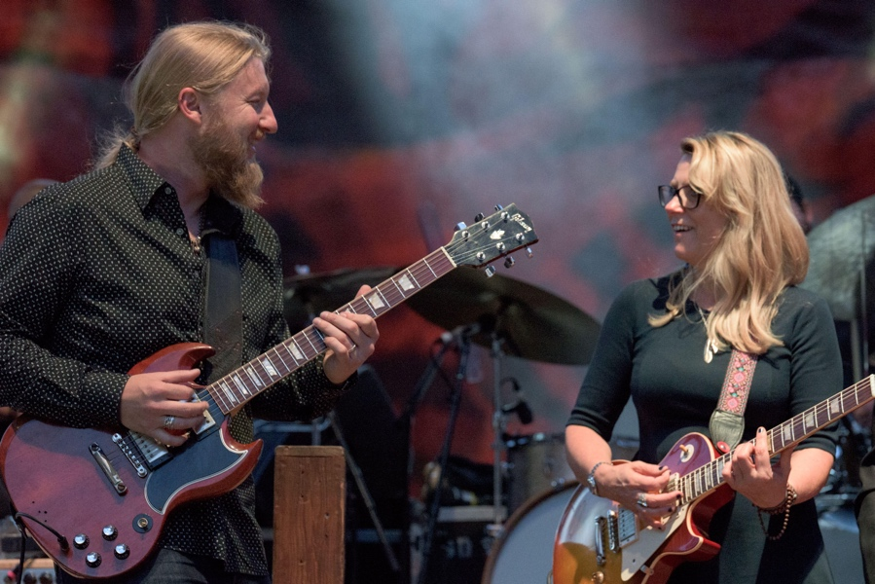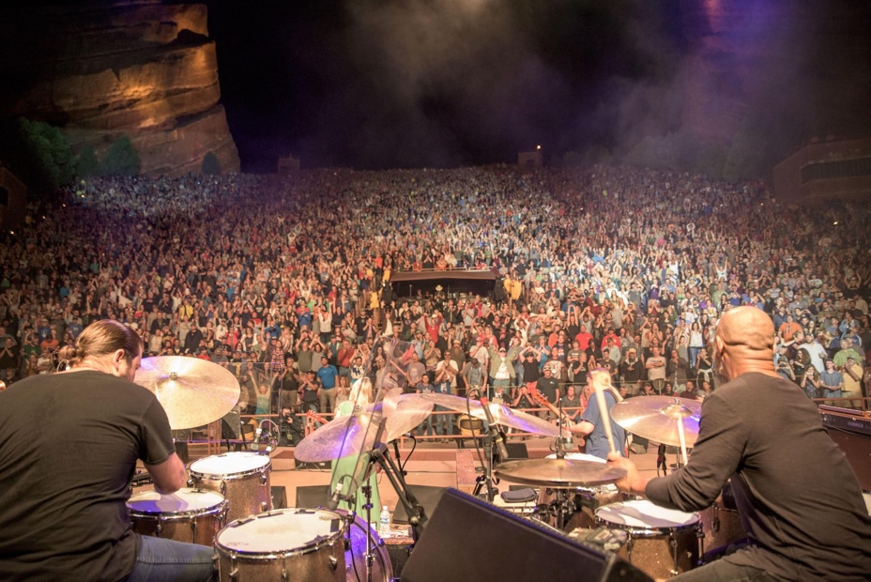

For Additional Press Information, please contact:
Renee Pfefer, On Tour PR
Renee@ontourpr.com
o) 203-724-9919 c) 914-806-2834

Joel Amsterdam – Fantasy Records – joel.amsterdam@concordmusicgroup.com
310-385-4206
High Res Jpegs available here: www.ontourpr.com/TTB

