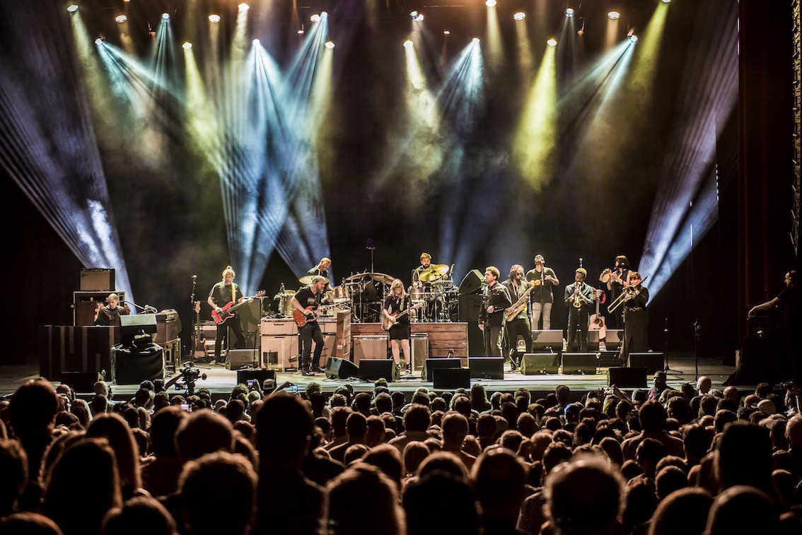
TEDESCHI TRUCKS BAND RAMPS UP FOR FALL TOUR SEASON
JACKSONVILLE, FL September 13, 2017 – Following another triumphant Wheels of Soul summer tour (the 3rd annual*) which featured sterling support from The Wood Brothers and Hot Tuna, Tedeschi Trucks Band eagerly returns to the road this September riding in high gear. Their fall slate of shows begins on September 15 in Birmingham, AL and takes the band to back to Arkansas, New Orleans and Texas before its annual six-night residency in NYC at the storied Beacon Theatre, including their 25th appearance at the celebrated venue on October 11. The band will wrap up the year with a string of two-night stays along the West Coast and a three-night stand in Susan’s native Boston. (see itinerary below)
With three dates in the Lone Star state, the band has pledged to support Hurricane Harvey relief efforts. A portion of proceeds from each of its upcoming Texas performances - Houston 9/21, Dallas 9/22 and Austin 9/23 – will be donated to Aransas County School District and Houston Food Bank to help victims of the storm.
Now with a catalog of five albums and nearly a decade of steady touring in the U.S. and abroad, Tedeschi Trucks Band carries a distinguished reputation earned from both audiences and critics as one of the premier live bands in the world. The 12-piece powerhouse, led by the husband-and-wife team of guitarist Derek Trucks and guitarist-singer Susan Tedeschi, continues to expand a growing repertoire of original material written both individually and as a band, plus tasty covers deep-seated in American Roots, embracing genres, from rock, jazz, blues, and Americana to gospel, country, soul, and funk.
Their latest release, Live From the Fox Oakland, (March, 2017) CD/DVD was recorded in a single night and beautifully captures the group’s incredible power in concert. The double-disc live recording, which debuted at #1 on Billboard’s Blues and #6 Rock Albums chart, showcases the band’s ability to move seamlessly from blistering rock and blues to soulful ballads and includes their take on classics from Derek and the Dominos, Leonard Cohen, and even Miles Davis among TTB’s original songs. The film also gives a behind-the-scenes look at the band on the road.
Live From the Fox Oakland, follows a quartet of critically-hailed and commercially successful TTB efforts: a Grammy-winning inaugural studio record Revelator (2011), a double-album live, Everybody’s Talkin’ (2012), Made Up Mind (2013), featuring a slew of guest songwriters, and 2016’s Let Me Get By, the first to be solely produced by Trucks and written in-house by the TTB family and called by the Associated Press “one of the great records of the year.” Additionally, in their recent days off the road, the band has been busy writing new songs and expects to roadtest a few on this fall’s run.
From their steady rise as solo artists to now being hailed as “two of the best roots rock musicians of their generation” (NPR), Tedeschi and Trucks have earned the respect of both heroes and peers. They have been invited to the White House filmed for PBS special, requested personally for tributes to B.B. King, Bob Dylan, and Hubert Sumlin, and appeared on countless recordings of renowned artists such as John Prine, Rosanne Cash, Eric Church, Wynonna Judd and Herbie Hancock.

Heaps of critical praise continue to follow nearly every show, declaring “Tedesch Trucks Band’s fusion of soul, rock and gospel is downright divine,” (Daily Herald) and suggesting the “flamethowing powers” (Hartford Courant) and “moments of bliss” (Fayetteville Flyer) make TTB “The Wall of Sound of Bands.” (NYSmusic)
* Read Wheels of Soul Summer Tour Wrap Up Press Release here

Upcoming 2017 Tedeschi Trucks Band Tour Dates:

9/15 Birmingham, AL Alabama Theatre +
9/16 New Orleans, LA Saenger Theatre
9/17 Little Rock, AR Robinson Center Music Hall +
9/21 Houston, TX Hobby Center #
9/22 Dallas, TX Music Hall at Fair Park #
9/23 Austin, TX ACL Moody Theater # sold out
10/6 New York, NY Beacon Theatre +
10/7 New York, NY Beacon Theatre
10/10 New York, NY Beacon Theatre %
10/11 New York, NY Beacon Theatre @
10/13 New York, NY Beacon Theatre
10/14 New York, NY Beacon Theatre
11/3 Portland, OR Keller Auditorium #
11/4 Seattle, WA Paramount Theatre #
11/5 Seattle, WA Paramount Theatre
11/7 Santa Barbara, CA Arlington Theatre &
11/9 San Diego, CA San Diego Civic Theatre #
11/10 Los Angeles, CA Orpheum Theatre #
11/11 Los Angeles, CA Orpheum Theatre &
11/14 Phoenix, AZ Orpheum Theatre +
11/15 Phoenix, AZ Orpheum Theatre +
11/17 Oakland, CA Fox Theater #
11/18 Oakland, CA Fox Theater
11/30 Boston, MA Orpheum Theatre @
12/1 Boston, MA Orpheum Theatre
12/2 Boston, MA Orpheum Theatre

+ with Greyhounds
# with Hard Working Americans
% with The Wood Brothers
@ with North Mississippi Allstars
& with David Luning
VIDEO: "Keep On Growing" - Live from the Fox Oakland
https://www.youtube.com/watch?v=h0kXfPrHHcw
VIDEO: 'Let Me Get By" - Live from the Fox Oakland
https://www.youtube.com/watch?v=um9TmblAcnw
NPR – Tiny Desk Concert
https://www.youtube.com/watch?v=RRipadkd6wk
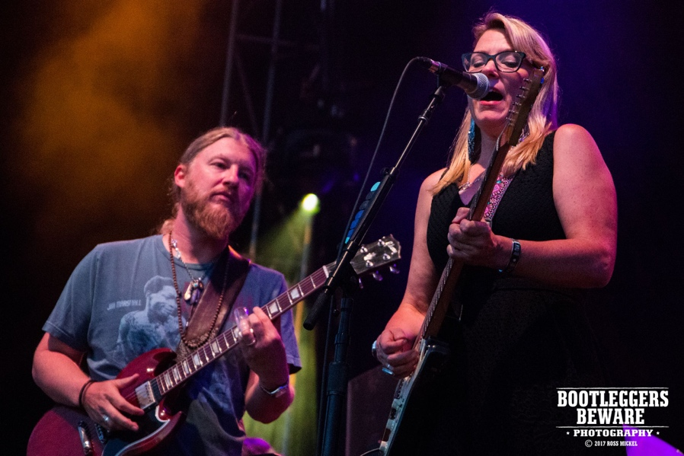

http://www.tedeschitrucksband.com

For additional press information, please contact:
Renee Pfefer, Renee@ontourpr.com 203-724-9919

