For Immediate Release
Press Contact:
Renee Pfefer On Tour PR 203-724-9919 Renee@ontourpr.com
High Res Jpegs: www.ontourpr.com/TTB
TEDESCHI TRUCKS BAND ANNOUNCES 2022 WINTER TOUR DATES

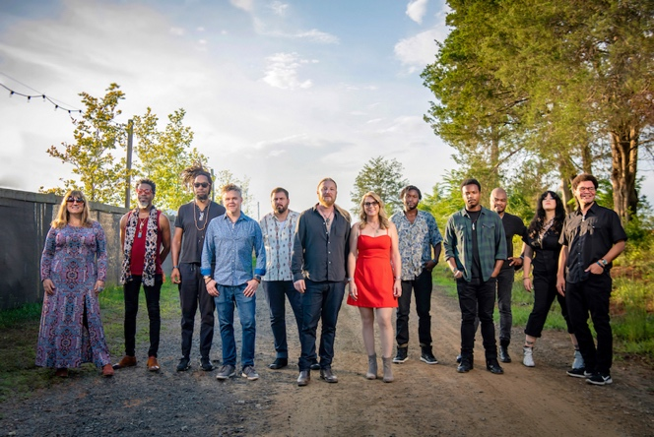
Photo credit: Caitlin Moore
JACKSONVILLE, FL (October 25, 2021) Following a very challenging yet creative year, Tedeschi Trucks Band announces the first batch of their 2022 winter itinerary with a series of multiple-night residencies in Washington D.C. (6), Nashville, TN (4), Chicago, IL (4) and a two night engagement in New Orleans, LA. Led by renowned guitarist Derek Trucks and singer/guitarist Susan Tedeschi, these will feature the full, reunited 12-piece band including new drummer Isaac Eady.

Tickets go on sale this Friday, October 29, 2021. Visit TedeschiTrucksBand.com/Tour for details.

A highlight of the Tedeschi Trucks Band touring schedule, fans look forward to these residencies and multi-night engagements for the opportunity it gives the multi-talented group to explore an especially large range of musical territory. Earlier this month, they delivered a spectacular seven-night sold-out run at New York’s Beacon Theatre which saw the full group joyously back together to perform nearly 100 different songs, numerous debuts, a rare acoustic set and were joined onstage by surprise special guests Chris Robinson, Warren Haynes and Marcus King.
TTB's recent return to the road with the full band follows an unprecedented 18 months of uncertainty for live music. While off the road due to the pandemic, Tedeschi and Trucks launched the Fireside Sessions, a successful livestream series that featured a scaled-down lineup and unique renditions of their classic repertoire. Over the summer they took the concept on the road as Fireside Live – a series of socially-distant limited-capacity shows - drawing sold-out crowds across the U.S.
In July 2021, the band released Layla Revisited (Live At LOCKN') featuring Trey Anastasio, a 2CD/3LP live recording of their performance of the classic Derek and the Dominos album Layla and Other Assorted Love Songs at the 2019 LOCKN’ Festival. The “transfixing” (Stereogum) musicianship of the “now-legendary set” (Relix) propelled the album to hit the top of the Billboard charts including #1 Blues Albums, #2 Americana/Folk Albums, #4 Current Rock Albums, and #47 on the Billboard Top 200.
Tedeschi Trucks Band is also the subject of a newly-released documentary, Learning To Live Together: The Return of Mad Dogs & Englishmen, which Variety hails as “a serious blast of rock 'n' roll love… and a testament to how one gorgeously raucous rock ‘n’ roll moment can reverberate through the decades.” The film chronicles the historic Mad Dogs reunion concert spearheaded by Tedeschi and Trucks that took place at 2015's LOCKN' festival. Visit MadDogsDoc.com for theatrical release dates and more information. Watch film trailer here.
In the midst of the rare time off, TTB convened in the studio to write and record a wealth of new songs for a future studio album. As the recording progresses towards an expected release in 2022, the album is growing into a unique and exciting conceptual project. In addition, Derek and Susan also used their time off to guest on albums by Oliver Wood, Doyle Bramhall ll, Gabe Dixon, Ryan Shaw, Neal Francis, and both appear on the upcoming Neal Casal project Highway Butterfly.
Tedeschi Trucks Band is Susan Tedeschi (guitar, vocals), Derek Trucks (guitar), Gabe Dixon (keyboards, vocals), Brandon Boone (bass), Tyler “Falcon” Greenwell (drums) Isaac Eady (drums), Mike Mattison (vocals), Mark Rivers (harmony vocals), Alecia Chakour (harmony vocals), Kebbi Williams (saxophone), Ephraim Owens (trumpet) and Elizabeth Lea (trombone).

TEDESCHI TRUCKS BAND 2021 – 2022 TOUR DATES
11/10 Orlando, FL Dr. Phillips Center for the Performing Arts
11/11 West Palm Beach, FL Kravis Center for the Performing Arts
11/12 Ft. Myers, FL Barbara B. Mann Performing Arts Hall
11/14 Key West, FL Key West Amphitheatre
11/16 Tampa, FL Ruth Eckerd Hall
11/18 Chattanooga, TN Tivoli Theatre
11/19 Birmingham, AL BJCC Concert Hall
11/20 Savannah, GA Johnny Mercer Theatre
11/30-12/4 Boston, MA Orpheum Theatre

2022
1/6 Shreveport, LA Shreveport Municipal Auditorium
1/7, 8 New Orleans, LA Saenger Theatre
1/18 Omaha, NE Orpheum Theatre
1/19 Des Moines, IA Des Moines Civic Center
1/21, 22, 28, 29 Chicago, IL Chicago Theatre
1/25 Peoria, IL Civic Center Theater
1/26 Cedar Rapids, IA Paramount Theatre
2/3, 4, 5, 17, 18, 19 Washington DC Warner Theatre
2/22, 23, 25, 26 Nashville, TN Ryman Auditorium

Previously announced
6/24/22 – 7/26/22 Wheels of Soul with Los Lobos and Gabe Dixon

VIDEOS:
“Layla” (Live at LOCKN’ 2019)
https://www.youtube.com/watch?v=gCL4o6i5934

“With A Little Help From My Friends” (Beacon 2019)
https://www.youtube.com/watch?v=omj8kC__RXU

“Signs/ High Times” (Los Angeles 2019)
https://youtu.be/1nyJ6O1qWjQ

VISIT TEDESCHI TRUCKS BAND
Website
Facebook
Instagram
Twitter
YouTube

