For Immediate Release
TEDESCHI TRUCKS BAND ROLLS OUT WHEELS OF SOUL 2019
5TH ANNUAL SUMMER TOUR INCLUDES SPECIAL GUESTS BLACKBERRY SMOKE AND SHOVELS & ROPE
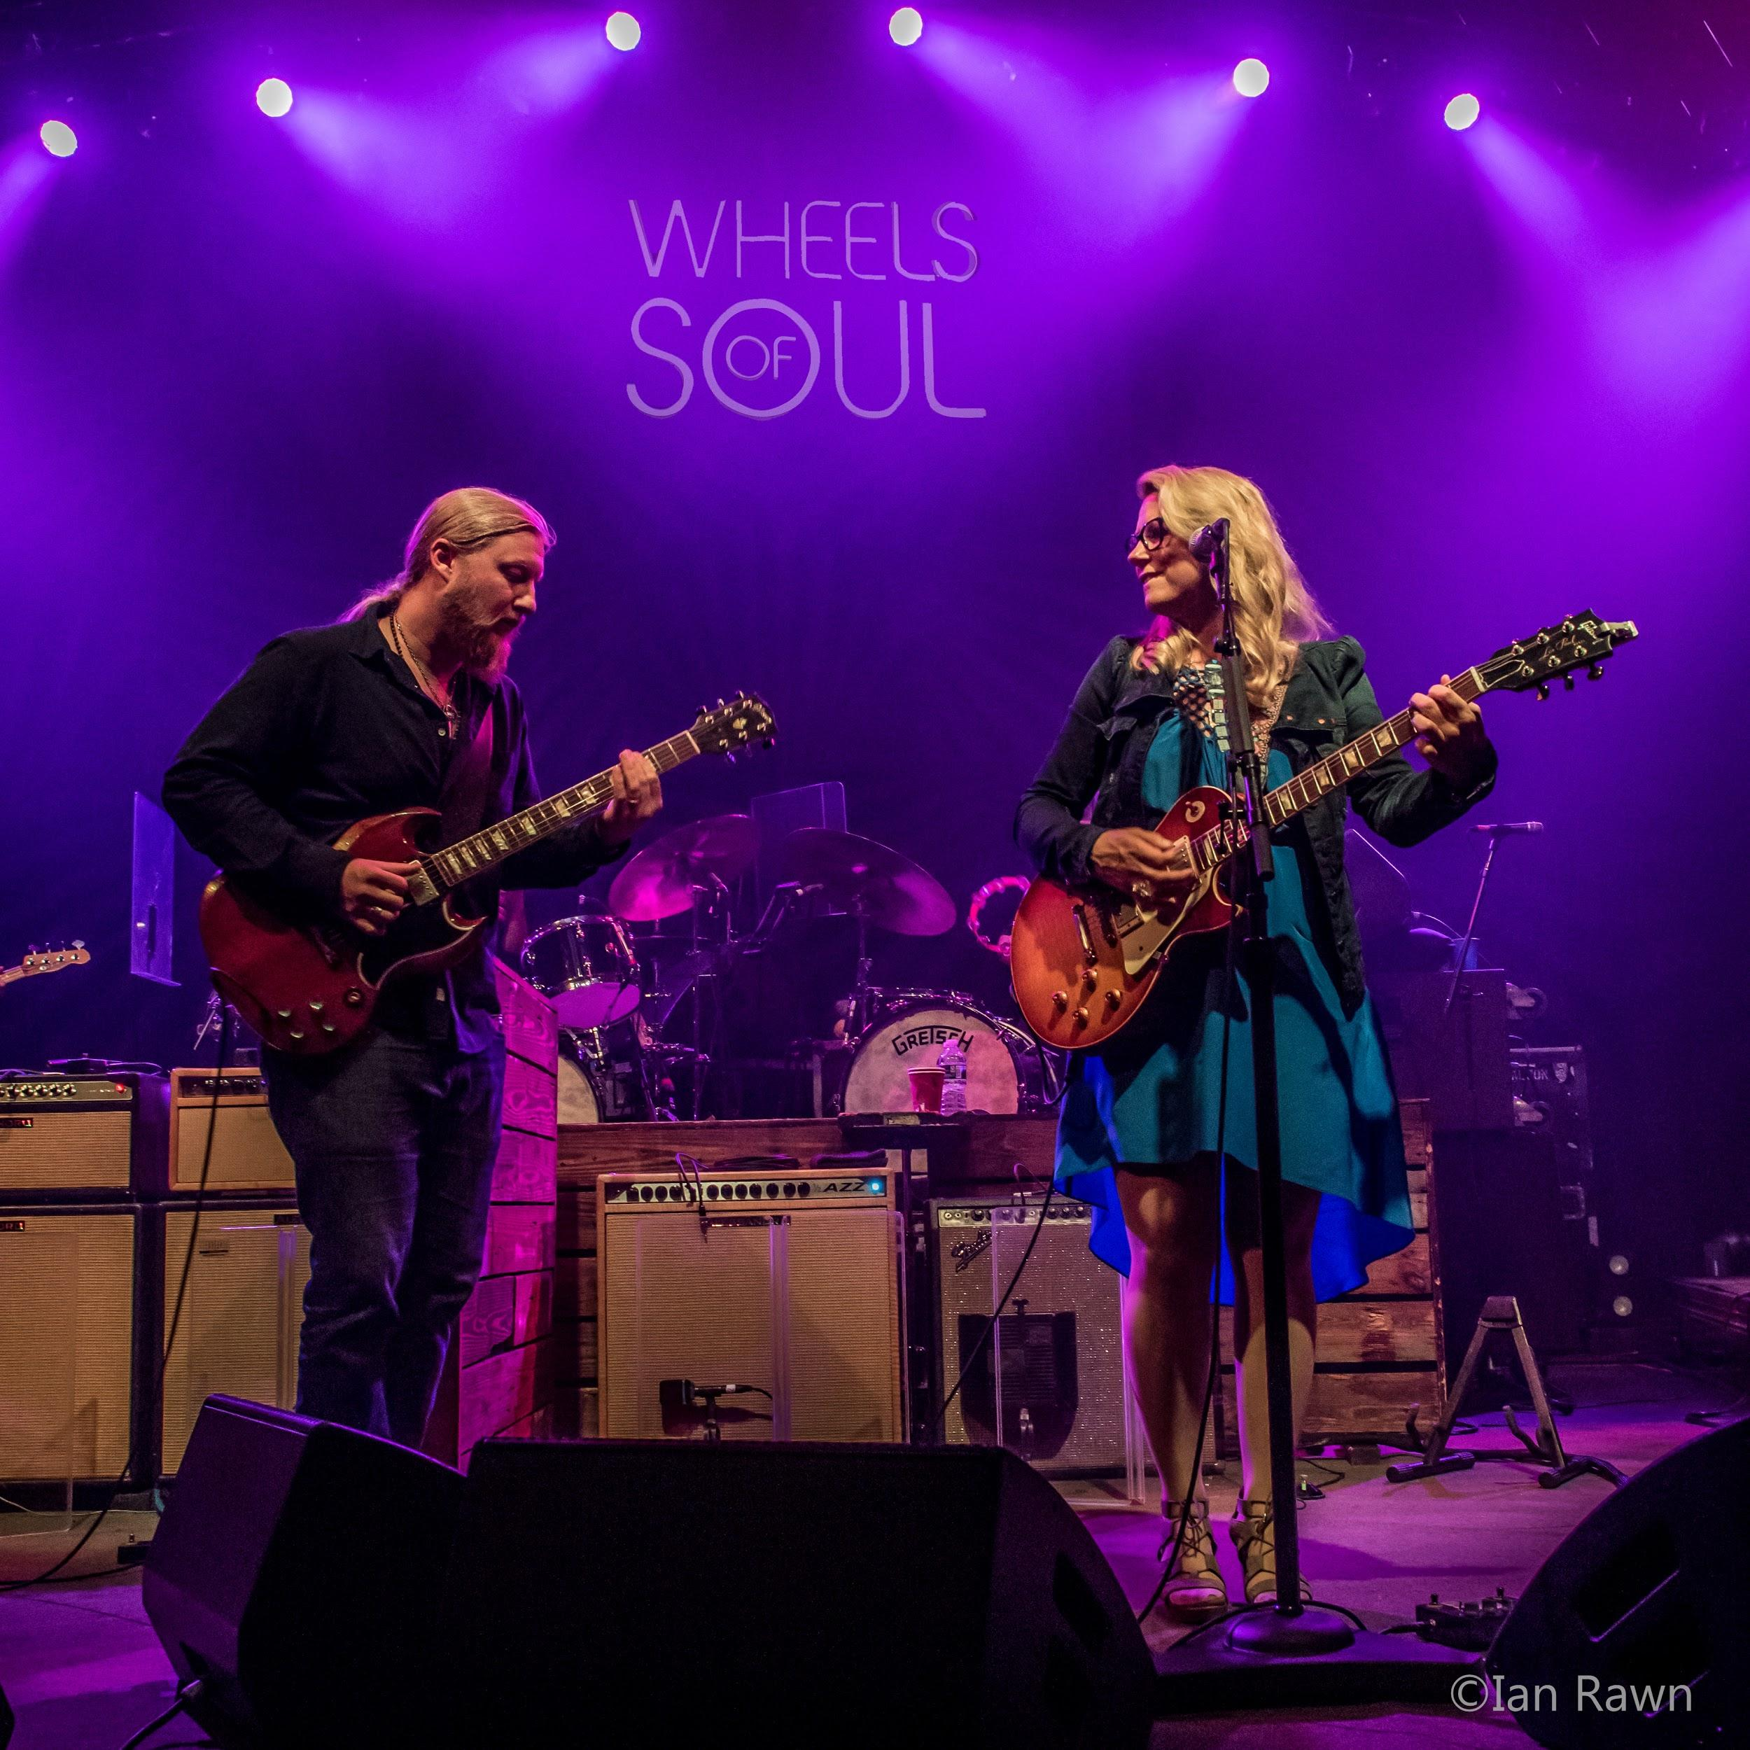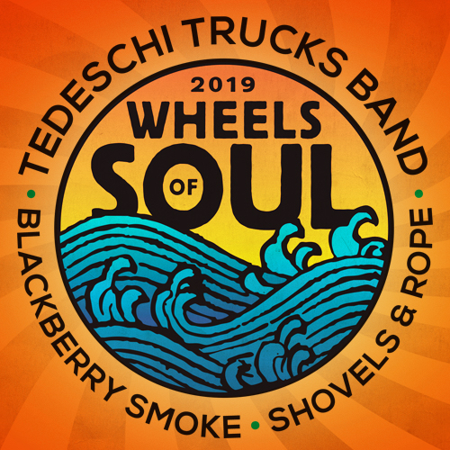
JACKSONVILLE, FL (June 2019) - Tedeschi Trucks Band’s increasingly successful Wheels of Soul tour returns to the road in 2019, for one of the most anticipated concert events of the summer. Kicking-off June 28th in the Grammy-winning group’s hometown of Jacksonville, Florida, the 5th annual amphitheater run welcomes special guests Blackberry Smoke and Shovels & Rope. The five-week slate of 25 shows includes another two-night stand at Colorado’s Red Rocks, following 8 straight sell-out performances at the renowned venue, and concludes with two nights at the famed Fox Theatre on August 2nd and 3rd in Atlanta.
Unrivaled in their blend of American soul, blues, rock and country, the 12-member Tedeschi Trucks Band, led by the husband and wife team of guitarist Derek Trucks and vocalist/guitarist Susan Tedeschi, has curated and cultivated this family-friendly experience into a highlight of the summer concert season. Each year the band selects kindred artists to join their rolling caravan, turning each night into a unique collaborative event rather than simply a three-band bill. Attracting larger audiences each successive year and expanding to new markets, critics hail the Wheels of Soul tour as “nothing short of spectacular,” (Saratogian), celebrating the “life-affirming power of music played with passion, skill and artistry,” (St. Louis Post Dispatch).
“The motivation and, really, the fun of Wheels of Soul is that we get to bring that spirit of musical camaraderie to a summer crowd,” says Trucks. “Traveling, being outside, playing music with friends new and old. We love the limitless energy of this tour.”
2018’s edition featured unparalleled musicianship, plenty of onstage sit-ins with guests Drive-By Truckers and The Marcus King Band, and broke TTB’s own attendance records. The group’s ever-changing setlists highlighted their evolving repertoire of more than 75 songs, including new originals such as “High and Mighty,” and surprising debuts like Ray Charles’ “Night Time Is the Right Time,” Al Green’s “Yield Not To Temptation,” and Neil Young’s “Rockin’ in the Free World.” Fans can expect more unforgettable moments as Tedeschi Trucks Band is joined this summer by Blackberry Smoke and Shovels & Rope.
Celebrating in 2019 its 10th year as a group, Tedeschi Trucks Band carries a distinguished reputation earned from both audiences and critics as one of the premier live bands in the world. Led by “two of the best roots rock musicians of their generation” (NPR), TTB is recognized for their supreme musicianship and genre-defying ability to explore almost any musical territory.
‘Signs’ –TTB’s fourth studio album - was released this February to widespread praise including a recent Americana Music Nomination for Duo/Group of the Year. Rolling Stone called it “electrifying,” the Associated Press dubbed it “an inspirational album for the times,” and NPR Music declared it an “instant classic,” saying “honesty and authenticity...informs every second of 'Signs.'” Tedeschi Trucks Band recently rocked Jimmy Kimmel Live’s outdoor stage delivering a blistering 4-song mini set that dazzled the packed audience and TV viewers nationwide to “Shame.”
American rock band Blackberry Smoke—made up of Charlie Starr (vocals, guitar), Paul Jackson (guitar, vocals), Richard Turner (bass, vocals), Brit Turner (drums) and Brandon Still (keyboards)—has become known for a singular sound indebted to classic rock, blues, country and folk. Since their debut in 2004, the Atlanta-based band has independently released six full-length albums and toured relentlessly, building a strong and loyal community of fans. In 2018, they released a full-length album, Find A Light, and an accompaniment acoustic EP, The Southern Ground Sessions. More press info HERE.
Shovels & Rope is the critically acclaimed, award-winning husband & wife duo of Michael Trent and Cary Ann Hearst, from Charleston, SC. Their signature blend of rock, country, punk and Americana has resonated with audiences and press worldwide. Their new album By Blood has garnered high praise from Rolling Stone, NPR Music, Associated Press, Garden & Gun, Consequence of Sound, A.V. Club, MOJO, Relix, American Songwriter and much more. More press info HERE.
TEDESCHI TRUCKS BAND - WHEELS OF SOUL 2019 ITINERARY
with Blackberry Smoke and Shovels & Rope
6/28/19 Jacksonville, FL Daily’s Place
6/29/19 Boca Raton, FL Mizner Park Amphitheater
6/30/19 St. Petersburg, FL Al Lang Stadium
7/03/19 Orange Beach, AL Wharf Amphitheater
7/05/19 Charleston, SC Volvo Car Stadium
7/06/19 Simpsonville, SC Heritage Park Amphitheater
7/07/19 Charlotte, NC PNC Music Pavilion
7/09/19 Raleigh, NC Coastal Credit Union Music Park at Walnut Creek
7/10/19 Philadelphia, PA The Mann
7/12/19 Marshfield, MA Levitate Music Festival
7/13/19 Gilford, NH Bank of New Hampshire Pavilion
7/14/19 Saratoga Springs, NY Saratoga Performing Arts Center
7/16/19 Canandaigua, NY CMAC
7/17/19 Vienna, VA Wolf Trap
7/19/19 Cincinnati, OH PNC Pavilion
7/20/19 Huber Heights, OH Rose Music Center at the Heights
7/21/19 Aurora, IL RiverEdge Park
7/23/19 Rochester Hills, MI Meadow Brook Amphitheatre
7/24/19 Indianapolis, IN Farm Bureau Insurance Lawn at White River State Park
7/26/19 Morrison, CO Red Rocks
7/27/19 Morrison, CO Red Rocks
7/30/19 St. Louis, MO Fox Theatre
7/31/19 Brandon, MS Brandon Amphitheater
8/02/19 Atlanta, GA Fox Theatre
8/03/19 Atlanta, GA Fox Theatre
VIDEOS:
Tedeschi Trucks Band
“Show Me” (with Marcus King) https://youtu.be/z2EvJwKhgjw
“Shame” Jimmy Kimmel Live! https://www.youtube.com/watch?v=F86QQ96P3E4
Blackberry Smoke
"Run Away From It All" - https://www.youtube.com/watch?v=YOJnrTmcIYA|
"Best Seat In The House" - https://www.youtube.com/watch?v=rBSADvPmk1Q
Shovels & Rope
“St Anne’s Parade” https://www.youtube.com/watch?v=twU8u0_hbmc
“The Wire” https://www.youtube.com/watch?v=7jpgvPwC7RA&feature=youtu.be
http://tedeschitrucksband.com/
https://www.blackberrysmoke.com/
https://shovelsandrope.com/
For additional press information, please contact:
Tedeschi Trucks Band: Renee Pfefer, Renee@ontourpr.com 203-724-9919 Digital PK
Blackberry Smoke: Catherine Snead, Catherine.snead@sacksco.com 615-320-7753 Digital PK
Shovels & Rope: Michelle Steele, Michelle@alleyesmedia.com 615-227-2770 Digital PK

