For Immediate Release

TEDESCHI TRUCKS BAND ROLLS OUT WHEELS OF SOUL 2020
SIXTH ANNUAL SUMMER TOUR FEATURES
SPECIAL GUEST ST. PAUL AND THE BROKEN BONES AND OPENER GABE DIXON
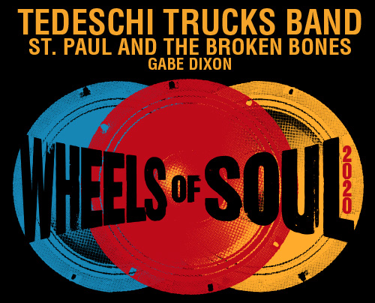
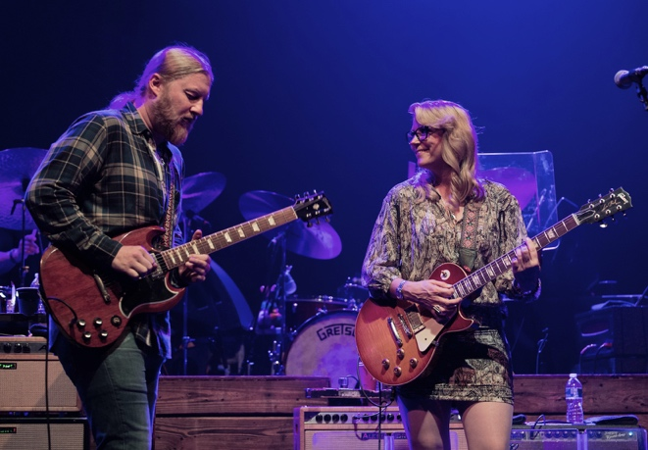
photo credit: Ian Rawn

JACKSONVILLE, FL (December 9, 2019) Tedeschi Trucks Band’s Wheels of Soul tour – a standout of the summer concert season – is returning next year with two performers who exemplify the best of the modern soul movement. Wheels of Soul 2020 welcomes St. Paul and The Broken Bones, as well as TTB’s own talented keyboardist Gabe Dixon and his trio, to the sixth annual amphitheater run. Kicking-off June 26th in TTB’s hometown of Jacksonville, Florida, the five-week tour will visit more than 20 cities across the country, concluding with two nights at Colorado’s Red Rocks Amphitheatre on July 31st and August 1st. Wheels of Soul will be a highlight of TTB’s 2020 itinerary, as the GRAMMY-winning group plans to reduce their touring load after 200+ days on the road each year.

The majority of dates go on sale Friday, December 13th, 2019. Visit www.tedeschitrucksband.com for ticket details.

Led by the husband and wife team of guitarist Derek Trucks and vocalist/guitarist Susan Tedeschi, the 12-member strong Tedeschi Trucks Band is acclaimed by critics and fans alike for their uncompromising commitment to bringing the highest level of musicianship to the stage. TTB has meticulously curated their flagship multi-band summer tour with the same focus on putting together not just a spectacular triple bill, but a true musical collaboration among the three bands to create a unique and unparalleled evening of music. Past guests have included Sharon Jones & The Dap-Kings, Los Lobos, The Wood Brothers and The Marcus King Band among several others and earned the tour a reputation as “nothing short of exhilarating,” (Salon) and “nonstop excellence, virtuosity and musical community on all fronts.” (Chicago Blues Guide).

“We’ve talked about having St. Paul and The Broken Bones out with us before – their sound is fantastic and certainly a natural fit for Wheels of Soul. And we enjoy the fun of touring and collaborating with another big band,” says Derek Trucks. “Adding Gabe to the bill was a no brainer. He’s insanely talented and it will be a privilege to be able to showcase what he can do.”

Paul Janeway of St. Paul and The Broken Bones says: "It’s an honor to open for such talented and kind people. I hope they enjoy having us as much as we enjoy getting to see their show every night."

In what has become a tour tradition, fans can expect 2020’s installment of Wheels of Soul to deliver onstage guest sit-ins and unpredictable set lists with a large catalog of songs covering a wide range of musical tastes. Gabe Dixon will pull double duty, taking the stage first with his trio, then joining his TTB bandmates to close out the evening.

Last year TTB performed over 65 songs during the summer trek, drawing on all four of its studio albums, including new fan favorites “I’m Gonna Be There” and “Shame,” from the 2019 releases Signs, and companion EP, High and Mighty. Fans were also treated to surprising debuts like Elton John’s “Border Song,” Leon Russell’s “Stranger in a Strange Land,” and rarities like The Band’s “Don’t Do It”.

One of contemporary music’s most respected bands, Tedeschi Trucks Band is unrivaled in their blend of American soul, blues, country and rock. Now celebrating 10 years together, the ensemble’s commanding performances and exceptional musical chemistry are perpetual hallmarks of the can’t-miss-concert experience fans have come to anticipate live. Simply stated by the Houston Press, “The band seamlessly showcases the genuine transformative power of music.”
Formed in 2012, St. Paul and The Broken Bones has spent the last seven years touring the world, receiving critical acclaim for stirring and dynamic live performances. The Birmingham, Alabama-based rock ‘n’ roll/soul band has opened for The Rolling Stones, headlined two nights at Ryman Auditorium, appeared on Jimmy Kimmel Live, Conan, Austin City Limits and twice on The Late Show with Stephen Colbert, and has issued an EP alongside three full-length albums, Half the City (2014) Sea of Noise (2016) and Young Sick Camellia (2018). Led by the insightful lyrics and vocals of their electrifying front man Paul Janeway, St. Paul and The Broken Bones possess the unique ability to make you dance and shout while simultaneously making you think.
Nashville bred singer-songwriter and keyboardist Gabe Dixon has been penning honest and heartfelt tunes to a growing fan base since he first emerged in 1999. His song “Live Again” was recently covered by Garth Brooks and many of his songs have been featured in films including The Proposal and TV shows such as Nashville, Grey’s Anatomy and Parks & Recreation. Along with his own appearances on Jimmy Kimmel Live! and The Late Late Show, Dixon has performed with Paul McCartney, Alison Krauss & Union Station, Supertramp, Loggins & Messina, and O.A.R. In 2019, he began touring with Tedeschi Trucks Band while also working on his new album, which is slated for release in 2020.

Previous Wheels of Soul Tour guests:
Blackberry Smoke / Shovels and Rope (2019)
Drive-By Truckers / The Marcus King Band (2018)
The Wood Brothers / Hot Tuna (2017)
Los Lobos / North Mississippi Allstars (2016)
Sharon Jones & The Dap-Kings / Doyle Bramhall II (2015)

TEDESCHI TRUCKS BAND ITINERARY - WHEELS OF SOUL 2020 *
All dates with special guest St. Paul and The Broken Bones and opener Gabe Dixon

June 26 Jacksonville, FL Daily’s Place
June 27 Orange Beach, AL The Wharf Amphitheater
June 28 Tuscaloosa, AL Tuscaloosa Amphitheater
July 1 Canandaigua, NY Constellation Brands Marvin Sands PAC
July 2 Saratoga, NY Saratoga Performing Arts Center
July 3 Gilford, NH Bank of New Hampshire Pavilion
July 5 Essex Junction, VT Midway Lawn
July 7 Philadelphia, PA Mann Center for the Performing Arts
July 10 Charlotte, NC PNC Music Pavilion
July 11 Raleigh, NC Coastal Credit Union Music Park at Walnut Creek
July 12 Huber Heights, OH Rose Music Center at The Heights
July 14 Lewiston, NY Artpark
July 15 Detroit, MI Fox Theatre
July 18 New Haven, CT Westville Music Bowl
July 19 Patchogue, NY Great South Bay Music Festival
July 24 Atlanta, GA Fox Theatre
July 25 Atlanta, GA Fox Theatre
July 26 Cincinnati, OH PNC Pavilion at Riverbend
July 28 Indianapolis, IN The Amphitheater at White River State Park
July 31 Morrison, CO Red Rocks Amphitheatre
August 1 Morrison, CO Red Rocks Amphitheatre

*Additional dates to be announced
VIDEOS:
Tedeschi Trucks Band: “Don’t Do It” (w/ Charlie Starr 7/27/19) https://www.youtube.com/watch?v=C2Xo0lsVJ48
Tedeschi Trucks Band “High & Mighty” Tokyo travelogue https://www.youtube.com/watch?v=98d_gh1Hes0
St. Paul and The Broken Bones “Apollo”
https://youtu.be/mHEPoG11EtE
Gabe Dixon “I Believe In Our Love”
https://youtu.be/sgVXRCJ0CVA

ON THE WEB:
https://www.tedeschitrucksband.com/
http://stpaulandthebrokenbones.com/
https://www.gabedixon.com/

Wheels of Soul press kit, bios, high res photos here: (https://bit.ly/37Zr4Yz)

Press contacts:
Renee Pfefer, On Tour PR Renee@ontourpr.com
Office: 203-724-9919 Mobile: 914-806-2834

Joel Amsterdam, Fantasy Records joel@fantasyrecordings.com
Office: 310-385-4206

