Tedeschi Trucks Band Release

I AM THE MOON: EPISODE IV. FAREWELL

Final Chapter Of The Band’s Epic 4-LP and 4-Companion Album Cycle OUT TODAY on CD + Digital

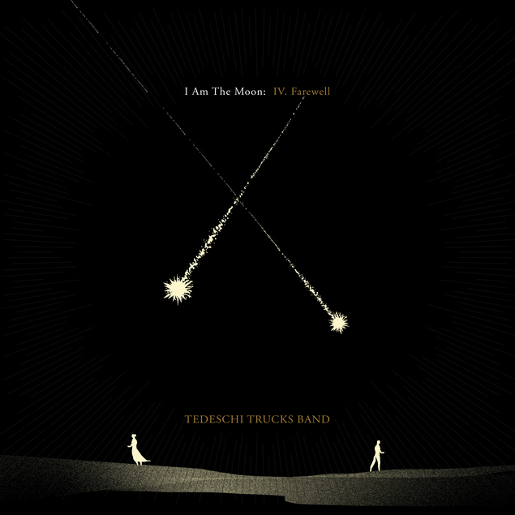
Album Art - Hi-Res Download

WATCH TTB Perform “Soul Sweet Song” on
Jimmy Kimmel LIVE!: HERE
Watch Their Special 3-Song KIMMEL ‘Off-Air’ Livestream: HERE
FOR IMMEDIATE RELEASE – Friday, August 26th, 2022 - Tedeschi Trucks Band, the GRAMMY-winning rock and soul 12-piece led by Derek Trucks and Susan Tedeschi, have released I Am The Moon: Episode IV. Farewell, the final chapter of their acclaimed 4-LP and 4-Companion album cycle, I Am The Moon. Listen to/purchase, I Am The Moon HERE. Fans can also stream the album-length companion visual from filmmaker Alix Lambert on the band's YouTube Channel.

An astonishing amalgamation of soul, rock, blues, funk, psyche, roots and Eastern influences, the project’s sweeping artistic ambition—and the sheer quality of its songwriting and musicianship—makes I Am The Moon one of the year’s most essential recordings. This week, the groundswell of excitement reached a crescendo in anticipation of the journey’s concluding episode as enthusiastic fans from all over the globe have embraced this project like no other in the band’s history.

In his bio notes, esteemed music journalist David Fricke summarized Farewell beautifully:
“Farewell – the final record in the groundbreaking studio release by Tedeschi Trucks Band, I Am The Moon – concludes a remarkable adventure and new beginning for the group, now in its 12th year as America's premier rock & roll big band: four distinct and, at the same time, deeply connected albums with a total of 24 original songs capturing the power of devotion in a time of crisis and separation, with a renewed energy in collective songwriting and performance. Opening with the lusty confrontation of "Last Night In The Rain" and ending with the rousing benediction "Another Day," Farewell is "a wish of well-being at parting," as one dictionary defines that word – with more road and love ahead.”

On Monday, August 22nd, Tedeschi Trucks Band performed their uplifting and poignant new single, "Soul Sweet Song," on Jimmy Kimmel LIVE!, watch it HERE. TTB also performed three additional songs from I Am The Moon for a special KIMMEL ‘off-air’ livestream, watch it HERE.

TTB began the west coast run of their Wheels of Soul tour this past week with triumphant performances at The Greek Theatre in Los Angeles and Berkeley. In their glowing show review, Glide Magazine raved, “The night of glorious soul, rock, and blues included guest sit-ins, powerful new music, and exceptional performances.” See full dates below.
TTB’s Mike Mattison recently sat down with PRX The World to discuss Persian poet Nizami Ganjavi’s “Layla & Majnun,” the influential epic romance poem that was the thematic throughline of I Am The Moon. Listen to the interview here. In addition, Derek Trucks spoke with Rick Beato for a far-reaching interview that delves into Derek’s one-of-kind guitar/audio technique, his deep-rooted jazz influences. Watch here.

Purchase I AM THE MOON HERE and watch the project trailer HERE

All vinyl configurations, including individual LPs and the 4-LP I Am The Moon Deluxe Box will be available on September 9th, 2022. (The TTB store has sold-out, please order EXCLUSIVELY through the Fantasy Records store.)

See below for the complete list of Tedeschi Trucks Band tour dates. For ticket information, please visit tedeschitrucksband.com.

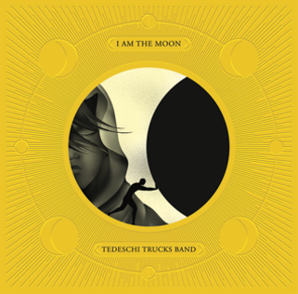
I Am The Moon - General Project Art Hi-Res Download

PRAISE FOR TEDESCHI TRUCKS BAND + I AM THE MOON:

“One of the strongest pieces of music they’ve ever done…Who even dares to do anything like this anymore?”
— Rolling Stone

“Stinging, dexterous, raga-blues brilliance.”
— MOJO

“I Am the Moon is dazzling in concept and execution. Tedeschi Trucks Band embrace this narrative with ambition, and expose its lessons with creative imagination, emotionally intelligent songwriting, and mind-blowing musicality.”
— AllMusic

“There aren't enough complimentary adjectives in the thesaurus to describe
Tedeschi Trucks Band.”
— WFUV

“We hear TTB capturing in the studio what it does so well on stage, namely engaging every member of the 12-piece band in a beautifully conversational way."
— Glide

“As it slowly pulls back the curtain on the full reveal of, I Am the Moon, TTB is dispensing an astonishing amount of detail and design to consider and appreciate. The band is cultivating anticipation in a way that feels more genuine than gimmicky."
— The Arts Fuse

“Musically, the Tedeschi Trucks Band is at their most compelling here: weaving through the seamless blend of blues, rock, jazz, raga, gospel, soul, folk,
and even classical for which they’re known.”
— No Depression

“The group's combination of musical excellence and daring won't be denied, which makes I Am the Moon, in all of its unapologetically indulgent grandeur, a career-defining work.”
— Ultimate Classic Rock

TEDESCHI TRUCKS BAND - I AM THE MOON: ALBUM + FILM RELEASE DATES:

I Am The Moon: I. Crescent
Film Premiere: May 31st
Album Release: June 3rd

I Am The Moon: II. Ascension
Film Premiere: June 28th
Album Release: July 1st

I Am The Moon: III. The Fall
Film Premiere: July 26th
Album Release: July 29th

I Am The Moon: IV. Farewell
Film Premiere: August 23rd
Album Release: August 26th

I Am The Moon vinyl configurations: individual LPs + the 4-LP Deluxe Box
Available September 9th, 2022.

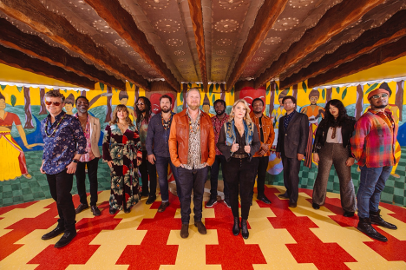
Photo Credit: David McClister Hi-Res Download

Tedeschi Trucks Band Tour Dates:
August 26 / Auburn, WA / White River Amphitheater
August 27 / Bend, OR / Hayden Homes Amphitheater
August 28 / Reno, NV / Grand Sierra Resort & Casino
August 31 / Boise, ID / Outlaw Field at the Idaho Botanical Garden
September 1 / Bonner, MT / Kettlehouse Amphitheater
September 3 / Moorhead, MN / Bluestem Center for the Arts Amphitheater
September 29 – Oct 8 / New York, NY / Beacon Theatre
October 17 / Copenhagen, DK / Amager Bio
October 18 / Copenhagen, DK / Amager Bio
October 20 / Randers, DK / Vaerket
October 21 / Oslo, NO / Sentrum Scene
October 22 / Stockholm, SE / Annexet
October 25 / Berlin, DE / Verti Music Hall
October 26 / Hamburg, DE / Edel-optics.de Arena
October 27 / Prague, CZ / Forum Karlin
October 30 / Rotterdam, NL / RTM Stage
November 2 / Dublin, IE / The Helix
November 4 / London, UK / The London Palladium
November 5 / London, UK / The London Palladium
November 6 / London, UK / The London Palladium
November 9 / Manchester, UK / Manchester Academy
November 10 / Glasgow, UK / O2 Academy Glasgow
November 12 / Paris, FR / Le Trianon
November 13 / Paris, FR / Le Trianon
November 15 / Paris, FR / Bataclan

Tedeschi Trucks Band:
Susan Tedeschi: Guitar and Vocals
Derek Trucks: Guitar
Gabe Dixon: Keys and Vocals
Brandon Boone: Bass Guitar
Tyler Greenwell: Drums and Percussion
Isaac Eady: Drums and Percussion
Mike Mattison: Guitar and Vocals
Mark Rivers: Vocals
Alecia Chakour: Vocals
Kebbi Williams: Saxophone
Ephraim Owens: Trumpet
Elizabeth Lea: Trombone

FOLLOW TEDESCHI TRUCKS BAND:
Website
Facebook
Twitter
Instagram
YouTube
TikTok

FOR MORE INFORMATION:
Matt Hanks / Shore Fire Media / mhanks@shorefire.com
James Rainis / Shore Fire Media / jrainis@shorefire.com
Renee Pfefer / On Tour PR / renee@ontourpr.com
Joel Amsterdam / Fantasy Records / joel@fantasyrecordings.com

