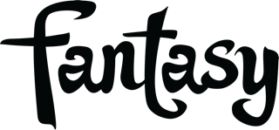

TEDESCHI TRUCKS BAND ANNOUNCES I AM THE MOON, A STUNNING FOUR ALBUM ROCK ‘N’ ROLL EXPERIENCE

I AM THE MOON: 4 ALBUMS AND 4 COMPANION FILMS
1ST FILM DEBUTS TUESDAY MAY 31ST
FOLLOWED BY FIRST ALBUM RELEASE, FRIDAY JUNE 3RD

TEDESCHI TRUCKS BAND HITS THE ROAD THIS SUMMER

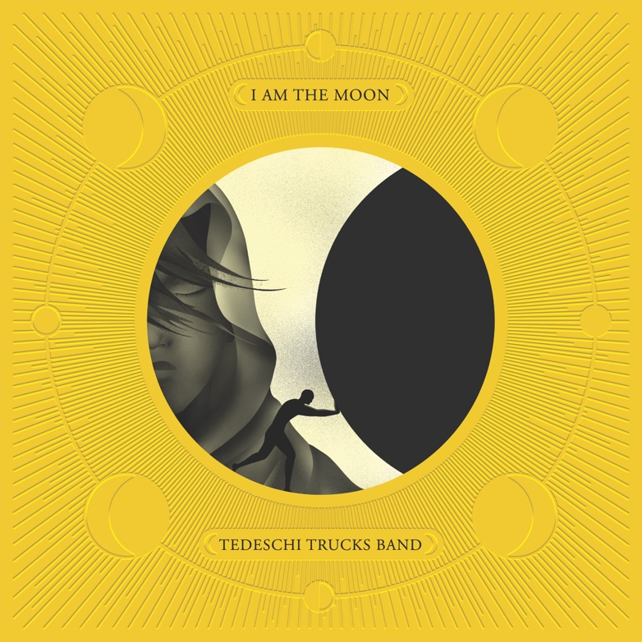

FOR IMMEDIATE RELEASE - APRIL 20, 2022 - Today, Tedeschi Trucks Band - the revered 12-piece collective founded by husband-and-wife duo, guitarist Derek Trucks and singer-guitarist Susan Tedeschi - announces the most ambitious studio project of their storied career: I Am The Moon, an epic undertaking in four albums with 24 original songs. Inspired by a mythic Persian tale of star-crossed lovers, and emotionally driven by the isolation and disconnection of the pandemic era, the thematic I Am The Moon totals more than two hours of music, unfolding across a robust tapestry of genre-defying explorations that propel the treasured American ensemble into new and thrilling creative territory.

The four albums that comprise I Am The Moon — I. Crescent, II. Ascension, III. The Fall, and IV. Farewell — will be released in successive months beginning with I. Crescent, available digitally and on CD, Friday, June 3rd. (All vinyl configurations, including individual LPs and the 4-LP I Am The Moon Deluxe Box will be available on September 9th.) Pre-order I AM THE MOON: HERE. Watch the project trailer HERE.

The decision to sequence and release I Am The Moon in four distinct episodes came "when we started thinking of records we love," Trucks says, citing Axis: Bold as Love, the 1967 LP by the Jimi Hendrix Experience. "It's 36 minutes long. That's the way to digest a record." With that approach in mind, TTB will present I Am The Moon: The Film, immersive visual companions to each album. The corresponding films will debut three days prior to each audio release, offering fans an early opportunity to digest each album in its entirety as a communal listening and viewing experience via the band’s YouTube channel. Directed by Alix Lambert, the films combine studio and performance footage with atmospheric photography and imagery beautifully capturing the music’s kaleidoscopic textures. The project launches with the first episode: I Am The Moon: The Film - I. Crescent on Tuesday, May 31st at 9:00pm ET/6:00pm PT. Release dates for each I Am The Moon album and companion film can be found below.

The concept behind I Am The Moon, the GRAMMY-winning band’s fifth studio recording, was suggested by TTB vocalist Mike Mattison in May 2020, two months after the band was forced off the road by the pandemic. The 12th century poem Layla & Majnun by Persian poet Nizami Ganjavi was the title inspiration for Eric Clapton’s 1970 double-LP with Derek and the Dominos, Layla and Other Assorted Love Songs – an influential album for TTB. But Ganjavi’s source material resonated with Mattison and the rest of the band in an altogether different way. Finding complex themes and storylines that inspired their creative process, they forged a new, modern interpretation of the vast 100-page poem. I Am The Moon was written collectively and collaboratively, with band members contributing their own unique perspectives on the work. By January 2021 the band was recording at Tedeschi and Trucks' home studio, Swamp Raga, in Jacksonville, FL, with Derek behind the soundboard as producer and long-time studio engineer Bobby Tis in charge of recording and mixing.

Operatic in scope, Tedeschi Trucks Band explores romantic relationships, collective struggle, faith, and the human experience on I Am The Moon. "It's amazing," Trucks says, "because we wrote most of this music in a pretty short time span. There are even chord changes that mirror other tunes on the albums – themes and variations, lyrical allusions, that pop back up." He continues: "You always want to do something bigger and thematic. This is the first time it happened naturally."

Tedeschi Trucks Band have extensive tour dates planned for 2022 including their annual headlining Wheels of Soul summer U.S. tour. See list of dates below.

Watch the I Am The Moon Trailer: HERE
Pre-order I Am The Moon: HERE

The limited-edition, I Am The Moon Deluxe Box Set, each individually-numbered, includes all four albums in the I Am The Moon series on 180g black vinyl, plus additional special items will be available September 9th, 2022 - order EXCLUSIVELY through the TTB store and the Fantasy Records store.

TEDESCHI TRUCKS BAND - I AM THE MOON: ALBUM + FILM RELEASE DATES:

I Am The Moon: I. Crescent
Film Premiere: May 31st
Album Release: June 3rd

I Am The Moon: II. Ascension
Film Premiere: June 28th
Album Release: July 1st

I Am The Moon: III. The Fall
Film Premiere: July 26th
Album Release: July 29th

I Am The Moon: IV. Farewell
Film Premiere: August 23rd
Album Release: August 26th

I Am The Moon – All Vinyl Configurations: individual LPs + the 4-LP Deluxe Box Available September 9th.

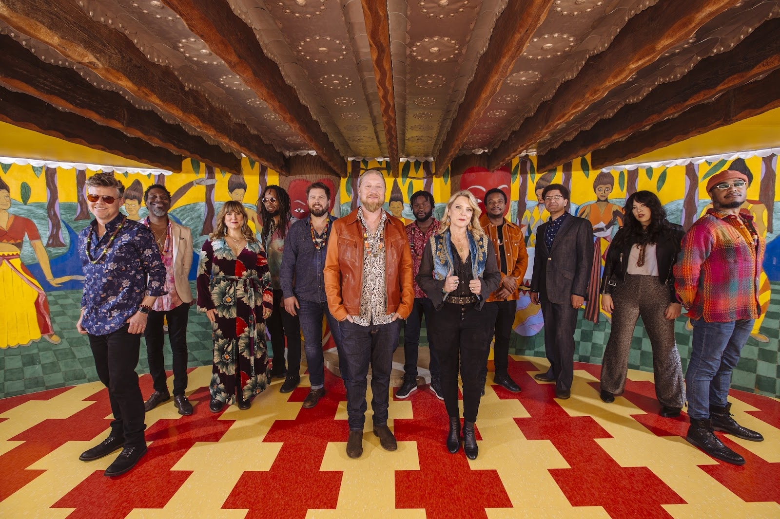
Photo Credit: David McClister

Tedeschi Trucks Band: Susan Tedeschi (Vocals/Guitar), Derek Trucks (Guitar), Gabe Dixon (Keys/Vocals), Brandon Boone (Bass Guitar), Tyler Greenwell (Drums/Percussion), Isaac Eady (Drums/Percussion), Mike Mattison (Vocals/Guitar), Mark Rivers (Vocals), Alecia Chakour (Vocals), Kebbi Williams (Saxophone), Ephraim Owens (Trumpet), and Elizabeth Lea (Trombone).

Tedeschi Trucks Band Itinerary *

June 24 Jacksonville, FL Daily’s Place Amphitheater
June 25 Mobile, AL Mobile Civic Center
June 26 Tuscaloosa, AL Tuscaloosa Amphitheater
June 28 Indianapolis, IN The Amphitheater at White River State Park
June 29 Detroit, MI Fox Theatre
July 1 Canandaigua, NY Constellation Brands - Marvin Sands Performing Arts Center
July 2 Gilford, NH Bank of New Hampshire Pavilion
July 3 Saratoga Springs, NY Saratoga Performing Arts Center
July 6 New Haven, CT Westville Music Bowl
July 8 Philadelphia, PA The Mann Center
July 9 Essex Junction, VT Midway Lawn at Champlain Valley Expo
July 10 Patchogue, NY Great South Bay Music Festival
July 12 Lewiston, NY ArtPark
July 13 Cincinnati, OH PNC Pavilion at Riverbend
July 15 - 16 Atlanta, GA Fox Theatre
July 19 Vienna, VA Wolf Trap
July 20 Richmond, VA Virginia Credit Union LIVE!
July 21 Raleigh, NC Coastal Credit Union Music Park
July 23 Charlotte, NC PNC Music Pavilion
July 24 Huber Heights, OH Rose Music Center at The Heights
July 26 Aurora, IL RiverEdge Park
July 27 St. Louis, MO Fabulous Fox Theatre
July 29 - 30 Morrison, CO Red Rocks Amphitheatre
August 18 San Diego, CA Cal Coast Credit Union Amphitheater
August 19 Los Angeles, CA The Greek Theatre
August 20 Berkeley, CA The Greek Theatre
August 23 Sacramento, CA Sacramento Memorial Auditorium
August 24 Eugene, OR Cuthbert Amphitheater
August 26 Auburn, WA White River Amphitheater
August 27 Bend, OR Hayden Homes Amphitheater
August 28 Reno, NV Grand Sierra Resort & Casino
August 31 Boise, ID Outlaw Field at the Idaho Botanical Garden
September 1 Bonner, MT Kettlehouse Amphitheater
September 3 Moorhead, MN Bluestem Center for the Arts Amphitheater
---------------------
October 17 -18 Copenhagen, DK Amager Bio
October 20 Randers, DK Vaerket
October 21 Oslo, NO Sentrum Scene
October 22 Stockholm, SE Cirkus
October 25 Berlin, DE Verti Music Hall
October 26 Hamburg, DE Edel-optics.de Arena
October 27 Prague, CZ Forum Karlin
October 30 Rotterdam, NL RTM Stage
November 2 Dublin, IE The Helix
November 4, 5, 6 London, UK The London Palladium
November 9 Manchester, UK Manchester Academy
November 10 Glasgow, UK O2 Academy Glasgow
November 12 - 13 Paris, FR Le Trianon
November 15 Paris, FR Bataclan
* US dates are TTB’s headlining Wheels of Soul summer tour with special guests Los Lobos and Gabe Dixon.

FOLLOW TEDESCHI TRUCKS BAND:
Website Facebook
Twitter Instagram YouTube
TikTok

Fantasy Records

Matt Hanks / Shore Fire Media / mhanks@shorefire.com
James Rainis / Shore Fire Media / jrainis@shorefire.com
TOUR PRESS: Renee Pfefer / On Tour PR - Renee@ontourpr.com
Joel Amsterdam / Fantasy Records / joel@fantasyrecordings.com

