For Immediate Release
TEDESCHI TRUCKS BAND HITS HALFWAY MARK OF THE FIRESIDE SESSIONS
ONLY THREE NEW EPISODES REMAIN
EPISODE 4 TO AIR MARCH 11 ON NUGS.NET
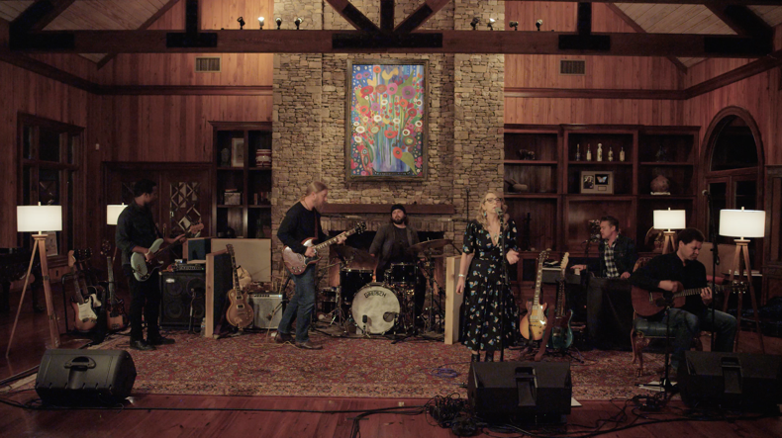
Credit: Fireside Sessions, 2/25/21, Episode 2
“With the “Fireside Sessions,” Tedeschi and Trucks have found the perfect online format for showcasing their attention to detail, nuance, and craft.” Arts Fuse

“Thursdays have already become the best night of the week for rock and roll music enthusiasts.”
Live for Live Music

March 10, 2021 - Tedeschi Trucks Band has reached the midpoint of its six-episode series, Fireside Sessions- the Grammy-winning group’s newly-filmed, up-close and personal home performances hosted by Derek Trucks and Susan Tedeschi. Only three new installments of these very special appearances remain: Episode 4 is slated for Thursday, March 11 at 8 pm EST at nugs.net. All previous episodes of the highly successful series are available on-demand, with a full six-night subscription.
WATCH PRO-SHOT VIDEOS
“When Will I Begin” (3/4/21) https://youtu.be/m7SSC8uBMAk
“Whiskey Legs”(2/25/21) https://youtu.be/u2FDU7sXsHk

TTB’s return to live performances has made these Fireside Sessions must-see Thursday night viewing, showcasing various configurations of the ensemble from an intimate vantage point most fans could never otherwise experience. The series opener featured the group as a quartet- with Derek and Susan joined by TTB’s bassist Brandon Boone and drummer Tyler Greenwell for a dozen-song set that included potent renditions of “Statesboro Blues,” “That Did It,” “Angel from Montgomery,” and a fiery finale of “I Want More” that morphed into “Soul Sacrifice.” Episode
two saw the addition of TTB members Gabe Dixon on keys and vocals along with Mike Mattison on vocals and guitar as the sextet delivered a sizzling full set with three sparkling debuts; a new original, “Here My Dear,” and a pair of covers: Leonard Cohen’s “Suzanne,” and Paul Pena’s “Gonna Move.”
The third installment, perhaps the most affecting so far, stripped the lineup back to a dynamic duo, with just Derek and Susan. From their home studio the pair played a variety of acoustic and electric guitars, offered detailed song introductions- including a heartful remembrance of Kofi Burbridge, the band’s late multi-instrumentalist, during “Strengthen What Remains”- and provided viewers, once again with the unique atmosphere of a “living room” performance. The two also revived their rendition of the Rolling Stones’ “You Got the Silver,” last played in 2014, as well as another new entry, “Smiling On Me,” co-written with Oliver Wood. For the final three episodes, fans can expect more surprises, including song debuts and visits from additional band members, sitting in for these rare, up-close and intimate sessions.

In a recent interview with the Jacksonville Times Union, Trucks said, "It was fun exploring these tunes in a different light.” He added “we were surprised at how some of the songs worked” and “it was quite a relief to get back. It’s one thing to sit home and play and it's another thing to get back into the action.” Trucks also expressed gratitude to fans for stepping up with donations to the band and crew.
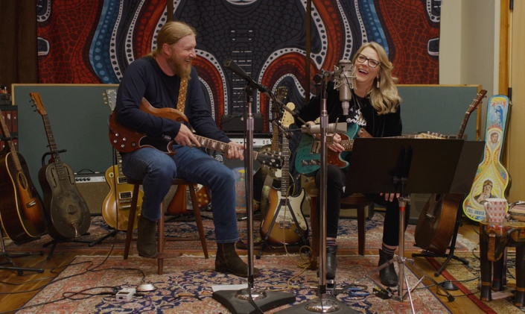
Credit: Fireside Sessions, 3/4/21 , Episode 3

Each episode was captured in stunning 4K detail by 7Cinematics, an award-winning crew of concert filmmakers, with audio recorded, mixed and mastered by TTB’s engineer Bobby Tis. Audio from each session is available, as well, in an mp3 bundle or separately for purchase in all additional formats. After each initial 8pm broadcast, episodes are also available for on-demand viewing for a 48-hour period. Ticket and bundle information can be found here: 2nu.gs/TTB
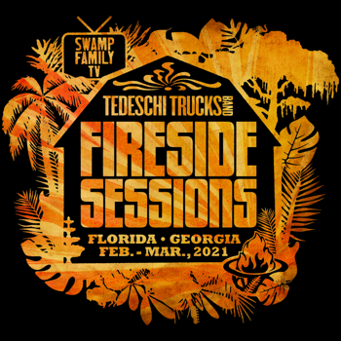
The past year has been a challenge for so many, and musicians and crew members are no exception. Beyond purchasing the Fireside Sessions, fans can also donate at givebutter.com/TTB.

In 2020, Tedeschi Trucks Band raised over $100,000 to benefit charities including Music Health Alliance, NAACP, Sweet Relief, Mr. Holland’s Opus Foundation, Feeding America and World Central Kitchen via their free Swamp Family TV webcast series.

Visit Tedeschi Trucks Band online at TedeschiTrucksBand.com and @DerekAndSusan

Media Contact:
Tedeschi Trucks Band/ Renee Pfefer, On Tour PR Renee@ontourpr.com
Office: 203-724-9919 cell: 914-806-2834

About nugs.net
Founded in 1997 as a fan site for downloading live music, nugs.net has evolved into the leading live music platform for the largest touring artists in the world. Bruce Springsteen, Metallica, Pearl Jam, Phish, Jack White, Red Hot Chili Peppers and many others distribute recordings of every concert they play through nugs.net. The platform offers live streams, downloads, CDs, Video on Demand, and the only streaming service dedicated to live music, delivering exclusive live content to millions of fans daily. nugs.net is available on iOS, Android, AppleTV, Sonos, BluOS, and Desktop. A free 30-day trial is available. Visit nugs.net or get the app at nugs.net/app.

