For Immediate Release

TEDESCHI TRUCKS BAND ANNOUNCES CONCERT RE-BROADCASTS FROM
THE BEACON THEATRE AND PREVIOUSLY UNRELEASED AUDIO DOWNLOADS
ON THURSDAY, OCTOBER 22 AND 29, 2020
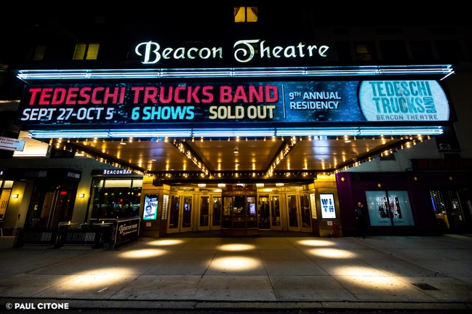
Photo credit: Paul Citone 10/5/2019

NEW YORK, NY (October 13, 2020) October usually marks a highlight of Tedeschi Trucks Band's schedule with their annual residency at the Beacon Theatre in New York City. As the global pandemic has forced the rescheduling of the band's touring plans for the foreseeable future - including what would have been their 10th year at the historic venue - TTB is offering a pay-per-view re-broadcast of the final two nights from last year's celebrated run. With special thanks to MSG Entertainment and the Beacon Theatre, fans missing the fall tradition can enjoy the sold-out October 4th and 5th, 2019 concerts from a front row seat at home. Previously unreleased full-show audio downloads from both nights will also be available for purchase.

The re-broadcasts will air on Thursday, October 22nd and 29th at 8pm EST and remain available for viewing for 72 hours. Tickets and full-show audio download bundles are available for purchase at Stellartickets.com ( https://www.stellartickets.com/events/tedeschi-trucks-band/tedeschi-trucks-band-from-the-beacon-theatre-2019). Audio downloads will also be available after the shows air through Nugs.net.

Fans may recognize these memorable concerts as they were streamed earlier this year on TTB’s weekly Swamp Family TV to raise funds for charity. This time around, the broadcast and download purchases will go directly to support TTB musicians, crew and their families during this challenging period, with a portion of proceeds donated to Sweet Relief Musicians Fund to help additional music professionals in dire need of assistance with stages dark across the country.

Since 2011, Tedeschi Trucks Band has played nine consecutive years and 39 concerts at the Beacon Theatre with over 100,000 tickets sold. The multi-night residency draws fans from all over the country to experience these special shows where the band digs deep into their extended repertoire and frequently welcomes special guests onto the stage.

The 12-member-strong collective, led by Derek Trucks and Susan Tedeschi, carries a distinguished reputation as one of the premier live bands to see for their outstanding musicianship. TTB's unique, genre-defying sound encompasses the best of American roots traditions - blending driving rock and roll with soul, blues, jazz and even gospel. They are also known as one of the hardest working groups around, often on the road for over 200 days a year, and look forward to being able to return to doing what they love. The band currently has no shows scheduled before the summer of 2021’s Wheels of Soul Tour.

VIDEO: “With A Little Help From My Friends” - Encore, 10/5/19, the Beacon Theatre
https://www.youtube.com/watch?v=omj8kC__RXU

MORE INFO ON TEDESCHI TRUCKS BAND
Website
Facebook
Instagram
Twitter
YouTube

Press contact:
Renee Pfefer, On Tour PR
Renee@ontourpr.com
203-724-9919

