For Immediate Release

**Tedeschi Trucks Band Returns to NYC for 2021 Beacon Theatre Residency   
7 Nights – September 30 – October 9  
  
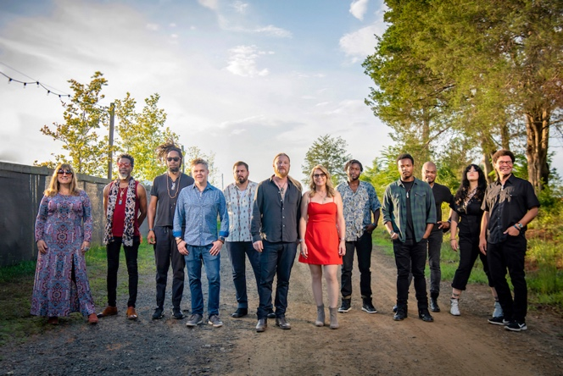***Photo credit: Caitlin Moore*

**NEW YORK, NY (September 20, 2021) Tedeschi Trucks Band** returns to the **Beacon Theatre** in New York City for their **annual** multiple-night residency. Proudly proclaiming, “We’re Back,” these will feature the full, **reunited 12-piece** bandincluding **new drummer Isaac Eady**. Concerts take place on **September 30, October 1, 2, 5, 6, 8, and 9.**

The **10th anniversary** residency will feature support acts **Nels Cline: Consentrik Quartet** on September 30, **Anders Osborne** on October 5 and **Jorma Kaukonen** on October 6. All other shows will feature two full sets by Tedeschi Trucks Band.

Since their first performance at The Beacon in 2011, Tedeschi Trucks Band has played **39 shows** at the legendary theatre. A highlight of the TTB touring schedule, fans look forward to the Beacon residency for the opportunity it gives the multi-talented group to explore an especially large range of musical territory, often exceeding **100 different songs** across the run with few repeats. Guest sit-ins and surprise appearances in recent years by **Norah Jones, Jerry Douglas, Jon Batiste, and Ravi Coltrane** have also made the Beacon shows special.

TTB's return to the Beacon marks a true homecoming for the full band following an unprecedented 18 months of uncertainty for live music. With touring still on hold in early 2021, Derek and Susan launched **Fireside Sessions**, an intimate **at-home livestream** performance series whose proceeds helped to support band and crew. Joined by a select number of band members (Mike Mattison, Tyler Greenwell, Brandon Boone, Gabe Dixon, Mark Rivers and Kebbi Williams), the Fireside Sessions re-energized fans and inspired the band to bring the scaled-down TTB line-up on the road as **Fireside LIVE** - a series of **socially distant, limited-capacity shows** throughout the summer. The sold-out dates were the first fully live public performances for the group since February 2020 though not with the entire ensemble.

­­­In July 2021, the band released ***Layla Revisited (Live At LOCKN'),*** a **2CD/3LP** live recording of their performance of the classic Derek and the Dominos album ***Layla and Other Assorted Love Songs*** at the 2019 LOCKN’ Festival with **Trey Anastasio** and longtime TTB collaborator, guitarist **Doyle Bramhall II.** The “transfixing” (*Stereogum*) musicianship of the “now-legendary set” (*Relix*) propelled the album to hit the top of the Billboard charts including **#1 Blues** Albums, #2 Americana/Folk Albums, #4 Current Rock Albums, and #47 on the Billboard Top 200.

This Beacon residency coincides with the just-announced release of a new documentary, ***Learning To Live Together: The Return of Mad Dogs & Englishmen.*** The feature film chronicles the reunion of remaining band members from **Joe Cocker’**s iconic 1970 tour (after 45 years) when they performed with Tedeschi Trucks Band at LOCKN' festival in 2015. *Learning To Live Together* world premieres at the **Woodstock Film Festival** on September 30th, prior to the debut theatrical release on October 22nd in NYC. Visit [MadDogsDoc.com](http://MadDogsDoc.com) for more info and future theatrical release details. Watch **film trailer** [**here.**](https://www.youtube.com/watch?v=FNmasK8RePs)

The pandemic has also given TTB ample time to **write new material.** They are currently in the process of recording their next studio album, which they expect to release sometime in 2022. In addition, Derek and Susan also used their time off the road to guest on albums by **Oliver Wood, Doyle Bramhall ll, Gabe Dixon, Ryan Shaw, Neal Francis,** and will both appear on the upcoming **Neal Casal** project *Highway Butterfly.*

Tedeschi Trucks Band is Susan Tedeschi (guitar, vocals), Derek Trucks (guitar), Gabe Dixon (keyboards, vocals), Brandon Boone (bass), Tyler “Falcon” Greenwell (drums) Isaac Eady (drums)

Mike Mattison (vocals), Mark Rivers (harmony vocals), Alecia Chakour (harmony vocals), Kebbi Williams (saxophone), Ephraim Owens (trumpet) and Elizabeth Lea (trombone).

**TEDESCHI TRUCKS BAND 2021 TOUR DATES**

9/30 New York, NY Beacon / with Nels Cline: Consentrik Quartet, 7:30pm*   
10/1 New York, NY Beacon / Evening with, 8pm*  
10/2 New York, NY Beacon / Evening with, 8pm*   
10/5 New York, NY Beacon / with Anders Osborne, 7:30pm*  
10/6 New York, NY Beacon / with Jorma Kaukonen, 7:30pm*   
10/8 New York, NY Beacon / Evening with, 8pm*

10/9 New York, NY Beacon / Evening with, 8pm*

11/10 Orlando, FL Dr. Phillips Center for the Performing Arts   
11/11 West Palm Beach, FL Kravis Center for the Performing Arts   
11/12 Ft. Myers, FL Barbara B. Mann Performing Arts Hall   
11/14 Key West, FL Key West Amphitheatre   
11/16 Tampa, FL Ruth Eckerd Hall   
11/18 Chattanooga, TN Tivoli Theatre   
11/19 Birmingham, AL BJCC Concert Hall   
11/20 Savannah, GA Johnny Mercer Theatre   
11/30-12/4 Boston, MA Orpheum Theatre

*A very limited number of Beacon Theatre tickets are available and can be purchased online at Ticketmaster.com, BeaconTheatre.com, by calling 866.858.0008 and at the box office. All guests age 12 and older are required to provide proof of COVID-19 vaccination.

**VIDEOS:**

“Layla” (Live at LOCKN’ 2019)

<https://www.youtube.com/watch?v=gCL4o6i5934>

“With A Little Help From My Friends” (Beacon 2019)   
<https://www.youtube.com/watch?v=omj8kC__RXU>

**VISIT TEDESCHI TRUCKS BAND**

[Website](http://tedeschitrucksband.com/)

[Facebook](https://www.facebook.com/DerekAndSusan/)

[Instagram](https://www.instagram.com/derekandsusan/)

[Twitter](https://twitter.com/DerekAndSusan)

[YouTube](https://www.youtube.com/user/TTBFromTheRoad)

Press Contact:   
Renee Pfefer On Tour PR 203-724-9919; [Renee@ontourpr.com](mailto:Renee@ontourpr.com)   
High Res Jpegs: [www.ontourpr.com/TTB](http://www.ontourpr.com/TTB)