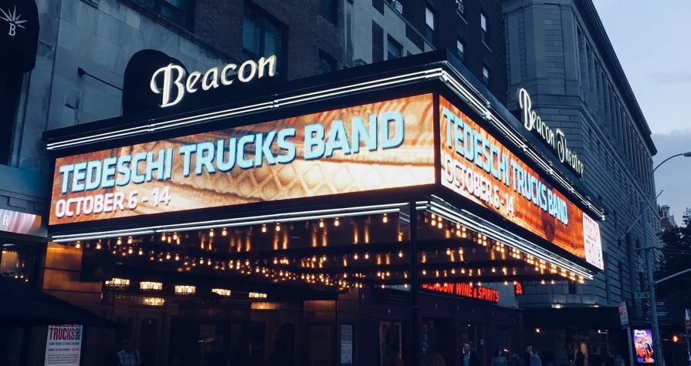

TEDESCHI TRUCKS BAND WRAP UP SIX-NIGHT RESIDENCY AT BEACON THEATRE

NEW YORK, NY October 30, 3017 Fall in New York City is known for many things including the opening of the ice rink in Rockefeller Center, the famed marathon and the Halloween Parade in Greenwich Village. Tedeschi Trucks Band’s annual residency at the Beacon Theatre on Manhattan’s Upper West Side now must be considered among these must-see New York City traditions. Derek Trucks and Susan Tedeschi recently led their powerhouse 12-piece ensemble through six memorable shows at the Beacon spanning October 6 - 14 and each night was chock full of highlights.

Tedeschi Trucks Band began the tradition in 2011 and have made the Beacon an annual stop ever since. All told, the TTB has now played 27 shows at the historic venue. This year’s seventh annual residency saw the group perform 110 songs in total including 69 different ones. Debuts were plentiful such as a 33-minute version of the Allman Brothers Band’s “Mountain Jam,” Toots & The Maytals’ reggae classic “Sailing On” and “You Don’t Know How It Feels” by the late Tom Petty just days after his passing. Keyboardist Kofi Burbridge underwent heart surgery earlier this year and returned to the fold just in time for the October concerts. Burbridge was in fine form throughout, a great sign for the rest of TTB’s 2017 and beyond.

Fans can always count on Tedeschi Trucks Band mixing “An Evening With” concerts with shows featuring exceptional openers. In 2017, Americana trio The Wood Brothers, blues-rockers North Mississippi Allstars and genre-defying Austin act Greyhounds were picked by the TTB to open select shows. Both The Wood Brothers and North Mississippi Allstars have toured with the Tedeschi Trucks Band on past Wheels Of Soul summer outings, cementing musical relationships that will last a lifetime.

Another tradition of Tedeschi Trucks Band’s annual residencies are special guests. The TTB has followed in the footsteps of the Allman Brothers Band’s March Madness runs by loading the residencies with their musical friends, heroes and those who they’ve inspired. Past special guests have included Taj Mahal, Dickey Betts, Leon Russell, Rosanne Cash, Jerry Douglas and Dave Mason. This year the group upped the ante by collaborating with the likes of Norah Jones, Trey Anastasio, John Medeski, Nels Cline, Marcus King, Jimmy Vivino, Jaimoe, Oliver Wood, Chris Wood, Jano Rix, Doyle Bramhall II, Luther Dickinson and Carey Frank.

Many of those guests joined the Tedeschi Trucks Band on Wednesday, October 11. The show that night was billed as “TTB & Friends” in honor of the group’s 25th show at the Beacon Theatre. Highlights included Derek’s former Allman Brothers Band mate drummer Jaimoe sitting in on a number of songs such as “Midnight In Harlem,” Norah Jones adding to “Love Has No Pride” and Wilco guitarist Nels Cline showing off his masterful skills on a pairing of “Ali” and “Let Me Get By.” Despite all the guests, Lou Montesano of Elmore Magazine noted, “the night belonged to Susan Tedeschi, Derek Trucks and their sprawling band: two drummers, bass, keyboards and a six-piece horn and vocals section.”

On October 14, the Tedeschi Trucks Band closed out the six-show 2017 residency with a Saturday night scorcher. Sit-ins from Phish guitarist Trey Anastasio are a rarity, but the legendary axeman made the trip to the Beacon to lead the 12-piece on Leon Russell’s “Delta Lady.” The TTB sans horns and vocalists then teamed with Anastasio on a wild 33-minute “Mountain Jam.” JamBase’s Scott Bernstein wrote of the collaboration, “The septet patiently worked through each and every segment of the instrumental based on Donovan’s “There Is A Mountain” and subsequent improvisations on his versions by the Grateful Dead and Herbie Mann. Anastasio had held back at some previous Allman family sit-ins, yet Trey let it rip in a tasteful way at the Beacon.” The unforgettable run concluded with an encore that saw Kofi and Susan present a beautiful rendition of Russell’s “A Song For You” that left nary a dry eye in the house before the entire band flexed their musical might on a powerful “Bound For Glory.”

After yet another successful Beacon Theatre residency, there’s only one question. How in the world will the Tedeschi Trucks Band top the high bar they set in 2017? Knowing Derek and Susan, there’s no doubt they will find a way.

www.tedeschitrucksband.com

For Additional Press Information, please contact:
Renee Pfefer, On Tour PR
203-724-9919; 914-806-2834
Renee@ontourpr.com

