For Immediate Release
TEDESCHI TRUCKS BAND GEARS UP FOR
BEACON THEATRE RESIDENCY
SEPTEMBER 29, 30, OCTOBER 1, 3, 6, 7 & 8, 2022
The 7-Night Stand Follows the Release of I Am The Moon,
TTB’s Epic New 4-Album Multi-Media Project
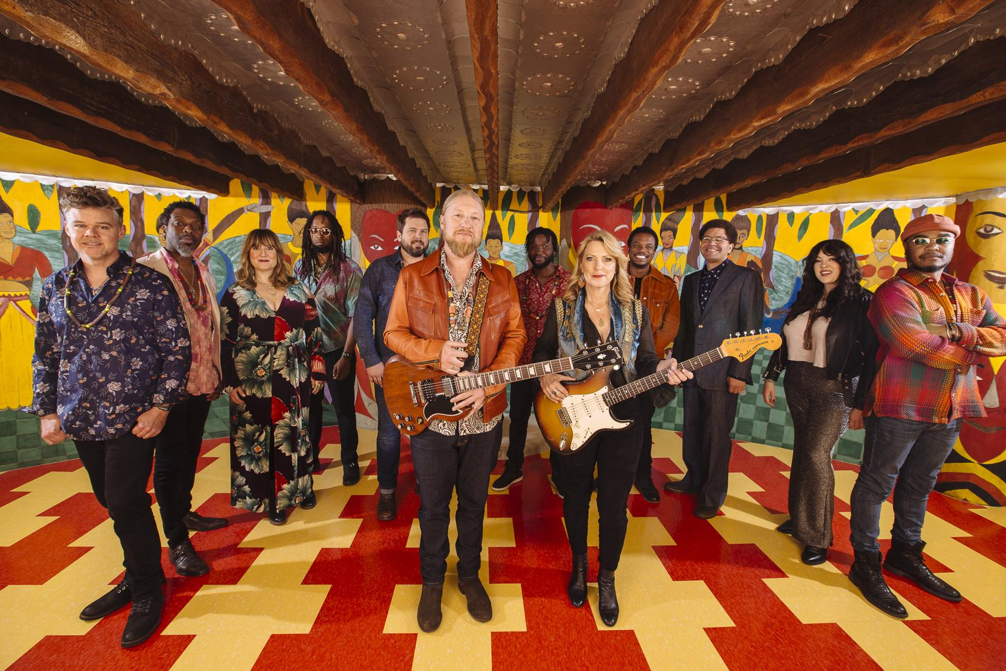
Photo credit: David McClister Hi-Res Download
"Tedeschi Trucks at their finest and most adventurous." — NPR

“I Am The Moon is dazzling in concept and execution… with creative imagination, emotionally intelligent songwriting, and mind-blowing musicality.” — AllMusic
“There aren't enough complimentary adjectives in the thesaurus to describe Tedeschi Trucks Band.”— WFUV
NEW YORK, NY (September 12, 2022) Tedeschi Trucks Band, America’s premier rock-and-roll big band, will mark its annual return to New York City’s Beacon Theatre with seven performances on September 29 & 30 and October 1, 3, 6, 7 & 8 - with a milestone 50th performance at the famed venue on October 3 - as part of their multi-year, dual city residency with MSG Entertainment, which also includes annual shows at The Chicago Theatre. They will also be performing new, original material from the entirety of their latest release, I Am The Moon, an epic, 4-album project released last month on Fantasy Records. Led by singer-guitarist Susan Tedeschi and guitarist Derek Trucks, the Grammy-winning 12-piece ensemble’s highly anticipated, seven-night return to the Big Apple will be the 11th multi-night Beacon Theatre run of their storied career. Over the past decade, the band’s recurring tenure in NYC has become a destination event and can't-miss concert experience featuring surprise sit-ins and set lists that go deep into the band's vast catalog.
This year’s residency follows the September 9th release of all vinyl configurations of I Am The Moon, including individual LPs and the 4-LP Deluxe Box set. It also comes on the heels of the band’s triumphant, flagship “Wheels of Soul” cross-country summer amphitheater tour, where they unveiled fresh performances of new music as each episode was released, to widespread acclaim. The Beacon Theatre concerts will be among the first shows where fans have an opportunity to catch songs from all four new albums.
“The Beacon is always a place for us to stretch out and explore musical territory,” says Derek Trucks. “We’ve had an incredible amount of new material come out this year with I Am The Moon and The Beacon shows will be some of the first where we'll be able to draw from all of it and have the space to really dig in."
Susan Tedeschi adds, "I Am The Moon is a creative milestone for us - and we've got our 50th show at The Beacon, another milestone. We're looking forward to celebrating both and all the hard work that went into getting here - it's not something that just happens."
I Am The Moon began as a pandemic-related writing exercise suggested by TTB vocalist Mike Mattison in May 2020, and transformed into a career-defining artistic statement as TTB reimagined a mythic Persian tale of star-crossed lovers, Layla and Majnun, through a modern-day lens: capturing the power of devotion in a time of crisis and separation. The endeavor evolved into Tedeschi Trucks Band’s fifth studio release that finds them “at their finest and most adventurous” (NPR) with 24 original songs and four album length companion films. It is an astonishing amalgamation of soul, rock, blues, funk, roots and Eastern influences, sweeping artistic ambition, and an exceptional quality of collective songwriting and musicianship that make I Am The Moon one of the year’s most essential recordings.
On August 22nd, Tedeschi Trucks Band performed their uplifting and poignant new single, "Soul Sweet Song," on Jimmy Kimmel LIVE!, watch it HERE. TTB also performed three additional songs from I Am The Moon for a special KIMMEL ‘off-air’ livestream, watch it HERE.
Tedeschi Trucks Band is Susan Tedeschi (guitar, vocals), Derek Trucks (guitar), Gabe Dixon (keyboards, vocals), Brandon Boone (bass), Tyler “Falcon” Greenwell (drums, percussion) Isaac Eady (drums, percussion) Mike Mattison (vocals, guitar), Mark Rivers (harmony vocals), Alecia Chakour (harmony vocals), Kebbi Williams (saxophone), Ephraim Owens (trumpet) and Elizabeth Lea (trombone).

TEDESCHI TRUCKS BAND - BEACON THEATRE 2022
Thu Sept. 29 Amy Helm opens, showtime 7:30pm
Fri Sept. 30 Two sets, no opener showtime 8pm
Sat Oct. 1 Two sets, no opener showtime 8pm
Mon Oct. 3 Surprise opening set, showtime 7:30pm
Thu Oct. 6 Ruthie Foster opens, showtime 7:30pm
Fri Oct. 7 Two sets, no opener showtime 8pm
Sat Oct. 8 Two sets, no opener showtime 8pm
Remaining tickets are limited. Tickets, priced $29.50 - $135.00 plus applicable fees, are available online at Ticketmaster.com, and in person at the Madison Square Garden, Radio City Music Hall and Beacon Theatre box offices.
TEDESCHI TRUCKS BAND - EUROPE 2022
Oct. 17 & 18 Copenhagen, DK / Amager Bio
Oct. 20 Randers, DK / Vaerket
Oct. 21 Oslo, NO / Sentrum Scene
Oct. 22 Stockholm, SE / Annexet
Oct. 25 Berlin, DE / Verti Music Hall
Oct. 26 Hamburg, DE / Edel-optics.de Arena
Oct. 27 Prague, CZ / Forum Karlin
Oct. 30 Rotterdam, NL / RTM Stage
Nov. 2 Dublin, IE / The Helix
Nov. 4, 5 & 6 London, UK / The London Palladium
Nov. 9 Manchester, UK / Manchester Academy
Nov. 10 Glasgow, UK / O2 Academy Glasgow
Nov. 12 & 13 Paris, FR / Le Trianon
Nov. 15 Paris, FR / Bataclan
VIDEOS
Jimmy Kimmel Live! Off-Air Performances 8-22-22
“Playing With My Emotions”, “La Di Da”, “I Am The Moon”
https://www.youtube.com/watch?v=xNSJlXEH80Y
"I Am The Moon" Project Film Trailer
https://www.youtube.com/watch?v=eFbRb1BZKQk
"Gravity" Live from Red Rocks, Colorado 7-29-22
https://www.youtube.com/watch?v=ShymVaosyl0

FOLLOW TEDESCHI TRUCKS BAND:
Website Facebook Twitter Instagram YouTube TikTok

FOR MORE INFORMATION:
Matt Hanks / Shore Fire Media / mhanks@shorefire.com
James Rainis / Shore Fire Media / jrainis@shorefire.com
Renee Pfefer / On Tour PR / renee@ontourpr.com
Joel Amsterdam / Fantasy Records / joel@fantasyrecordings.com
Kaitlin Blanton / MSG Entertainment / kaitlin.blanton@msg.com

