TEDESCHI TRUCKS BAND ANNOUNCES 2023 DATES
TTB’s Epic New 4-Album Multi-Media Project, “I Am The Moon” Out Now
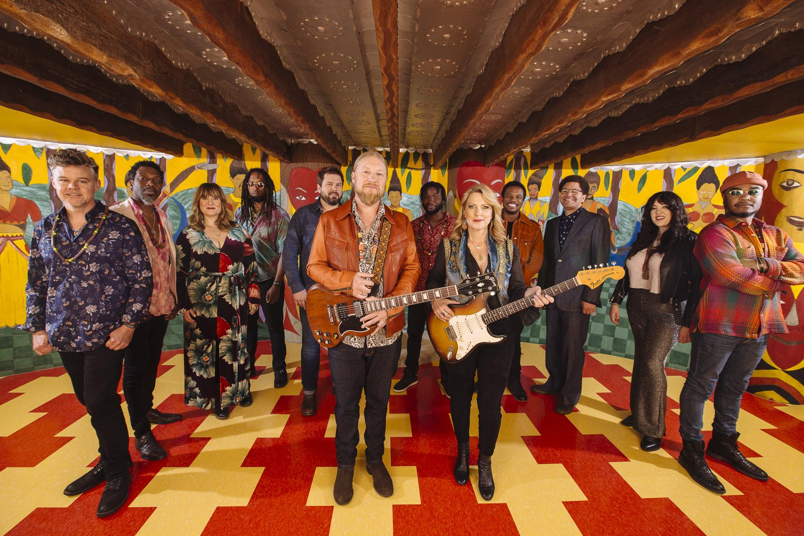
Photo credit: David McClister Hi-Res Download

December 2022 – Tedeschi Trucks Band, America’s premier rock-and-roll big band, touring in support of their new album, I Am The Moon, has announced their initial tour dates for 2023. Upcoming highlights include a series of shows across their home state of Florida and multiple night residencies in Washington DC, Nashville, and Chicago.
The Grammy-winning 12-piece powerhouse holds a well-deserved reputation as one of the best live acts touring today. Led by the husband/wife duo of guitarist Derek Trucks and singer/guitarist Susan Tedeschi, “two of the best roots rock musicians of their generation” (NPR), TTB is known for its world-class musicianship and contemporary blend of a wide range of American musical influences that also define their extensive catalog.
I Am The Moon, TTB's fifth studio release, finds them “at their finest and most adventurous” (NPR). Written while off the road during the pandemic and released in 2022, I Am The Moon “explodes with joyful, powerful and positive music (Guitar Player)” and captures a prolific and collaborative songwriting period for TTB that was inspired by an ancient poem of star-crossed lovers. I Am The Moon includes four albums, I. Crescent, II. Ascension, III. The Fall, IV. Farewell and four companion films - delivering more than two hours of music that unfold across a robust tapestry of soul, rock, blues, funk, roots and Eastern explorations that propel the treasured American ensemble into new and thrilling creative territory.
Derek Trucks and Susan Tedeschi talk about I Am The Moon in a recent New York Times feature HERE – as well as Broken Record Podcast and cover stories of Relix and Guitar Player Magazine. In addition, Derek Trucks spoke with Rick Beato for a far-reaching interview that delves into Derek’s one-of-kind techniques and deep-rooted jazz influences HERE and Susan spoke with Maggie Rose for the Salute the Songbird podcast HERE.
Tedeschi Trucks Band performed their uplifting and poignant single, "Soul Sweet Song," on Jimmy Kimmel LIVE!, watch it HERE. TTB also performed three additional songs from I Am The Moon for a special KIMMEL ‘off-air’ livestream, watch it HERE.
Tedeschi Trucks Band is Susan Tedeschi (guitar, vocals), Derek Trucks (guitar), Gabe Dixon (keyboards, vocals), Brandon Boone (bass), Tyler “Falcon” Greenwell (drums, percussion) Isaac Eady (drums, percussion) Mike Mattison (vocals, guitar), Mark Rivers (harmony vocals), Alecia Chakour (harmony vocals), Kebbi Williams (saxophone), Ephraim Owens (trumpet) and Elizabeth Lea (trombone).
2023 Itinerary
1/20 Fort Myers, FL Barbara B. Mann Performing Arts Center
1/21 Clearwater, FL Ruth Eckerd Hall
1/22 Gainesville, FL Curtis M Phillips Center for the Performing Arts
1/27 Boca Raton, FL Mizner Park Amphitheater
1/28 Orlando, FL Hard Rock Live
1/29 Pensacola, FL Saenger Theatre
2/16,17,18 Washington DC Warner Theatre
2/21/23 Knoxville, TN Knoxville Civic Auditorium
2/23,24,25 Nashville, TN Ryman Auditorium
3/2,3,4 Washington DC Warner Theatre
3/17,18 Chicago, IL Chicago Theatre
3/21 Columbus, OH Palace Theatre
3/22 Moon Township, PA UPMC Events Center
3/23 Newark, NJ NJPAC
3/25 Asheville, NC ExploreAsheville.com Arena
3/28 Durham, NC DPAC
3/31, 4/1 Chicago, IL Chicago Theatre
4/28 N. Little Rock, AR Simmons Bank Arena
4/29 Birmingham, AL BJCC Concert Hall
(VIDEOS)
"I Am The Moon" Project Film Trailer
https://www.youtube.com/watch?v=eFbRb1BZKQk
"Soul Sweet Song" Live from Berkeley, CA 8-20-22
https://www.youtube.com/watch?v=IXj8glQCIqM
"Gravity" Live from Red Rocks, Colorado 7-29-22
https://www.youtube.com/watch?v=ShymVaosyl0
“Yes We Will” Live from Berkeley, CA 8-20-22
https://www.youtube.com/watch?v=AQHF-3_NsAo

FOLLOW TEDESCHI TRUCKS BAND:
Website Facebook Twitter Instagram YouTube TikTok

FOR MORE INFORMATION:
Renee Pfefer / On Tour PR / renee@ontourpr.com; cell: 914-806-2834
Press Kit: https://bit.ly/3tIGGfa

