TEDESCHI TRUCKS BAND GEARS UP FOR 2019 BEACON RUN
September 27, 28, October 1, 2, 4, and 5

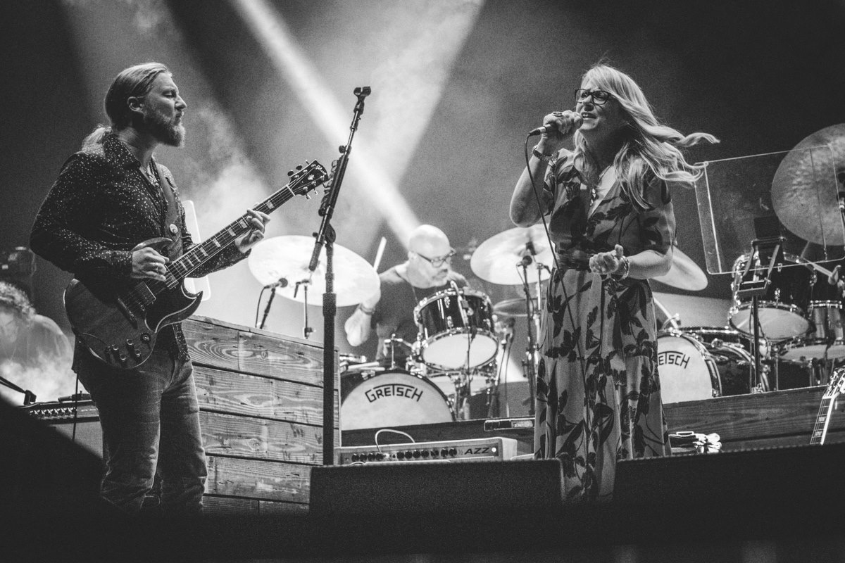
Credit: Gregg Greenwood

“Soulful rock that wears its roots-music bona fides on its sleeve performed by some of the genre’s most exceptional musicians." New York Times

“One of the best live bands on the road right now -- versatile, inventive, improvisatory and fearless.” Oakland Press

“…Nonstop excellence, virtuosity and musical community on all fronts.”
Chicago Blues Guide

JACKSONVILLE, FL (AUGUST 30, 2019) For a ninth consecutive year, Tedeschi Trucks Band continues their tradition of a multiple-night residency at New York City’s Beacon Theatre, with a half-dozen electrifying performances scheduled for September 27th and 28th, and October 1st, 2nd, 4th and 5th.
The band’s tenure at the iconic venue has encapsulated 30+ shows, drawing fans from all over the country, and remains as unique as the city that plays host. The multi-night stay offers the talented 12-member ensemble an opportunity to explore an especially large range of musical territory - often exceeding 100 different songs across the six nights. Guest sit-ins have also made the Beacon shows special, with surprise appearances in recent years by Norah Jones, Trey Anastasio, Nels Cline, Leon Russell and Ravi Coltrane, among others.

Celebrating their 10th year as a group, TTB is currently touring in support of their fourth studio album, Signs, released in February to widespread praise and nominated for an Americana Music Award; (Rolling Stone called it “electrifying,” the Associated Press dubbed it “an inspirational album for the times,” and NPR Music declared it an “instant classic.”) The collection is notable for much of its songwriting informed by the loss of loved ones and mentors such as Gregg Allman, Butch Trucks, Leon Russell and Col. Bruce Hampton; the latter to whom the record is dedicated.

The band recently wrapped their headlining cross-country “Wheels of Soul” summer tour with this year’s special guests Blackberry Smoke and Shovels & Rope. Additionally, the group undertook a pair of historic performances, including a Bethel, NY appearance on the 50th anniversary weekend of Woodstock, as well as re-creating Derek and the Dominos’ legendary album, Layla and Other Assorted Love Songs, with Trey Anastasio for their headlining stop at the Lockn’ Music Festival. (Video) With increased demand from an “incredibly dedicated fanbase hanging on each night's unique setlist” (Forbes), previous residencies in Boston, Chicago, Nashville, and Washington D.C. have sold-out.

Led by guitarist Derek Trucks’ stinging fretwork and Susan Tedeschi’s naturally stunning, emotive vocals and six-string talents, Tedeschi Trucks Band carries a distinguished reputation as one of the premier live bands performing today. The talented collective continues to expand musical boundaries in ways that only a rare caliber of musical collective can achieve, delivering commanding performances and exceptionally intuitive group chemistry. From uplifting soulful anthems to bittersweet ballads and driving rock and roll- all hallmarks of their can’t-miss-concert experiences- Tedeschi Trucks Band connects with a sound and a message that taps tradition while extending the edges of American music with a genre-defying conviction all their own.

TEDESCHI TRUCKS BAND - BEACON THEATRE 2019
Fri Sept 27 Two sets, no opener showtime 8pm
Sat Sept 28 Two sets, no opener showtime 8pm
Tue Oct. 1 With the Capitol Sun Rays (ft. Luther Dickinson, Amy Helm,
Birds of Chicago and Grahame Lesh) showtime 7:30pm
Wed Oct. 2 With John Moreland showtime 7:30pm
Fri Oct. 4 Two sets, no opener showtime 8pm
Sat Oct. 5 Two sets, no opener showtime 8pm
Tickets are priced at $49.50, $69.50, $89.50, $129.50 plus applicable fees. Tickets can be purchased online at Ticketmaster.com, BeaconTheatre.com and by calling 866.858.0008 and at the box office.
TEDESCHI TRUCKS BAND - 2019 TOUR DATES
9/20/19 Dallas, TX American Airlines Arena (Crossroads Festival)
9/21/19 Dallas, TX American Airlines Arena (Crossroads Festival)
9/27/19 New York, NY Beacon Theatre
9/28/19 New York, NY Beacon Theatre
10/1/19 New York, NY Beacon Theatre
10/2/19 New York, NY Beacon Theatre
10/4/19 New York, NY Beacon Theatre
10/5/19 New York, NY Beacon Theatre
11/6/19 Houston, TX Hobby Center for the Performing Arts
11/7/19 Dallas, TX Majestic Theatre
11/8/19 Dallas, TX Majestic Theatre
11/11/19 Cleveland, MS Bologna Performing Arts Center
11/12/19 Tulsa, OK Brady Theatre
11/14/19 San Antonio, TX Tobin Center for the Performing Arts
11/15/19 Austin, TX Bass Concert Hall
11/16/19 Little Rock, AR Robinson Center Music Hall
2/1/20 London, UK SSE Wembley Arena

VIDEO: “Shame” Jimmy Kimmel Live!
https://www.youtube.com/watch?v=F86QQ96P3E4
VIDEO: “I Never Loved A Man (The Way I Love You) – Live at Lockn’ 2018
https://www.youtube.com/watch?v=E3Bm0BnyP-Q

VIDEO: “Little Wing” TTB + Trey Anastasio – Live at Lockn’ 2019
https://www.youtube.com/watch?v=HO3YW4v9kaY

VISIT TEDESCHI TRUCKS BAND
Website
Facebook
Instagram
Twitter
YouTube

Press Contact:
Renee Pfefer On Tour PR 203-724-9919; Renee@ontourpr.com
High Res Jpegs: www.ontourpr.com/TTB

