For Immediate Release
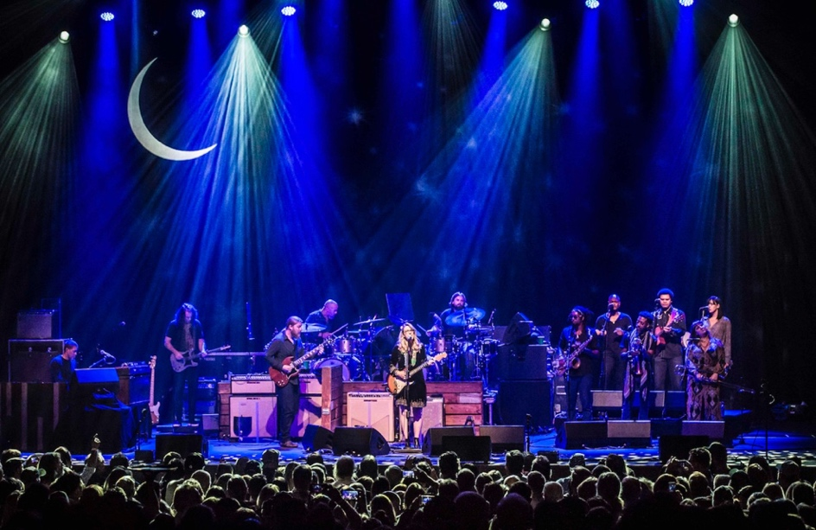

Tedeschi Trucks Band Announces "Wheels of Soul" 2018 Summer Tour
Fourth Annual Run Features Drive-By Truckers and The Marcus King Band
“Live From The Fox Oakland” Nominated for Grammy Award
JACKSONVILLE, FL – January 8, 2018 - Tedeschi Trucks Band is pleased to announce the fourth installment of their annual multi-band Wheels of Soul summer tour. Unrivaled in their blend of American soul, blues, rock and country, the 12-member Tedeschi Trucks Band, led by the husband and wife team of guitarist Derek Trucks and vocalist/guitarist Susan Tedeschi, offers a one-of-a-kind musical experience. This year, the Wheels of Soul tour will feature two highly acclaimed special guests Drive-By Truckers and opener The Marcus King Band. The five-week tour will kick off in the southeast in late June and wrap up with two nights at Red Rocks in Colorado July 28 and July 29. (See itinerary below)
Tickets will be available for fan pre-sale starting Tuesday, January 9, 2018 at 10am local time. The public on-sale for most cities is Friday, January 12, 2018. Visit www.tedeschitrucksband.com for further ticketing details.
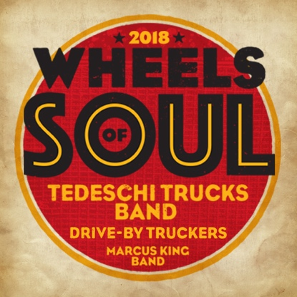
Growing larger and more successful each year, the Wheels of Soul tour has established itself as a unique and can’t miss concert experience. Hailed by audiences and critics as “a champion of the summer concert season” (Cincinnati.com) and “a musically pure and soulful night of music” (Atlanta Journal Constitution), the annual summer series is loved for its incredible musicianship, stage collaborations, and unpredictable set lists. During last summer’s tour - which brought Tedeschi Trucks Band together with The Wood Brothers and Hot Tuna - TTB performed more than 70 different songs and broke its own attendance records, selling out the majority of the dates. Previous Wheels of Soul bills have included Los Lobos/North Mississippi Allstars (2016) and Sharon Jones & The Dap-Kings/Doyle Bramhall II (2015).
(Continued)

Trucks and Tedeschi are looking forward to the unique southern flavor that Drive-By Truckers and
The Marcus King Band will bring to this year’s tour. “We all draw from some of the same roots,” says Trucks. “But we also share a different perspective than your typical southern rock bands do. I have a lot of respect and admiration for the Truckers’ songwriting. It’s an honest take on the world we live in.” In King, Trucks is reminded of his early days as a talented guitar player plugging away on the road. “It’s been fun getting to know Marcus and watching him develop. He sat in with us at the Beacon and it will be great to have a chance to collaborate more on stage over the summer”. Trucks and King also collaborated on The Marcus King Band’s self-titled 2016 release, for which Trucks recorded on “Self-Hatred.”
The excitement over hitting the road is mutual. “An amazing band and great folks. It’s going to be a blast,” says Patterson Hood from Drive-By Truckers. From King: "Two years ago I saw Doyle Bramhall II, Sharon Jones & The Dap-Kings and TTB in Charlotte, NC. I felt the electricity of the show through every part of me and said, we need to be part of this tour. It's a blessing to be part of the energy this year."
Now in their ninth year, Tedeschi Trucks Band carries a distinguished reputation as one of the premier live bands performing today. They are a "major force in American music" raved Austin American Statesman, with “unassailable musicianship across the board.” Embracing improvisation over convention, the genre-defying collective has seemingly endless potential to explore any musical territory - from their own catalog of Grammy Award-winning originals to Sly & the Family Stone, Miles Davis, George Jones, Joe Cocker, or Nina Simone. Trucks’ masterful guitar skills and Tedeschi’s soaring vocals and bluesy guitar shine but don’t overpower the breadth of talent on stage, a testament to the genuine respect within TTB’s ranks.
The band’s latest release, Live From The Fox Oakland debuted at #1 and #6 on Billboard’s Blues and Rock Album charts, respectively, and was just nominated for Best Contemporary Blues Album GRAMMY Award. “A scintillating performance that captured this world-class band at the top of their game.” (Popmatters) Tedeschi Trucks Band is currently working on material for their next studio album and fans can expect to hear them road testing some of the new tunes over the summer run. They recently warmed up the sound board to mix a live version of Neil Young’s “Alabama,” which they performed on the last leg of their fall tour and released as a single. Links: iTunes, Spotify, YouTube
Drive-By Truckers are a southern American rock band, hard edged and finely honed, all backed by sonic ambition and social conscience. Founded in 1996 by singer/songwriter/guitarists Mike Cooley and Patterson Hood, the band continues their outspoken craft with its critically-acclaimed American Band, the most provocative album in their extraordinary canon. They followed with a 7” live version of the track “What It Means” as well as a new song, “The Perilous Night,” which they have been playing live to the delight of fans around the country.

Having spent the last year playing ever-larger venues and festivals to a burgeoning fan base, The Marcus King Band performs a fiery brand of psychedelic soul, rock & roll from the South that led the Philadelphia Inquirer to proclaim, “Marcus King is about to become a Southern rock guitar superstar.” In 2017, the band released the Due North EP, the follow up to their 2016 self-titled LP that captured the energy of the band's amazing live show and the talent of a rising young singer songwriter reaching well beyond his years. The band made their network TV debut last year on CBS This Morning Saturday, and King made the cover of Guitar Player as one of "10 Young Players Spreading the Gospel of Kick-Ass Guitar.”

Tedeschi Trucks Band Itinerary - Wheels of Soul Summer Tour 2018
All dates with special guest Drive-By Truckers and opener The Marcus King Band
June 29 Soon to be announced
June 30 Tuscaloosa, AL * Tuscaloosa Amphitheater
July 1 Charleston, SC* Volvo Car Stadium
July 3 Saratoga, NY Saratoga Performing Arts Center
July 6 Hartford, CT The Xfinity Theatre
July 7 Gilford, NH Bank of NH Pavilion
July 8 Mansfield, MA Xfinity Center
July 10 Canandaigua, NY Constellation Brands – Marvin Sands PAC
July 11 Soon to be announced
July 13 Raleigh, NC Coastal Credit Union Music Park @ Walnut Creek
July 14 Soon to be announced
July 15 Charlotte, NC Charlotte Metro Credit Union Amphitheatre
July 17 Buffalo, NY Artpark
July 18 Burgettstown, PA* KeyBank Pavilion
July 20 Indianapolis, IN Farm Bureau Insurance Lawn @White River State Park
July 21 Detroit, MI Michigan Lottery Amphiteatre @ Freedom Hill
July 22 Cincinnati, OH PNC Pavilion @ Riverbend Music Center
July 26 St. Louis, MO* Fox Theatre
July 28 & 29 Morrison, CO Red Rocks Amphitheatre
(*) – new markets for 2018

VIDEO LINKS:
Tedeschi Trucks Band - "Keep On Growing" - Live From The Fox Oakland
https://www.youtube.com/watch?v=h0kXfPrHHcw

Tedeschi Trucks Band - “Let Me Get By” – Live From The Fox Oakland
https://www.youtube.com/watch?v=um9TmblAcnw
Drive-By Truckers - “The Perilous Night”
https://www.youtube.com/watch?v=Luoe-6ok_TE

The Marcus King Band - "Ain't Nothin' Wrong With That"
https://www.youtube.com/watch?v=cfIc-20zOX0

Tedeschi Trucks Band online:
Website * Facebook * Twitter * Instagram
HIGH RES JPEGS available for download here: www.ontourpr.com/TTB
For additional press information, please contact: Renee Pfefer, On Tour PR
O) 203.724.9919 C) 914.806.2834 Renee@ontourpr.com

