Tedeschi Trucks Band Set To Embark On Another Impressive Year of Touring

A Bonnaroo debut, cross country North American dates, and multiple trips abroad provide an ambitious schedule for the Grammy-winning group

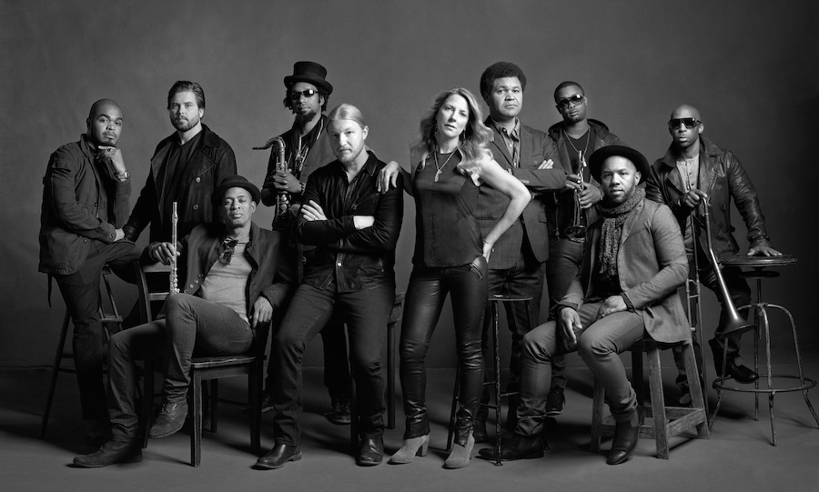

March 6, 2014 -- Tedeschi Trucks Band, coming off of a year in which the 11-piece juggernaut led by husband/wife duo Derek Trucks and Susan Tedeschi released a chart-topping third album, welcomed a new bassist, and played headline slots across the globe, is quickly filling its calendar for 2014. Peppered with highlights, TTB’s docket includes a return to the Wanee Music Festival in April, a three-night engagement in May at the newly-minted Brooklyn Bowl Las Vegas, a first-time stop at Bonnaroo in June, a July headlining appearance at Colorado’s famed Red Rocks Amphitheatre following last year’s sell-out, and another installment of its annual residency at New York City’s Beacon Theatre for four nights in September. Having performed last fall at London’s Royal Albert Hall, the band is also looking forward to a return visit to the continent, with two European tours this spring and summer as well.

With Trucks recently announcing his impending departure from The Allman Brothers Band at year’s end, it’s evident the renowned guitarist has made TTB his top priority. Owing to a line-up of incredible talent now solidified by the addition of full-time bassist Tim Lefebvre, the group has widened its diverse fanbase even more with an early winter return tour to Japan, an inaugural trip to India, and Super Bowl-weekend appearances in New York City on CBS This Morning as well as at John Varvatos' intimate performance space at the former site of CBGB’s. Coupled with the chart success of 2013’s studio set Made Up Mind, landing at #11 on Billboard's Top 200 Album chart, #1 Blues and #2 Rock charts, its repertoire of blues-soaked, roots rock neo-classics add to an ever-evolving setlist that bolsters Tedeschi Trucks Band’s growing reputation as a can’t-miss concert experience.
Just four years since its inception, Tedeschi Trucks Band has already released three critically-acclaimed and commercially successful albums. Its debut, Revelator, produced at the couple’s Swamp Raga home studio, earned a Grammy, while 2011's dynamic live follow-up, Everybody’s Talkin’, delivered a brilliant double-disc classic capturing the band’s incendiary musicianship on stage. Reconvening at Swamp Raga, the band followed up with 2013’s Made Up Mind, hailed by Rolling Stone as “equal parts Stax and Muscle Shoals without dilution of either."
Prior to forming TTB, Trucks, as one of the most respected guitarists of his generation, maintained a membership since 1999 with The Allman Brothers Band, toured with Eric Clapton and Carlos Santana, and, for over 15 years, helmed the Grammy-winning Derek Trucks Band. Additionally as the youngest musician to make the list, the slide guitar wunderkind was voted #16 of the top 100 Guitarists of All Time (Rolling Stone - November 2011) by a panel of fellow musicians and industry experts. Joining him at center stage is Massachusetts native Susan Tedeschi, a singer blessed with a voice that ranges from commanding R&B belters to gentle ballads that has led a prolific solo career full of award-winning records, six Grammy nominations, and a devoted following. A talented guitarist in her own right, her style alternately recalls post-war electric blues and Hendrix-inspired rock.
Easily capable of shining as individuals, this ensemble of 11 is concerned more with the sound than the spotlight. Sharing a level of respect and camaraderie rarely found in rock and roll, Tedeschi Trucks Band has found a magical combination that delivers nightly an unforgettable evening of music, one the Boston Herald says, “booms like a soul thunderclap.” With a slew of high-profile and headlining appearances on tap, Tedeschi Trucks Band is poised for another remarkable year on the road.
Tedeschi Trucks Band is Derek Trucks (Guitar), Susan Tedeschi (Guitar, Vocals), Kofi Burbridge (Keyboards, Flute), Tyler Greenwell (Drums), J.J. Johnson (Drums), Mike Mattison (Vocals), Mark Rivers (Vocals), Kebbi Williams (Saxophone), Maurice Brown (Trumpet), Saunders Sermons (Trombone, Vocals), Tim Lefebvre (Bass).

Jan/Feb 2014 Feb 2014 Rolling Stone INDIA

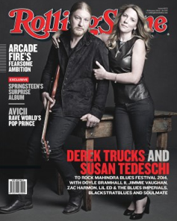
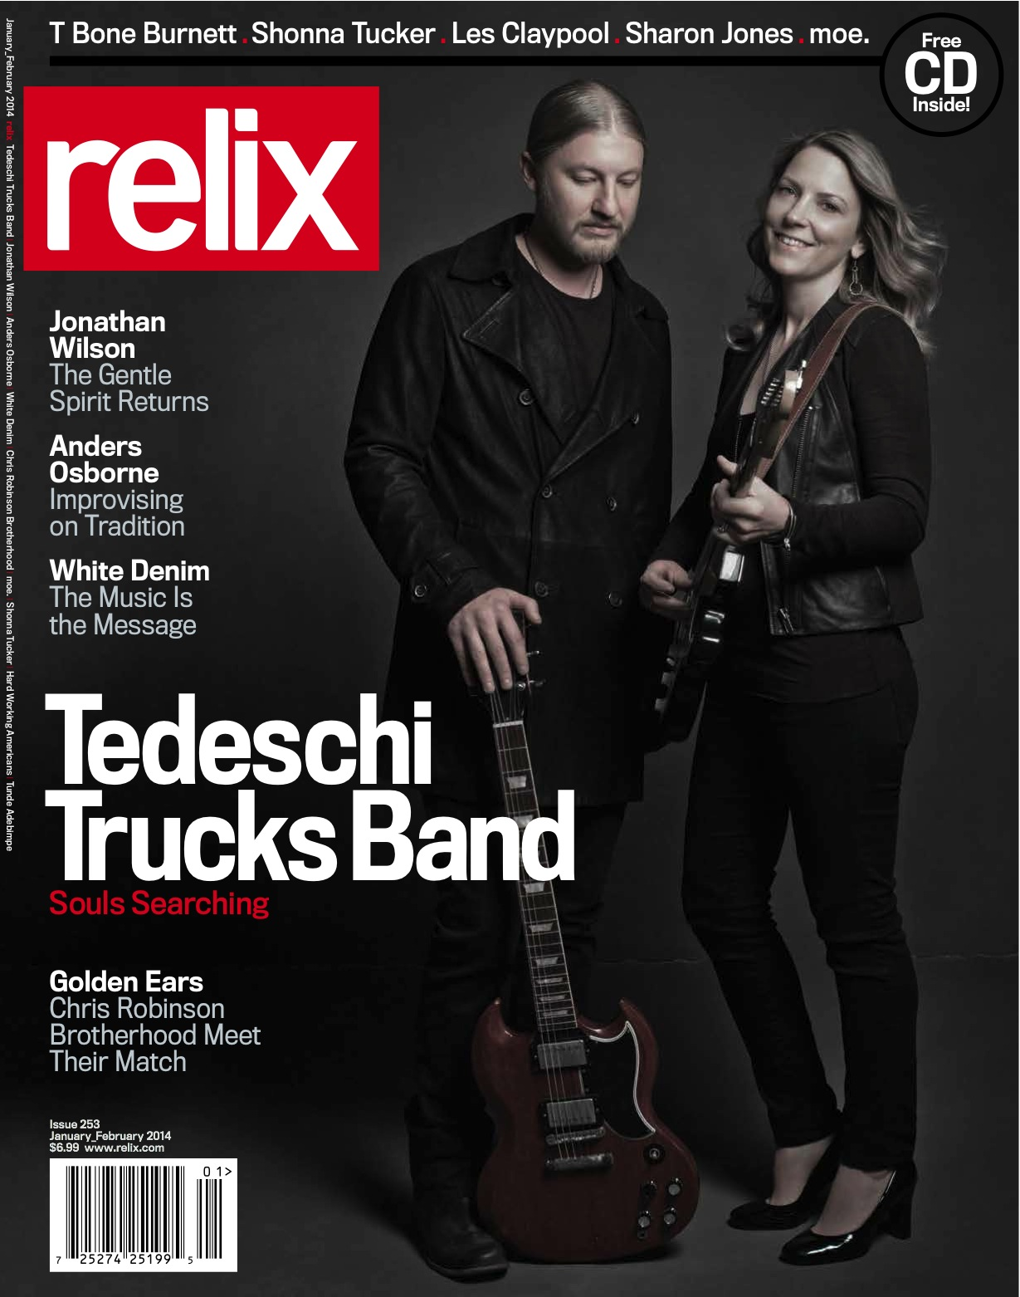

WATCH “Made Up Mind” on CONAN
http://m.youtube.com/watch?v=Kjha9ffO-G8

WATCH “Part of Me” (acoustic)
http://m.youtube.com/watch?v=QnO6Dxi2qtQ

ITINERARY
4/2 Harrisburg, PA The Forum
4/3 Collingswood, NJ Scottish Rite Auditorium - sold out
4/4 Collingswood, NJ Scottish Rite Auditorium - sold out
4/10 Athens, GA Classic Center
4/11 Live Oak, FL Wanee Music Festival
4/23 Cologne, DE E-Werk
4/25 Munich, DE TonHalle
4/26 Berlin, DE Huxleys Neu Welt
4/28 Paris, FR Olympia
4/30 Brussels, BEL Ancienne Belgique
5/2 Ospel, NL Moulin Blues Festival
5/3 Groningen, NL De Oosterpoort
5/29 Las Vegas, NV Brooklyn Bowl Las Vegas
5/30 Las Vegas, NV Brooklyn Bowl Las Vegas
5/31 Las Vegas, NV Brooklyn Bowl Las Vegas
6/7 Hunter, NY Mountain Jam
6/10 New Bedford, MA Zeiterion Performing Arts Center
6/11 Aston, PA Sun Center
6/12-15 Manchester, TN Bonnaroo
6/20 Chicago, IL FirstMerit Bank Pavilion (with Widespread Panic)
7/7 Lucca, IT Piazza Napoleone (with Jeff Beck & Robben Ford)
7/11 Rotterdam, NL North Sea Jazz
7/12 Frankfurt, DE Capitol Offenbach
7/14 Stuttgart, DE Jazz Open (with Jimmie Vaughan)
7/15 Hamburg, DE Stadtpark (with Jeff Beck)
7/25 Morrison, CO Red Rocks Amphitheatre w/ Gary Clark Jr.
8/15 Scranton, PA Peach Music Festival
9/13 Danville, IL Phases of the Moon Music &Art Festival
9/19 New York, NY Beacon Theatre w/ Valerie June
9/20 New York, NY Beacon Theatre w/ Hard Working Americans
9/26 New York, NY Beacon Theatre w/ Shakey Graves
9/27 New York, NY Beacon Theatre w/ Pedrito Martinez
11/1 Los Angeles, CA Greek Theatre w/ Gary Clark Jr.

http://www.tedeschitrucksband.com.
https://www.facebook.com/DerekAndSusan
https://twitter.com/DerekAndSusan
http://www.youtube.com/user/tedeschitrucksvevo

For additional press information, please contact
Renee Pfefer, On Tour PR
914-273-0007; Renee@ontourpr.com

