MEDIA ALERT
Grammy-Winning Tedeschi Trucks Band Launches Extensive Fall Tour
3rd Annual Sunshine Music & Blues Festival Confirmed for January

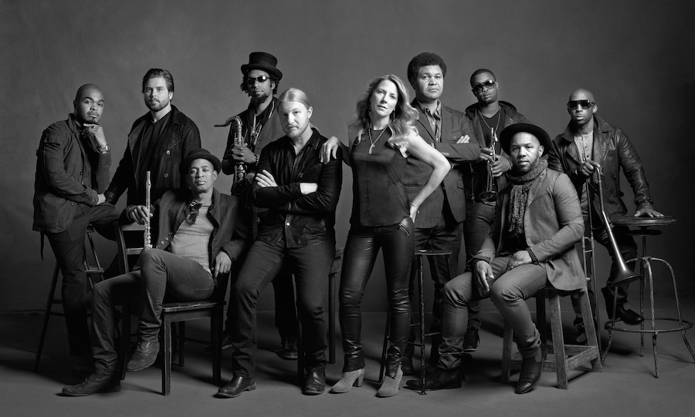

(October 16, 2014) With guitar great Derek Trucks’ impending departure from The Allman Brothers Band at month’s end, Tedeschi Trucks Band, the 11-piece tour de force he leads with wife Susan Tedeschi, has positioned itself as the vanguard of modern blues rock. The Grammy-winning group continues to play headline slots across the globe supporting its chart-topping third album Made Up Mind.

Closing out 2014 with a Western U.S. run of shows and a slew of Northeast dates, including multi-night stops in Philadelphia and Boston, Tedeschi Trucks Band will cap off another year of remarkable performances and accolades during which the group spent part of 2014 criss-crossing the globe, from Europe to the Far East. Tedeschi Trucks Band’s domestic slate was equally as active, featuring headline slots, festival appearances, and a fourth consecutive residency at New York City’s Beacon Theatre, leaving audiences with unforgettable concert memories, welcoming special guests and incorporating an acoustic mini-set, as well as continuing to garner the genre’s highest honors.
Always eager to share the stage, during its annual return to Beacon Theatre for four nights in September, TTB played musical host to a multitude of special guests. From dobro master Jerry Douglas, Taj Mahal, Jaimoe, Jimmy Herring, and Duane Trucks to Jackie Greene, Eric Krasno, Alecia Chakour, and the Shady Horns, TTB once again left out the welcome mat, joining up with honored friends to deliver instantly classic performances that have now become synonymous with the group. Echoing the mid-set, acoustic segment the band debuted at the Lockn’ Music Festival, once again the group ‘unplugged’ during each of the evenings at the Beacon.
This summer saw the group blazing new trails with a stop at Bonnaroo for a first-time mainstage performance as well the coveted Friday SuperJam set at Midnight, led by Derek and featured Susan and other members of TTB along with an amazing lineup of guests including Chaka Khan, David Hidalgo, Ben Folds, Taj Mahal and Eric Krasno. Check out ESQUIRE's inside look. Headlining Red Rocks and performances at festivals such as Outside Lands, Wanee, Lockn’, and the Peach Fest, as well as several during a July visit to Europe, its second trip to the Continent this year, were particular highpoints following a busy winter and spring in which the band made a return trip to Japan, an inaugural trip to India, and Super Bowl-weekend appearances in New York City on CBS This Morning as well as at John Varvatos' intimate performance space at the former site of CBGB’s. Tedeschi Trucks Band’s mantel got a little more crowded, as well, with three 2014 Blues Music awards for Best Band, Best Rock Blues Album for Made Up Mind, and Best Contemporary Blues Female Artist, which went to Susan Tedeschi. This marks the third consecutive year Tedeschi Trucks Band took home Best Band honors.
Looking ahead to 2015, Tedeschi Trucks Band are thrilled to again present its own music festival - The Sunshine Music & Blues Festival. Now in its third year, the two- city event takes place in their home state of Florida and features a family friendly full day/evening of music featuring a hand picked selection of great artists. For a full line up visit http://www.sunshinemusicandblues.com/
Just four years since its inception, Tedeschi Trucks Band has already released three critically-acclaimed and commercially successful albums. Its debut, Revelator, produced at the couple’s Swamp Raga home studio, earned a Grammy, while 2011's dynamic live follow-up, Everybody’s Talkin’, delivered a brilliant double-disc classic capturing the band’s incendiary musicianship on stage. The band followed up with 2013’s Made Up Mind which landed #11 on Billboard's Top 200 Album chart, #1 Blues and #2 Rock charts. Hailed by Rolling Stone as “equal parts Stax and Muscle Shoals without dilution of either, Made Up Mind's repertoire of blues-soaked, roots rock neo-classics add to an ever-evolving setlist that bolsters Tedeschi Trucks Band’s growing reputation as a can’t-miss concert experience.
Prior to forming TTB, Trucks, as one of the most respected guitarists of his generation, maintained a membership since 1999 with The Allman Brothers Band, toured with Eric Clapton and Carlos Santana, and, for over 15 years, helmed the Grammy-winning Derek Trucks Band. Additionally as the youngest musician to make the list, the slide guitar wunderkind was voted #16 of the top 100 Guitarists of All Time (Rolling Stone - November 2011) by a panel of fellow musicians and industry experts. Joining him at center stage is Massachusetts native Susan Tedeschi, a singer that has led a prolific solo career full of award-winning records, six Grammy nominations, and a devoted following.
Tedeschi Trucks Band has found a magical combination that delivers nightly an unforgettable evening of music, a chemistry called “spellbinding” by the Tennessean with “impeccable musical instincts, rising to the occasion when it was called for, but also displaying a healthy regard for a softer dynamic,” reported Ottawa Citizen. The Syracuse Herald Journal concluded, “Trucks played the lightning to Tedeschi's thunder, accenting her soulful voice and bluesy guitar with his furious six-string. Its a partnership unparalleled in rock 'n roll, and one that makes the Tedeschi Trucks Band a group that will go down in history as one of the great rock groups of this generation.”
Tedeschi Trucks Band is Derek Trucks (Guitar), Susan Tedeschi (Guitar, Vocals), Kofi Burbridge (Keyboards, Flute), Tyler Greenwell (Drums), J.J. Johnson (Drums), Mike Mattison (Vocals), Mark Rivers (Vocals), Kebbi Williams (Saxophone), Maurice Brown (Trumpet), Saunders Sermons (Trombone, Vocals), Tim Lefebvre (Bass).
WATCH “Made Up Mind” on CONAN
http://teamcoco.com/video/tedeschi-trucks-band-10-21-2013

WATCH “Part of Me” (acoustic)
http://m.youtube.com/watch?v=QnO6Dxi2qtQ

Itinerary
10/30 Santa Barbara, CA Arlington Theater
10/31 San Diego, CA Balboa Theatre
11/1 Los Angeles, CA Greek Theatre w/ Gary Clark Jr.
11/3 Arcata, CA Van Duzer Theatre
11/4 San Jose, CA City National Civic
11/5 Santa Rosa, CA Wells Fargo Center
11/7 Portland, OR Arlene Schnitzer Concert Hall
11/8 Spokane, WA INB PAC
11/12 Austin, TX ACL Live at Moody Theatre
11/13 Houston, TX Bayou Music Center
11/15 Dallas, TX Majestic
12/4 Philadelphia, PA Keswick Theatre w/ Pedrito Martinez
12/5 Philadelphia, PA Keswick Theatre w/ Amy Ray
12/6 Philadelphia, PA Keswick Theatre w/ Alan Evans’ Playonbrother
12/8 Red Bank, NJ Count Basie
12/9 State College, PA Bryce Jordan Center
12/11 Richmond, VA Carpenter Center
12/12 Boston, MA House of Blues
12/13 Boston, MA House of Blues
1/16 Jacksonville, FL Florida Theatre
1/17 St. Petersburg, FL Sunshine Blues Festival - Vinoy Park
1/18 Boca Raton, FL Sunshine Blues Festival - Mizner Park Amphitheatre
For additional press information, please contact
Renee Pfefer, On Tour PR
203-724-9919; Renee@ontourpr.com

High Res Jpegs available for download from here:
http://www.ontourpr.com/2013/09/03/tedeschi-trucks-band/

http://www.tedeschitrucksband.com
https://www.facebook.com/DerekAndSusan
https://twitter.com/DerekAndSusan

