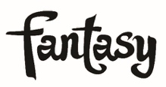

TEDESCHI TRUCKS BAND’s HIGH & MIGHTY 4-SONG EP AVAILABLE DIGITALLY BEGINNING SEPT 27th; PRE-ORDER HERE

WATCH THE “HIGH & MIGHTY” PERFORMANCE CLIP HERE

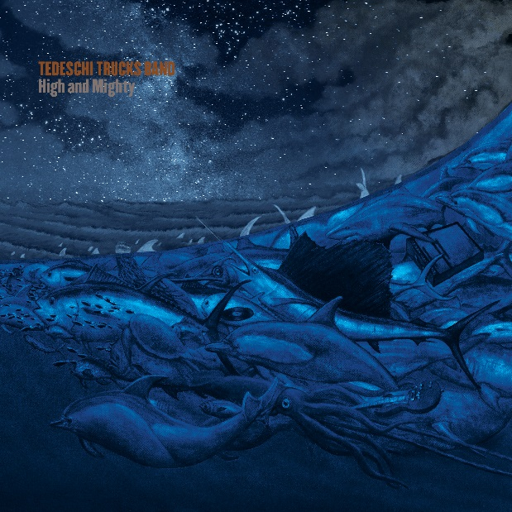

TTB READIES FALL TOUR INCLUDING 6-SHOW RUN AT NYC’S BEACON THEATRE SEPT 27 – OCT 5

FOR IMMEDIATE RELEASE – September 13, 2019 – Tedeschi Trucks Band has announced the September 27th digital release of their 4-song High & Mighty EP, which previously was available only as a Record Store Day special edition 12” vinyl. Pre-order the EP HERE. Fans can get an early listen to the dynamic title track and accompanying video HERE. The live performance clip captures behind-the-scenes footage during the band’s 3-night run at the Tokyo Dome City Hall on their Signs 2019 world tour this past spring.

The High & Mighty EP contains three tracks from the Signs recording sessions that did not appear on the album, along with an inspired live version of one of Signs’ standout songs, “Shame”, that was recorded at the Chicago Theater in January, 2018. Previously unreleased tracks include two new original songs: “High & Mighty” written by Derek Trucks and longtime collaborator Doyle Bramhall II, and the unique waltz-tempoed “All You Can Do” from TTB’s own talented songwriter, Mike Mattison. Also previously unreleased is the band’s take on Scott Boyer’s beautiful ballad “All My Friends”, which Gregg Allman recorded and released on his 1973 debut solo album, Laid Back. The loss of Allman, as well as TTB mentors Butch Trucks, Colonel Bruce Hampton, Leon Russell and Boyer himself, influenced much of the band’s songwriting during the recording of Signs and inspired the band to cover “All My Friends” in their memory.

Pre-order the High & Mighty EP HERE
Watch the “High & Mighty” official music video HERE

Later this month the band will kick off their ninth annual multi-night residency at NYC’s iconic Beacon Theatre with six performances scheduled for September 27th and 28th, and October 1st, 2nd, 4th and 5th. A highly anticipated New York tradition, the band’s tenure at the Beacon has now encapsulated 30+ shows, drawing fans from all over the country. The multi-night stay offers the talented 12-member group an opportunity to explore an especially large range of musical territory - often exceeding 100 different songs across the six nights. Guest sit-ins have also made the Beacon residencies special, with surprise appearances by Norah Jones, Trey Anastasio, Nels Cline and Ravi Coltrane among others.

Now ten years in, Tedeschi Trucks Band has solidified their reputation as one of the premier live bands on tour today. With increased demand from an “incredibly dedicated fanbase hanging on each night's unique setlist” (Forbes), multi-night, sold-out residencies in Boston, Chicago, Nashville and Washington D.C. in addition to New York City have become a staple of the band’s heavy touring schedule. The band recently wrapped their fifth “Wheels of Soul” tour - with this year’s special guests Blackberry Smoke and Shovels & Rope. The cross-country summer amphitheater tour was followed by a pair of historic performances in Bethel, NY on the 50th anniversary weekend of Woodstock, and at the Lockn’ Music Festival where as headliners they performed Derek and the Dominos’ legendary album, Layla and Other Assorted Love Songs, with Trey Anastasio.

After the fall Beacon shows, TTB’s Signs 2019 tour continues with a November run that includes several dates Texas and annual end-of-year series in Boston. Also, greater demand for the band in the UK and Europe will be temporarily satisfied with a one-night only performance at SEE Wembley Arena in London on Feb 1, 2020.

Tedeschi Trucks Band’s Signs – the band’s fourth studio album - was released this February via Fantasy Records to widespread praise. Rolling Stone called it “electrifying,” the Associated Press dubbed it “an inspirational album for the times,” and NPR Music declared the album an “instant classic,” saying, “honesty and authenticity...informs every second of Signs."

High & Mighty EP Track List:
- All My Friends
- High & Mighty
- All You Can Do
- Shame (live)

TEDESCHI TRUCKS BAND 2019 TOUR DATES:
9/20-21/19 – Dallas, TX – American Airlines Arena (Crossroads Festival)
9/27/19 – New York, NY – Beacon Theatre Sold Out
9/28/19 – New York, NY – Beacon Theatre Sold Out
10/1/19 – New York, NY – Beacon Theatre
10/2/19 – New York, NY – Beacon Theatre
10/4/19 – New York, NY – Beacon Theatre Sold Out
10/5/19 – New York, NY – Beacon Theatre Sold Out
11/6/19 – Houston, TX – Hobby Center for the Performing Arts
11/7/19 – Dallas, TX – Majestic Theatre
11/8/19 – Dallas, TX – Majestic Theatre Sold Out
11/11/10 – Cleveland, MS – Bologna Performing Arts Center
11/12/19 – Tulsa, OK – Brady Theatre
11/14/19 – San Antonio, TX – Tobin Center for the Performing Arts
11/15/19 – Austin, TX – Bass Concert Hall
11/16/19 – Little Rock, AR – Robinson Center Music Hall
12/5/19 – Boston, MA – Orpheum Theatre
12/6/19 – Boston, MA – Orpheum Theatre
12/7/19 – Boston, MA – Orpheum Theatre
2/1/20 – London, UK – SSE Wembley Arena

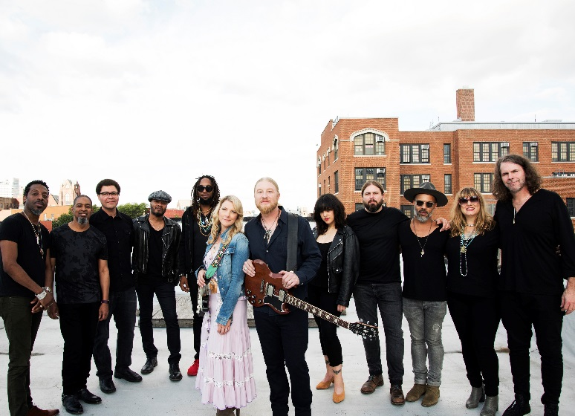
Photo Credit: Shervin Lainez

MORE INFO ON TEDESCHI TRUCKS BAND
Website Facebook Instagram Twitter YouTube

Fantasy Records

CONTACT INFO
Joel Amsterdam / Fantasy Records / joel@fantasyrecordings.com
Lauren Covey / Fantasy Records / lauren@fantasyrecordings.com
Renee Pfefer / On Tour PR / Renee@ontourpr.com

