*****MEDIA ALERT*****

ICYMI:
TEDESCHI TRUCKS BAND AND TREY ANASTASIO PERFORMED
ENTIRETY OF LAYLA AND OTHER ASSORTED LOVE SONGS
AT LOCKN' THIS PAST WEEKEND

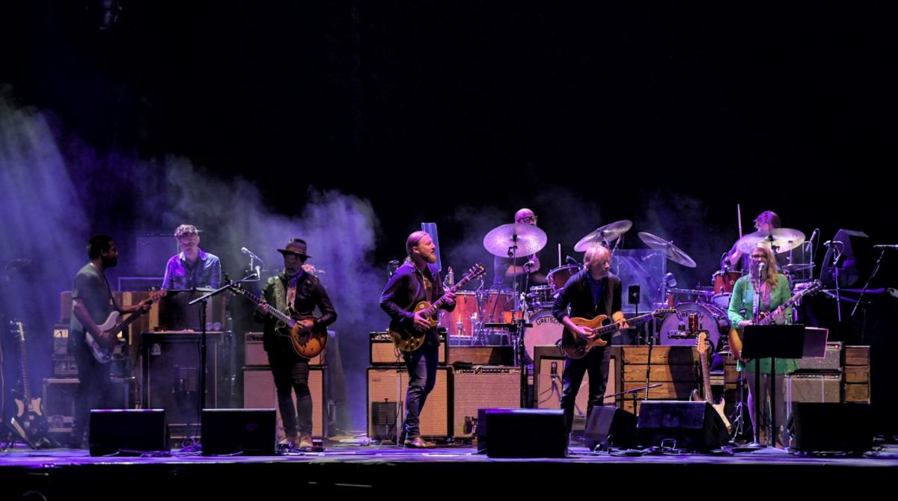
photo credit: Dave Vann

ARRINGTON, VA - August 26, 2019 The highly anticipated Saturday night collaboration between Trey Anastasio and Tedeschi Trucks Band at LOCKN' delivered a stunning surprise for fans. Kept a secret until the band took the stage, they performed the Derek and the Dominos' album Layla and Other Assorted Love Songs (ranked #117 on Rolling Stone's top 500 albums of all time) from beginning to end. The set also featured longtime Eric Clapton band guitarist Doyle Bramhall II. The band exited the stage following their powerful performance of the song "Layla" while the album closer, "Thorn Tree in the Garden," played over the PA system.

The legendary album was released on the day Tedeschi was born and even inspired Trucks' parents to name him Derek. Trucks also broke out his 1957 Les Paul Goldtop for "Why Does Love Got To Be So Sad" and "Have You Ever Loved a Woman?" This guitar is one serial number digit different from the one Duane Allman used on the original album recording.

WATCH "LITTLE WING" FROM LOCKN’

The mainstage performance Saturday night was the second of two collaborations between Trucks and Anastasio at LOCKN' this weekend. Friday night featured Trucks joining Trey Anastasio Band (TAB) during the second set of their headlining appearance, which also featured Susan Tedeschi on vocals for two songs, including a stirring rendition of the Anastasio original, "A Life Beyond the Dream," which he debuted this past spring on the Ghosts of the Forest tour.
WATCH "A LIFE BEYOND THE DREAM" FROM LOCKN’

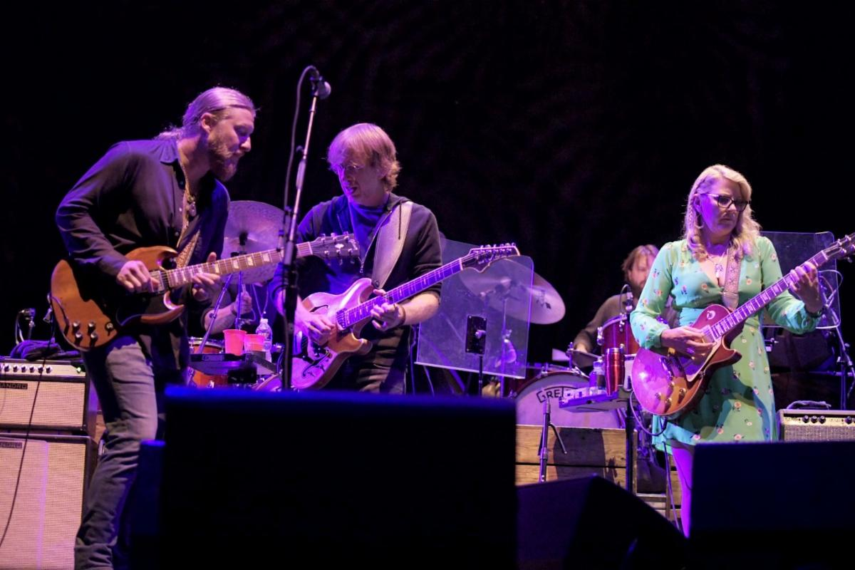
photo credit: Dave Vann

And to wrap up the weekend, in a pre-announced set, Susan Tedeschi sat in with Bob Weir on Sunday evening for six songs including, "Don't Think Twice, Its Alright," "Angel From Montgomery," and "Lovelight."
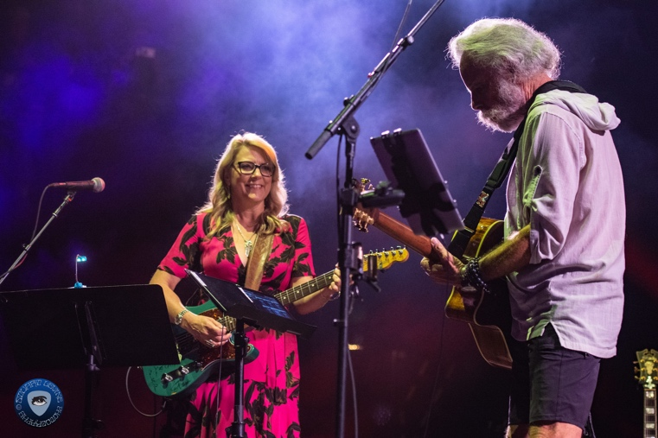
photo credit: Stuart Levine

# # #
Press contact:
Renee Pfefer, On Tour PR 914-806-2834 Renee@ontourpr.com

