For Immediate Release Embargo until April 20, 2021 – 10am ET

TEDESCHI TRUCKS ANNOUNCE FIRESIDE LIVE
UPCOMING JUNE-JULY DATES FEATURE UNIQUE LINEUPS WITH MEMBERS OF TEDESCHI TRUCKS BAND
WILL ALSO REBROADCAST FIRESIDE SESSIONS
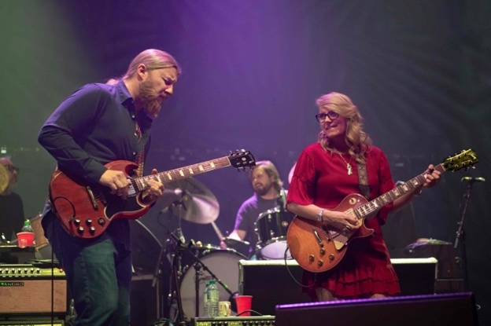
Photo credit: Stuart Levine

APRIL 20, 2021 - Derek Trucks and Susan Tedeschi announce Fireside LIVE - a special series of socially distanced, limited-capacity performances this summer. They will be joined by varying members of Tedeschi Trucks Band each night with the total band configuration ranging between four and seven musicians depending on the show. The modified lineup will perform under the name ‘Tedeschi Trucks’ for the first time as a nod to their band members who are unable to join the tour because of the challenging conditions with the current pandemic.

Fireside LIVE was inspired by their very successful at-home online performance series from earlier this year, the Fireside Sessions. The shows will be the first fully live public performances for the ensemble since February 2020, and come on the heels of the recent postponement of their annual summer Wheels of Soul Tour to next year (2022). Venues will include a mix of small or reduced-capacity outdoor amphitheaters, drive-ins and pod set-ups, all of which are covid-19 compliant and taking precautions to ensure the safety of fans, staff, band and crew.

Fireside LIVE will kick off in Jacksonville, FL with a two-night run on June 11/12 then hit cities across the south and northeast through the months of June and July. Tickets for all shows, except Red Rocks, will go on sale to the general public Friday, April 23 at 10am ET.
“We're really looking forward to getting on the road and seeing everybody's beautiful faces," said Susan. "Getting together earlier this year to record the Fireside Sessions was really re-energizing, and we are excited to play live in front of fans again. As much as we love performing as the full Tedeschi Trucks Band, current conditions just don’t allow for us to do that.”

The decision as to which members will join for each show will be decided week to week, depending on local conditions at the time.

Fireside LIVE brings to the stage the same intimate window into the band's creative chemistry that was on display during the Fireside Sessions, which streamed back in Feb-March on nugs.net. Packed with deep cuts, reimagined songs, and several premieres of rare covers and new original songs that the band has been working on during the break, the six-episode streaming series was enthusiastically received for delivering something new and unique each week.

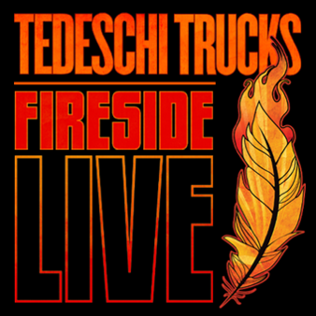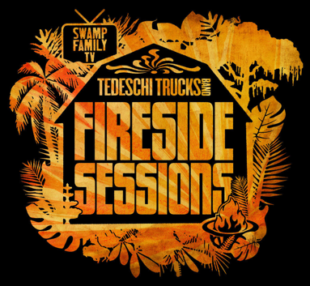

For fans who missed the original broadcasts or want to watch it again, TTB and nugs.net will offer a rebroadcast of all six Fireside Sessions. Fans who originally purchased the 6-episode bundle will be able to view the shows for free. Details on the broadcasting schedule for the encore presentation of the Fireside Sessions will be announced shortly.

FIRESIDE LIVE 2021 ITINERARY
June 11-12 Jacksonville, FL Daily’s Place Amphitheater
June 18 Huntsville, AL Von Braun Center
June 19-20 Murfreesboro, TN Hop Springs Brew Park
June 24-25 N. Charleston, SC The Bend
June 26 Cayce, SC Columbia Speedway Entertainment Center
July 1, 2, 3 Frederick, MD Showtime at the Drive-In
July 9, 10, 11 Lafayette, NY Apple Valley Park
July 16 Gilford, NH Bank of New Hampshire Pavilion
July 18 Elmer, NJ Appel Farm Arts & Music Center
July 20-21 Eatontown, NJ Concerts on the Green
July 30-31 Morrison, CO Red Rocks ON SALE TBA *
More dates to be announced

* These dates will now be 'Fireside Live' shows with a separate ticket sale and with priority access to people who bought tickets for the 2021 ‘Wheels of Soul’ shows at Red Rocks. We are working closely with Red Rocks to confirm ticketing details and will announce further information when finalized. (The 2021 'Wheels of Soul' shows have been postponed to July 29, 30, 2022 and tickets for the 2021 WOS shows will be honored for 2022).

Visit Tedeschi Trucks Band online at TedeschiTrucksBand.com and @DerekAndSusan
Media Contact: Renee Pfefer, On Tour PR Renee@ontourpr.com
Office: 203-724-9919 cell: 914-806-2834 High Res JPEGs available here: www.ontourpr.com/TTB

