For Immediate Release

Tedeschi Trucks Band Kicks Off SummerStage
Season in Central Park on May 18

Summer Highlights also include 30 City Amphitheatre tour with Sharon Jones & Dap-Kings and New Orleans Jazz & Heritage Festival

"A deeply skilled groove machine" - Los Angeles Times

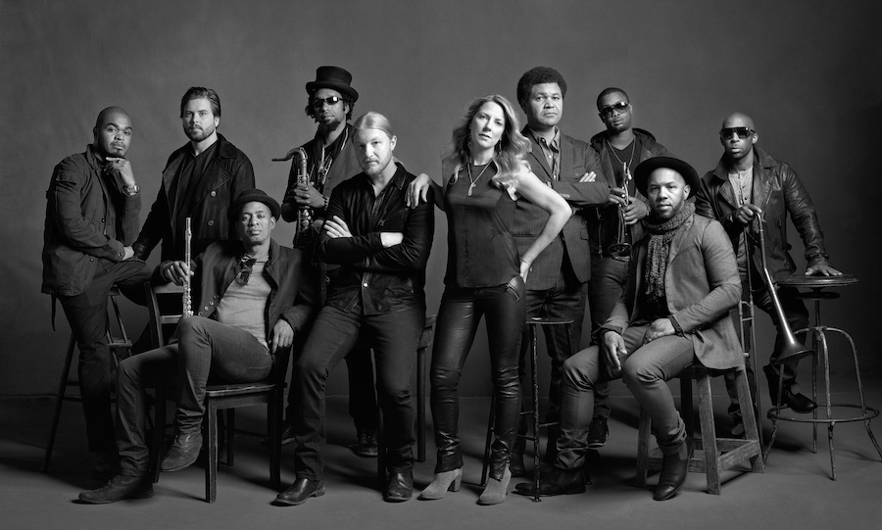

New York, NY April 8, 2015 – Tedeschi Trucks Band, the Grammy winning blues rock dynamo, today announced the group will perform in Central Park on May 18. This free concert marks the opening of SummerStage’s 30th Anniversary season, New York City's largest free performing arts festival.

From headlining festivals to multi-night residencies, the 11-piece powerhouse led by Susan Tedeschi and Derek Trucks has captured the admiration of both concert audiences and critics worldwide. With guitarist Derek Trucks’ 15 year tenure with The Allman Brothers Band wrapped up, the band has fully dedicated itself to expanding its legendary live performances with an increasing repertoire of soulful neo-classics as well as new material the band has been working on for their next album.

The SummerStage announcement adds to the band’s growing reputation of delivering countless memorable performances in New York City - where the group has performed multiple-night residencies each fall at the Beacon Theatre for the past four years.

After launching 2015 with their own annual Sunshine Music Festivals in Florida, two sold out nights at Nashville’s storied Ryman Auditorium, and a performance by Derek and Susan at February’s high-profile MusicCares concert honoring Bob Dylan, TTB is looking forward to an inaugural mainstage appearance at the New Orleans Jazz & Heritage Festival in April and a 30-city cross country amphitheatre tour with soul hipsters Sharon Jones & the Dap-Kings that kicks off in June. November will find the band back in Europe, including a headlining set at the London Blues Festival, plus stops in France, Germany, Holland and Denmark.

In 2014 Tedeschi Trucks Band crossed the globe with two tours of Europe, a return to Japan, and a maiden visit to India. Equally as active was the group’s domestic slate, its peak moments including a first-time mainstage performance at Bonnaroo as well as the coveted Midnight SuperJam set, led by Derek and featuring an amazing lineup of guests including Chaka Khan, David Hidalgo, Ben Folds and Taj Mahal. During its fourth consecutive residency at NYC’s Beacon Theatre, TTB played musical host to a multitude of special guests over four nights in September welcoming visits from dobro master Jerry Douglas, Eric Krasno, and blues legend Taj Mahal to Jaimoe, Jimmy Herring, and Jackie Greene. At year’s end, the band’s multiple-night runs in Philadelphia and Boston played to sold-out, SRO audiences, as well.

2014 also found Derek and Susan making contributions in the studio guesting on a pair of Grammy-winning releases. Tedeschi lent her vocal talents to "Gibsom Street" on Billy Childs’ Map to the Treasure: Reimagining Laura Nyro (2014), while Trucks’ slide guitar adorned Rosanne Cash’s “World of Strange Design” from her The River & The Thread album.

Formed in 2010 with a spirit of adventure that saw Susan Tedeschi and Derek Trucks shelve their equally successful solo careers, Tedeschi Trucks Band – who was recently profiled on CBS This Morning with Anthony Mason - debuted big with its Grammy Award-winning Revelator, 2012’s dynamic live follow up, Everybody’s Talkin’, and most recently 2013’s Made Up Mind bolstering the Jacksonville-based group’s growing reputation as the preeminent blues-rock leader. Driven by Trucks, #16 of the top 100 Guitarists of All Time (Rolling Stone), and Tedeschi, blessed with a voice that passionately delivers a range of powerful R&B belters to gentle ballads, the group enlists two drummers, two vocalists, a three-piece horn section, bass, and a multi-instrumentalist keyboard player for what is a greater-than-the-sum-of-its-parts collective.

WATCH “Do I Look Worried” Live from Boston 12/14
https://www.youtube.com/watch?v=s54i4st_f9E

WATCH “Made Up Mind” Live from Vienne 7/4/14
https://www.youtube.com/watch?v=VHGnvkJbZXc

2015 Itinerary
4/16 Torrington, CT Warner Theatre
4/17 Reading, PA Santander Performing Arts Center w/ Kristina Train
4/18 Arrington, VA Blue Ridge Bowl at Lockn’ Farm
4/21 Melbourne, FL Maxwell King Center for the Performing Arts w/ Kristina Train
4/22 Savannah, GA Johnny Mercer Theatre w/Kristina Train
4/24 New Orleans, LA Jazz & Heritage Festival
5/13 Kalamazoo, MI Kalamazoo State Theatre
5/14 Carmel, IN The Palladium at the Center for Performing Arts
5/16 Livingston, MS Livingston LIVE
5/18 New York, NY Central Park SummerStage
6/5 Paso Robles, CA Vina Robles Amphitheatre +
6/6 Berkeley, CA Greek Theatre +
6/7 Santa Barbara, CA Santa Barbara Bowl +
6/9 Las Vegas, NV Pearl Concert Theater at Palms Casino Resort +
6/10 Los Angeles, CA Greek Theatre +
6/12 Salt Lake City, UT Red Butte Garden +
6/13 Morrison, CO Red Rocks Amphitheatre +
6/14 Snowmass, CO Snowmass Mammoth Festival +
6/17 Oklahoma City, OK Zoo Amphitheatre +
6/19 Somerset, WI Somerset Amphitheater + *
6/21 Highland Park, IL Ravinia Festival +
6/23 Rochester, MI Meadow Brook Music Festival +
6/25 Rochester, NY Eastman Theatre (Rochester Jazz Fest) +
6/26 Cincinnati, OH PNC Pavilion +
6/27 Huber Heights, OH Rose Music Center at The Heights +
7/10 Houston, TX Cynthia Woods Mitchell Pavilion +
7/11 Dallas, TX Gexa Energy Pavilion +
7/12 Austin, TX Austin360 Amphitheater +
7/17 Alpharetta, GA Verizon Wireless Amphitheatre +
7/18 Cary, NC Koka Booth Amphitheatre +
7/19 Cleveland, OH Jacobs Pavilion at Nautica +
7/22 Boston, MA Blue Hills Bank Pavilion +
7/24 Portland, ME Maine State Pier +
7/25 Gilford, NH Bank of New Hampshire Pavilion at Meadowbrook+
7/29 Saratoga, NY SPAC +
7/30-7/31 Bridgeport, CT Gathering of the Vibes
8/1 Baltimore, MD Pier Six Pavilion +
8/2 Philadelphia, PA Mann Music Center +
8/4 Lewiston, NY Artpark +
9/10-13 Arrington, VA Lockn Music Festival – 2 shows.

+ = Wheels of Soul Tour with Sharon Jones & the Dap-Kings with Doyle Bramhall II
* without Doyle Bramhall II

For additional press information, please contact
Renee Pfefer, On Tour PR
203-724-9919; Renee@ontourpr.com

High Res Jpegs available for download from here:
http://www.ontourpr.com/ttb

http://www.tedeschitrucksband.com

