For Immediate Release

Tedeschi Trucks Band
Summer Highlights include 30 City Amphitheatre tour with Sharon Jones & Dap-Kings,
Central Park SummerStage and New Orleans Jazz & Heritage Festival

"A deeply skilled groove machine" - Los Angeles Times

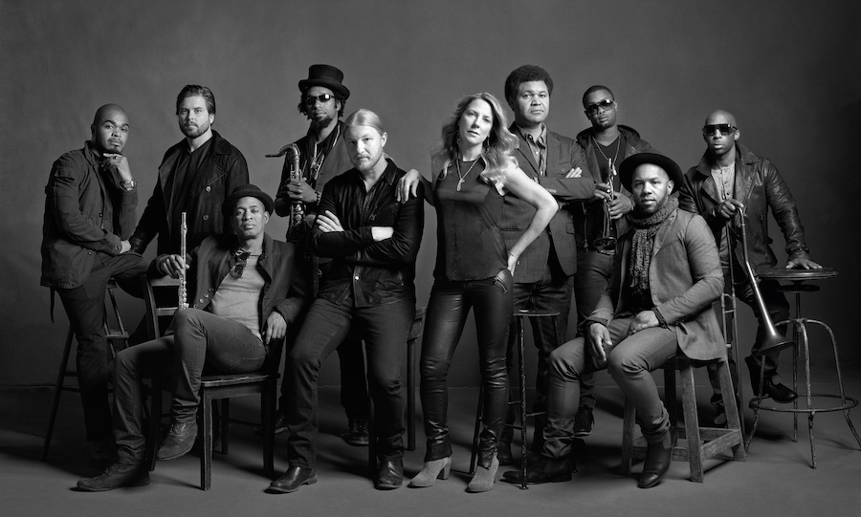

New York, NY May 2015 – From headlining festivals to multi-night residencies, the 11-piece powerhouse led by Susan Tedeschi and Derek Trucks has captured the admiration of both concert audiences and critics worldwide. With guitarist Derek Trucks’ 15 year tenure with The Allman Brothers Band wrapped up, the band has fully dedicated itself to expanding its legendary live performances with an increasing repertoire of soulful neo-classics as well as new material the band has been working on for their next album.

After launching 2015 with their own annual Sunshine Music Festivals in Florida, two sold out nights at Nashville’s storied Ryman Auditorium, and a performance by Derek and Susan at February’s high-profile MusicCares concert honoring Bob Dylan, TTB recently received rave reviews from their mainstage appearance at the New Orleans Jazz & Heritage Festival in April.
Times Picayune described the “powerful, soul-kissed, thunderous groove” while Rolling Stone declared the tour de force as “a masterful binding of spiritual-blues prowess.”

The band is looking forward to a 35-city cross-country amphitheater tour with soul hipsters Sharon Jones & the Dap-Kings and Doyle Bramhall II that kicks off June 5th. Delivering over 4 ½ hours of music each night at some of the finest outdoor venues in the country, the potential for collaborations seem boundless.

In September, TTB returns to Lockn’ Music Festival for a special two-night performance in September one of which includes an all star tribute to Joe Cocker hosted and curated by Tedeschi Trucks Band and featuring original Mad Dogs and Englishmen band members Leon Russell, Dave Mason, Rita Coolidge Bobby Jones plus special guests Chris Robinson, Anders Osborne and more . They’ll then continue its Beacon Theatre tradition with a return for a fifth consecutive year, appearing four nights. November will find the band back in Europe, including a headlining set at the London Blues Festival, plus stops in France, Germany, Holland and Denmark.

In 2014 Tedeschi Trucks Band crossed the globe with two tours of Europe, a return to Japan, and a maiden visit to India. Equally as active was the group’s domestic slate, its peak moments including a first-time mainstage performance at Bonnaroo as well as the coveted Midnight SuperJam set, led by Derek and featuring an amazing lineup of guests including Chaka Khan, David Hidalgo, Ben Folds and Taj Mahal. During its fourth consecutive residency at NYC’s Beacon Theatre, TTB played musical host to a multitude of special guests over four nights in September welcoming visits from dobro master Jerry Douglas, Eric Krasno, and blues legend Taj Mahal to Jaimoe, Jimmy Herring, and Jackie Greene. At year’s end, the band’s multiple-night runs in Philadelphia and Boston played to sold-out, SRO audiences, as well.

2014 also found Derek and Susan making contributions in the studio guesting on a pair of Grammy-winning releases. Tedeschi lent her vocal talents to "Gibsom Street" on Billy Childs’ Map to the Treasure: Reimagining Laura Nyro (2014), while Trucks’ slide guitar adorned Rosanne Cash’s “World of Strange Design” from her The River & The Thread album.

Formed in 2010 with a spirit of adventure that saw Susan Tedeschi and Derek Trucks shelve their equally successful solo careers, Tedeschi Trucks Band – who was recently profiled on CBS This Morning with Anthony Mason - debuted big with its Grammy Award-winning Revelator, 2012’s dynamic live follow up, Everybody’s Talkin’, and most recently 2013’s Made Up Mind bolstering the Jacksonville-based group’s growing reputation as the preeminent blues-rock leader. Driven by Trucks, #16 of the top 100 Guitarists of All Time (Rolling Stone), and Tedeschi, blessed with a voice that passionately delivers a range of powerful R&B belters to gentle ballads, the group enlists two drummers, two vocalists, a three-piece horn section, bass, and a multi-instrumentalist keyboard player for what is a greater-than-the-sum-of-its-parts collective.
Tedeschi Trucks Band is Derek Trucks (Guitar), Susan Tedeschi (Guitar, Vocals), Kofi Burbridge (Keyboards, Flute), Tyler Greenwell (Drums), J.J. Johnson (Drums), Mike Mattison (Vocals), Mark Rivers (Vocals), Elizabeth Lea (Trombone), Tim Lefebvre (Bass), Kebbi Williams (Saxophone), Maurice Brown (Trumpet),.
WATCH “Do I Look Worried” Live from Boston 12/14
https://www.youtube.com/watch?v=s54i4st_f9E

WATCH “Made Up Mind” Live from Vienne 7/4/14
https://www.youtube.com/watch?v=VHGnvkJbZXc

For additional press information, please contact
Renee Pfefer, On Tour PR
203-724-9919; Renee@ontourpr.com

High Res Jpegs available for download from here:
http://www.ontourpr.com/ttb

http://www.tedeschitrucksband.com
https://www.facebook.com/DerekAndSusan
https://twitter.com/DerekAndSusan

YouTube Channel: From the Road
https://www.youtube.com/user/TTBFromTheRoad

