For Immediate Release
Updated October 5, 2015

Tedeschi Trucks Band
Once in a Lifetime Collaborations at Lockn’ Festival in Virginia, Fall Tour Dates Include Four Nights at NYC”s Beacon Theatre and select dates across U.S.
"A deeply skilled groove machine" - Los Angeles Times

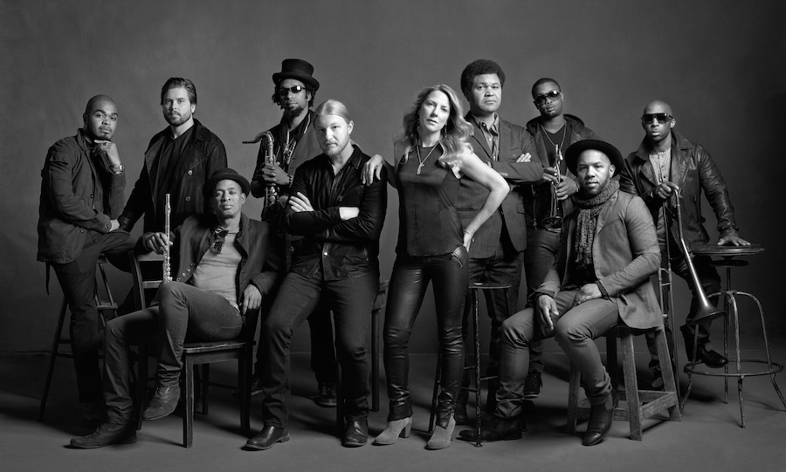

New York, NY September 15, 2015 – From headlining festivals to multi-night residencies, the 12-piece powerhouse led by Susan Tedeschi and Derek Trucks has captured the admiration of both concert audiences and critics worldwide. With guitarist Derek Trucks’ 15 year tenure with The Allman Brothers Band wrapped up, the band has fully dedicated itself to expanding its legendary live performances with an increasing repertoire of soulful neo-classics as well as new material the band has been working on for their next album, set for release early 2016.

After launching 2015 with their own annual Sunshine Music Festivals in Florida, two sold out nights at Nashville’s storied Ryman Auditorium, and a performance by Derek and Susan at February’s high-profile MusicCares concert honoring Bob Dylan, TTB delivered an inaugural mainstage appearance at the New Orleans Jazz & Heritage Festival in April. The group then spent its summer headlining the 35-city “Wheels of Soul” Amphitheatre tour with soul hipsters Sharon Jones & the Dap Kings and Doyle Bramhall II. Numerous nightly collaborations had critics describing the show “magical,” “epic,” and “fireworks might as well have been going off on stage — it was that captivating.”

TTB also just returned from the Lockn’ Festival in Virginia where they delivered an all-star tribute to Joe Cocker. Hosted and curated by Tedeschi Trucks Band and featuring Leon Russell, they brought together ten original members of the legendary 1970 Mad Dogs & Englishmen tour including Rita Coolidge, Claudia Lennear, Chuck Blackwell plus special guests Chris Robinson, Dave Mason, John Bell, and Warren Haynes for a once in a lifetime evening.

Upcoming fall highlights of the group’s schedule include a return to Beacon Theatre in New York City for a fifth consecutive year, appearing four nights September 25, 26 and October 2 and 3. In October, they have a string of headline dates and November finds the band back in Europe, including a headlining set at the London Blues Festival, plus stops in France, Germany, Holland and Denmark.

In 2014 Tedeschi Trucks Band crossed the globe with two tours of Europe, a return to Japan, and a maiden visit to India. Equally as active was the group’s domestic slate, its peak moments including a first-time mainstage performance at Bonnaroo as well as the coveted Midnight SuperJam set, led by Derek and featuring an amazing lineup of guests including Chaka Khan, David Hidalgo, Ben Folds and Taj Mahal. During its fourth consecutive residency at NYC’s Beacon Theatre, TTB played musical host to a multitude of special guests over four nights in September welcoming visits from dobro master Jerry Douglas, Eric Krasno, and blues legend Taj Mahal to Jaimoe, Jimmy Herring, and Jackie Greene. At year’s end, the band’s multiple-night runs in Philadelphia and Boston played to sold-out, SRO audiences, as well.

2014 also found Derek and Susan making contributions in the studio guesting on a pair of Grammy-winning releases. Tedeschi lent her vocal talents to "Gibsom Street" on Billy Childs’ Map to the Treasure: Reimagining Laura Nyro (2014), while Trucks’ slide guitar adorned Rosanne Cash’s “World of Strange Design” from her The River & The Thread album.

Formed in 2010 with a spirit of adventure that saw Susan Tedeschi and Derek Trucks shelve their equally successful solo careers, Tedeschi Trucks Band –recently profiled on CBS This Morning with Anthony Mason - debuted big with its Grammy Award-winning Revelator, 2012’s dynamic live follow up, Everybody’s Talkin’, and most recently 2013’s Made Up Mind bolstering the Jacksonville-based group’s growing reputation as the preeminent blues-rock leader. Driven by Trucks, #16 of the top 100 Guitarists of All Time (Rolling Stone), and Tedeschi, blessed with a voice that passionately delivers a range of powerful R&B belters to gentle ballads, the group enlists two drummers, two vocalists, a three-piece horn section, bass, and a multi-instrumentalist keyboard player for what is a greater-than-the-sum-of-its-parts collective.

WATCH “Do I Look Worried” Live from Boston 12/14
https://www.youtube.com/watch?v=s54i4st_f9E

WATCH “Made Up Mind” Live from Vienne 7/4/14
https://www.youtube.com/watch?v=VHGnvkJbZXc

2015 Itinerary
9/11-9/12 Arrington, VA Lockn’ Festival
9/19 Mill Valley, CA Sound Summit – A benefit for the Mountain
9/25 New York, NY Beacon Theatre w/ Los Lobos
9/26 New York, NY Beacon Theatre w/ Charles Bradley & His Extraordinaires
9/27 Erie, PA Warner Theater
10/1 Binghamton, NY Broome County Forum Theater
10/2 New York, NY Beacon Theatre w/ Scrapomatic
10/3 New York, NY Beacon Theatre – An Evening with TTB
10/15 Athens, GA Classic Center
10/16 Live Oak, FL Magnolia Festival
10/17 Raleigh, NC American Roots Music & Arts Festival
10/21 Huntsville, AL Von Braun Center
10/22 Evansville, IN Victoria Theatre
10/23 Montgomery, AL Montgomery Performing Arts Center
10/30 Tempe, AZ Monster Mash
11/6-11/17 EUROPE
12/3 Port Chester, NY Capitol Theatre
12/4 New Haven, CT College Street Music Hall
12/5 Providence, RI Providence Performing Arts Center
12/12 Asheville, NC Christmas Jam
2016
1/16 St. Petersburg, FL Vinoy Park / Sunshine Music Festival
1/17 Boca Raton, FL l Mizner Park/ Sunshine Music Festival

For additional press information, please contact
Renee Pfefer, On Tour PR
203-724-9919; Renee@ontourpr.com

High Res Jpegs available for download
http://www.ontourpr.com/ttb

http://www.tedeschitrucksband.com

